Sunday | Monday | Tuesday | Wednesday |  | Thursday | Friday | Saturday
 |  |  |  | 1 | 2 | 3 | 4  Shavuot Begins
5 | 6 | 7 |  | 8 | 9 | 10 | 11
12 | 13 | 14  Flag Day (US) |  | 15 | 16 | 17 | 18
19  Father’s Day  Juneteenth | 20 | 21  Summer Begins |  | 22 | 23 | 24 | 25
26 | 27 | 28 |  | 29 | 30

WIFI: NHC-guestaccess Password: nhcguest |  |  | 10 Sit & Be Fit  10:30 Resident Council  2:30 Welcome to June Gazette | 10 Sit & Be Fit  10:30 Temple Baptist Church  Zoom Service  2:30 Bingocize | 10 Sit & Be Fit  10:30 Let’s Laugh  2:30 Patio Social | Room to Room Leisure Cart  Wing 1  Summer Puzzle Packet
Temple Baptist Church 11 AM  TV: Channel 4 | 10 Sit & Be Fit  10:30 Ten Things about Shavout  2:30 Games Galore | 10 Sit & Be Fit  10-11 Manicures  2:30 Bingo | 10 Sit & Be Fit  10:30 Daily Chronicles and Current Events  2:30 Snacks & Scripture | 10 Sit & Be Fit  10:30 Temple Baptist Church  Zoom Service  2:30 Bingocize | 10 Sit & Be Fit  10:30 Junk Drawer Detectives  2:30 Iced Tea on the Patio | Room to Room Leisure Cart  Wing 1  Flag Day/Juneteenth  Puzzle Packet
Temple Baptist Church 11 AM  TV: Channel 4 | 10 Sit & Be Fit  10:30 Flag Day History  2:30 Memory Matching | 10 Sit & Be Fit  10-11 Manicures  2:30 Bingo | 10 Sit & Be Fit  10:30 Daily Chronicles and Current Events  2:30 Monthly Birthday Party | 10 Sit & Be Fit  10:30 Temple Baptist Church  Zoom Service  2:30 Bingocize  (CNA Week 16th-23rd) | 10 Sit & Be Fit  10:30 Juneteenth  True or False  2:30 Patio Social | Room to Room Leisure Cart  Wing 1  Donuts for Dads
Temple Baptist Church 11 AM  TV: Channel 4 | 10 Sit & Be Fit  10:30 EZ Does It Trivia  2:30 Short Story: A Day at the Deli | 10 Sit & Be Fit  10-11 Manicures  2:00 Homemade Ice Cream- The Longest Day | 10 Sit & Be Fit  10:30 Daily Chronicles and Current Events  2:30 Snacks & Scripture | 10 Sit & Be Fit  10:30 Temple Baptist Church  Zoom Service  2:30 Bingocize | 10 Sit & Be Fit  10:30 Felt Art  2:30 Lemonade in the Shade | Room to Room Leisure Cart  Wing 1  Musical Memories
Temple Baptist Church 11 AM  TV: Channel 4 | 10 Sit & Be Fit  10:30 Sentimental  Travel  2:30 Craft Corner | 10 Sit & Be Fit  10-11 Manicures  2:30 Bingo | 10 Sit & Be Fit  10:30 Daily Chronicles and Current Events  2:30 Snacks & Scripture | 10 Sit & Be Fit  10:30 Temple Baptist Church  Zoom Service  2:30 Bingocize | Leisure Supplies Available:  CD/Radio, DVD Player/Movies, Board Games, Cards, Jig Saw Puzzles, Books, Adult Color, Magazines, Tablets, and WIFI. FaceTime assistance available upon request.  Beauty Shop open on Tuesdays
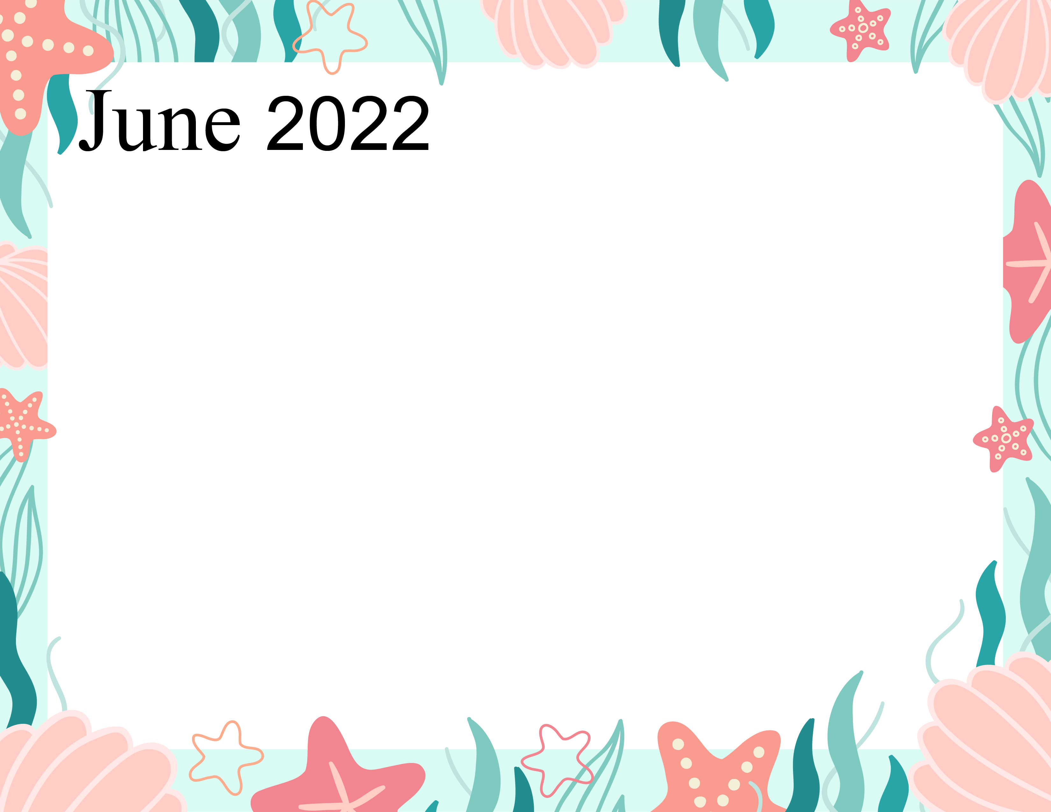
*Activities are subject to change to meet the needs of our residents and COVID-19 Guidelines*

