Sunday | Monday | Tuesday | Wednesday | Thursday | Friday | Saturday
 |  |  |  |  | 1 | 2
3 | 4 | 5 | 6 | 7 | 8 | 9
10 | 11  Columbus Day (US)  Indigenous Peoples’ Day  Thanksgiving (Canada) | 12 | 13 | 14 | 15 | 16
17 | 18 | 19 | 20 | 21 | 22 | 23
24 | 25 | 26 | 27 | 28 | 29 | 30
31

Halloween

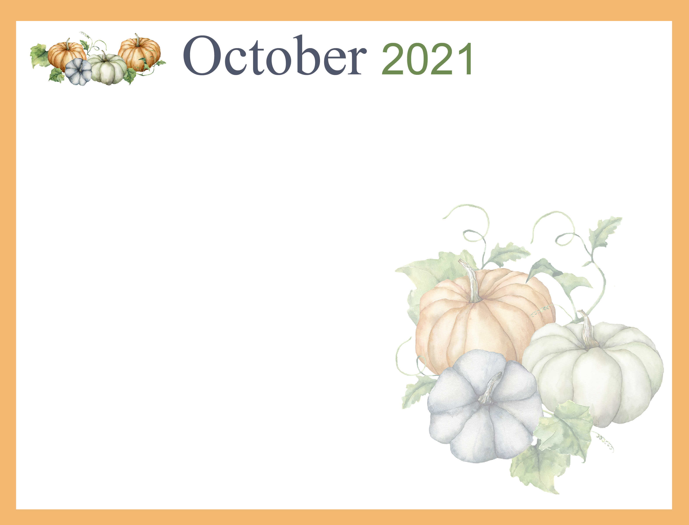  WIFI: NHC-guestaccess PASSWORD: nhcguest |  |  |  |  | 10 Sit & Be Fit  10:30 Welcome to October Bookclub  2:30 Bingocize | Walk to End Alzheimer’s  12 Tennessee VS  Missouri
Temple Baptist  Church 11AM  TV: Channel 4 | 10 Sit & Be Fit  10:30 EZ Does it Trivia  2:30 Manicures | 10 Sit & Be Fit  10:30 Junk Drawer Detectives  2:30 Bingo | 10 Sit & Be Fit  10:30 Resident Council  2 Music by David  2:30 Patio Sitters | 10 Sit & Be Fit  10:30 Let’s Make a Deal-Gameshow  2:30 Games Galore | 10 Sit & Be Fit  10:30 Weekly  Chronicles  2:30 Bingocize | Room to Room  Leisure Cart  Patio Sitters  12 Tennessee VS  South Carolina
Temple Baptist  Church 11AM  TV: Channel 4 | 10 Sit & Be Fit  10:30 Reminisce with Friends  2:30 Manicures | 10 Sit & Be Fit  10:30 Sentimental  Travel  2:30 Bingo | 10 Sit & Be Fit  10:30 Weekly  Chronicles  2:30 Patio sitters | 10 Sit & Be Fit  10:30 Gaither’s Gospel Music  2:30 Pumpkin Painting | 10 Sit & Be Fit  10:30 Halloween Ha! Ha! Ha!  2:30 Bingocize | Room to Room  Leisure Cart  Patio Sitters  Tennessee VS Mississippi-TBD
Temple Baptist  Church 11AM  TV: Channel 4 | 10 TV Land  2:30 Manicures | 10 Sit & Be Fit  10:30 Weekly Chronicles  2:30 Bingo | 10 Sit & Be Fit  10:30 October Monthly Birthday Party  2:30 Pumpkin Craft | 10 Sit & Be Fit  10:30 Temple Baptist Church Zoom  2:30 Adult Color | 10 Sit & Be Fit  10:30 Craft Corner  2:30 Bingocize | Room to Room  Leisure Cart  Patio Sitters  Tennessee VS Alabama-TBD
Temple Baptist  Church 11AM  TV: Channel 4 | 10 Sit & Be Fit  10:30 Juice & Conversation  2:30 Manicures | 10 Sit & Be Fit  10:30 Weekly  Chronicles  2:30 Bingo | 10 Sit & Be Fit  10:30 Momma’s  Kitchen  2:30 Patio Sitters | 10 Sit & Be Fit  10:30 Temple Baptist Church  Zoom  2:30 Movie Mania- Hocus Pocus | 10 Halloween Jingo  2:30 Hallway Halloween Parade  Costume Contest | Room to Room  Leisure Cart  Patio Sitters
Temple Baptist  Church 11AM  TV: Channel 4 | Leisure Supplies Available:  CD/Radio, DVD Player/Movies, Board Games, Cards  Jigsaw Puzzles, Books, Adult Color,  Magazines, Tablets, and WIFI  FaceTime and DUO assistance available  upon request
*Activities are subject to change to meet the needs of our residents.*

