 | 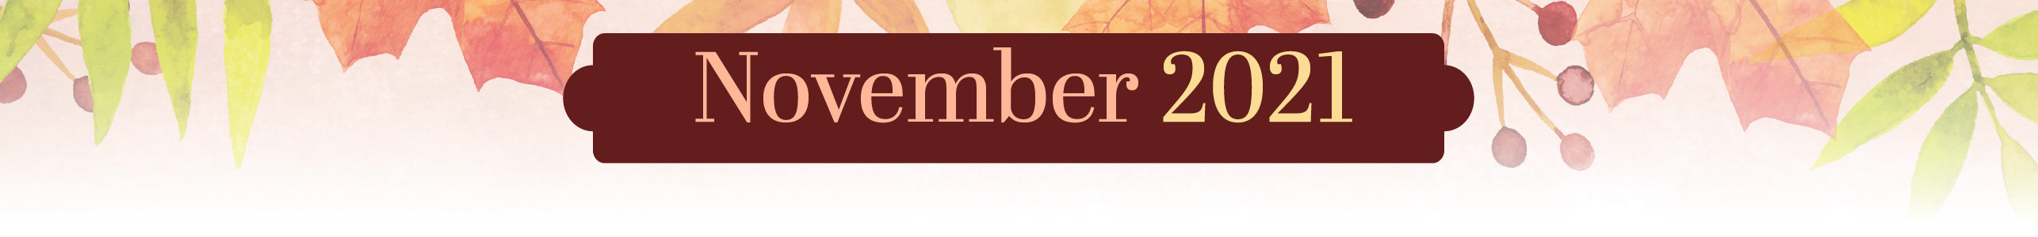  NHC Place Farragut
  Sunday | Monday | Tuesday | Wednesday | Thursday | Friday | Saturday
  31 | 1 | 2 | 3 | 4 | 5 | 6
 | 9:30am Exercise w/ Patsy (SF)  10:30am Bingo! (SF)  1:30pm UNO! (SF)  3:00pm Ball Circle (SF) | 9:30am Exercise w/ Patsy (SF)  10:30am Piano Music w/ Jan (SF)  2:00pm Bingo! (SF)  3:15pm Balloon Volleyball (SF) | 9:30am Exercise w/ Patsy (SF)  10:30am Devotions (SF)  1:30pm Bowling (SF)  3:00pm Oldies in the Courtyard (CY) | 9:30am Exercise w/ Patsy (SF)  10:30am Thursday Trivia (SF)  1:00pm Bird Talk w/ Patsy (LR)  2:00pm Theater Thursday (SF) | 9:30am Exercise w/ Patsy (SF)  10:30am Shut the Box (SF)  1:30pm Jewelry Making (SF)  3:00pm Happy Hour! (SF) | Emily  9:30am Chair Chi (SF)  10:30am Fall Coloring (SF)  2:00pm Movie (SF)
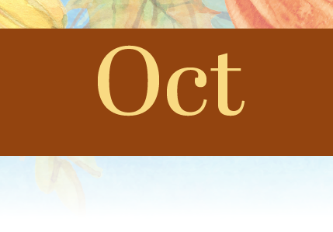
SF- Soda Foutain, DR- Dining Room, LR- Living Room, CY- Courtyard. Physical, Emotional/Spiritual, Vocational, Intellectual, Social, Environmental
Sunday | Monday | Tuesday | Wednesday | Thursday | Friday | Saturday
7 | 8 | 9 | 10 | 11 | 12 | 13

NHC Place Farragut

9:30am Chair Chi (SF)  10:30am Sunday Service (DR)  1:30pm Chaplain’s Intercom Service  2:30pm Movie (SF) | 9:30am Exercise w/ Trevor (SF)  10:30am Bingo! (SF)  1:30pm UNO! (SF)  3:00pm Funny Videos (SF) | 9:30am Exercise w/ Patsy (SF)  10:30am Reading w/ Patsy  10:30am Word Puzzles (SF)  2:00pm Bingo! (SF)  3:15pm Washer Toss (SF) | 9:30am Exercise w/ Patsy (SF)  10:30am Devotions (SF)  1:30pm Family Feud (SF)  2:30pm Scenic Drive (Meet in Lobby)  2:30pm Balloon Volleyball (SF) | 9:30am Exercise w/ Patsy (SF)  10:30am Nerf Range (SF)  1:30pm The Price is Right (SF)  2:30pm Veterans Day Celebration! (SF) | 9:30am Exercise w/ Patsy (SF)  10:30am Shut the Box (SF)  1:30pm Chat-a-Chini Game (SF)  3:00pm Happy Hour! (SF) | Patsy  9:30am Exercise w/ Patsy (SF)  10:30am Jewelry Making (SF)  2:00pm Movie (SF)
SF- Soda Foutain, DR- Dining Room, LR- Living Room, CY- Courtyard. Physical, Emotional/Spiritual, Vocational, Intellectual, Social, Environmental
Sunday | Monday | Tuesday | Wednesday | Thursday | Friday | Saturday
14 | 15 | 16 | 17 | 18 | 19 | 20

NHC Place Farragut

9:30am Chair Chi (SF)  10:30am Sunday Service (DR)  1:30pm Chaplain’s Intercom Service  2:30pm Movie (SF) | 9:30am Exercise w/ Patsy (SF)  10:30am Bingo! (SF)  1:30pm UNO! (SF)  3:00pm Ball Circle (SF) | 9:30am Exercise w/ Patsy (SF)  10:30am Cranium Crunches (SF)  2:00pm Bingo! (SF)  3:15pm Balloon Volleyball (SF) | 9:30am Exercise w/ Patsy (SF)  10:30am Devotions (SF)  1:30pm Guess That Oldies Tune (SF)  2:30pm Live Music w/ Jon Wigle: Man of a Thousand Voices! (DR) | 9:30am Exercise w/ Patsy (SF)  10:30am Turkey Foot Dominoes  1:30pm Washer Toss (SF)  2:00pm Theater Thursday (SF) | 9:30am Exercise w/ Patsy (SF)  10:30am Shut the Box (SF)  1:30pm Turkey Craft (SF)  3:00pm Happy Hour! (SF) | Trevor  9:30am Chair Chi (SF)  10:30am Checkers (SF)  2:00pm Ball Exercise (SF)
SF- Soda Foutain, DR- Dining Room, LR- Living Room, CY- Courtyard. Physical, Emotional/Spiritual, Vocational, Intellectual, Social, Environmental
Sunday | Monday | Tuesday | Wednesday | Thursday | Friday | Saturday
21 | 22 | 23 | 24 | 25 | 26 | 27

NHC Place Farragut

9:30am Chair Chi (SF)  10:30am Sunday Service (DR)  1:30pm Chaplain’s Intercom Service  2:30pm Movie (SF) | 9:30am Exercise w/ Patsy (SF)  10:30am Bingo! (SF)  1:30pm UNO! (SF)  3:00pm Nerf Range (SF) | 9:30am Exercise w/ Patsy (SF)  10:30am Tuesday Turkey Trivia (SF)  2:00pm Bingo! (SF)  3:15pm Friendsgiving (SF)  3:15pm Balloon Volleyball (SF) | 9:30am Exercise w/ Patsy (SF)  10:30am Devotions (SF)  1:30pm Turkey Tales (SF)  2:30pm Scenic Drive (Meet in Lobby)  2:30pm Balloon Volleyball (SF) | THANKSGIVING | 9:30am Exercise w/ Patsy (SF)  10:30am Shut the Box (SF)  1:30pm Conversation Ball (SF)  3:00pm Happy Hour! (SF) | Emily  9:30am Chair Chi (SF)  10:30am Word Puzzles (SF)  2:00pm Movie (SF)
SF- Soda Foutain, DR- Dining Room, LR- Living Room, CY- Courtyard. Physical, Emotional/Spiritual, Vocational, Intellectual, Social, Environmental
 |  |  | NHC Place Farragut
  Sunday | Monday | Tuesday | Wednesday | Thursday | Friday | Saturday
  28 | 29 | 30 | 1 | 2 | 3 | 4
9:30am Chair Chi (SF)  10:30am Sunday Service (DR)  1:30pm Chaplain’s Intercom Service  2:30pm Movie (SF) | 9:30am Exercise w/ Patsy (SF)  10:30am Bingo! (SF)  1:30pm UNO! (SF)  3:00pm Ball Circle (SF) | 9:30am Exercise w/ Patsy (SF)  10:30am Bingo! (SF)  2:00pm Resident Council (DR)  3:15pm Monthly Birthday Party (SF)
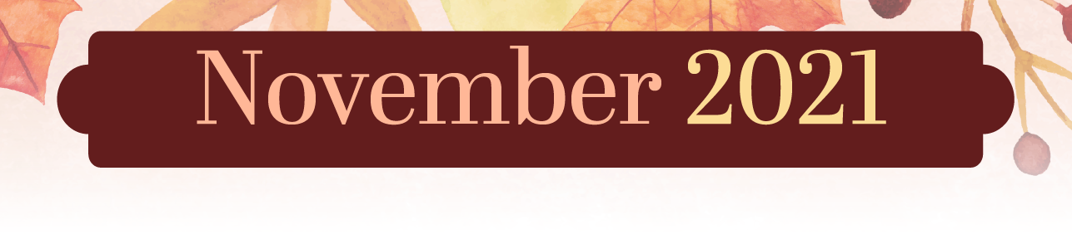
SF- Soda Foutain, DR- Dining Room, LR- Living Room, CY- Courtyard. Physical, Emotional/Spiritual, Vocational, Intellectual, Social, Environmental

