Sunday | Monday | Tuesday | Wednesday | Thursday | Friday | Saturday
26 | 27 | 28 | 29 | 30 | 1 | 2

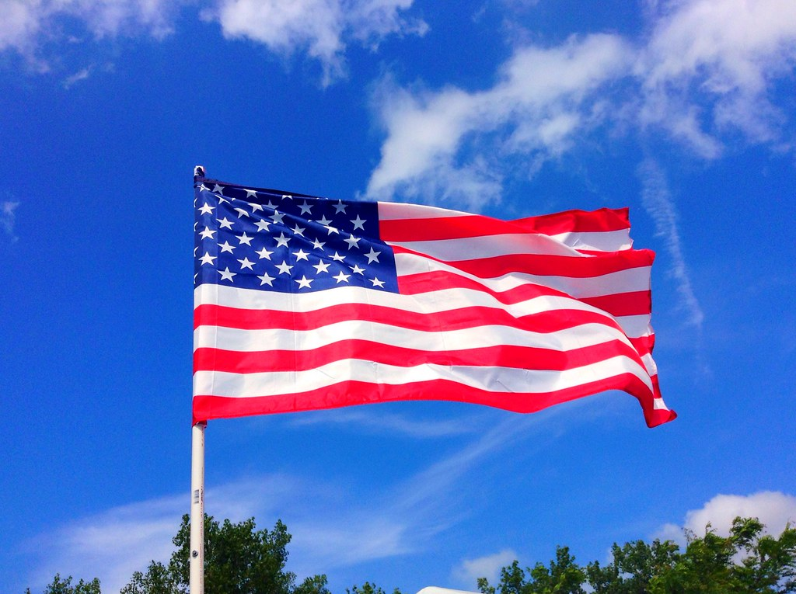 |  | Activity Calendar is subject to change. Please check daily activities posters |  |  | 9:30am Exercise with Patsy (SF)  10:30am Reading with Patsy Love Comes Softly (SF)  1:30pm Pet Therapy with Murphy (room to room)  2:00pm Happy Hour (SF) | 9:30am Chair Chi  (SF)  10:30am Shut the  Box (SF)  2:00pm Movie Matinee (SF)
Activity Calendar is subject to change. Come join us in some fun!!
NHC Place Farragut ALF
Sunday | Monday | Tuesday | Wednesday | Thursday | Friday | Saturday
3 | 4 | 5 | 6 | 7 | 8 | 9

9:30am Chair Chi  (SF)  10:30am Sunday Service (DR)  1:30pm Chaplain’s Intercom Service  2:30am Sunday Afternoon at the Movies (SF) | Happy 4th of July  9:30am Exercise with Patsy (SF)  10:30am Patriotic Trivia (SF)  10:30am Pet Therapy with Heather (room to room)  1:00pm 4th of July Celebration (SF)  2:00pm BINGO!  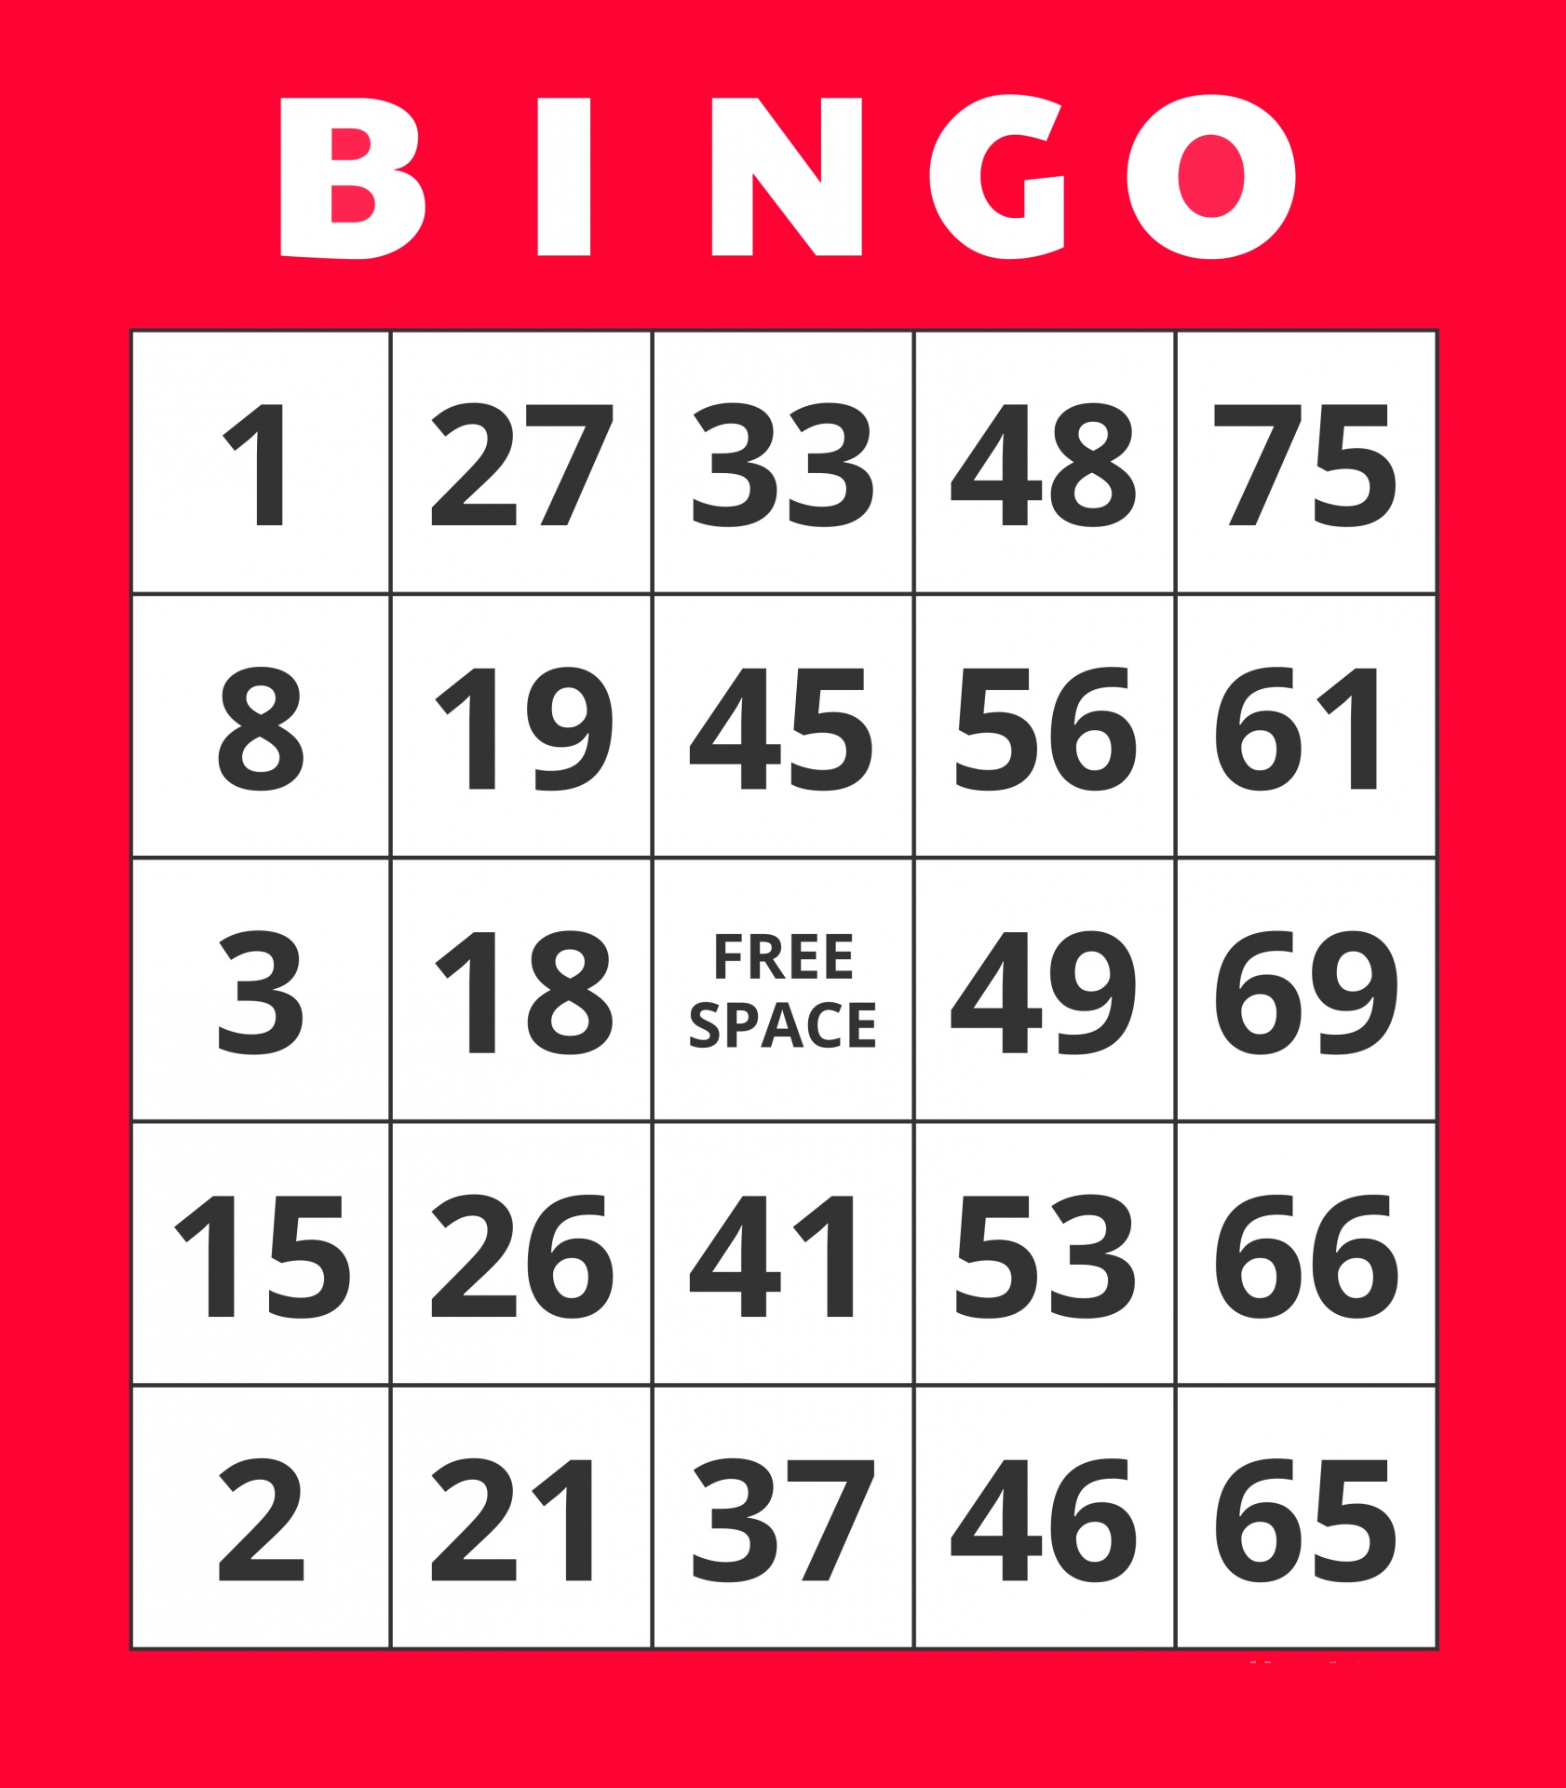 | 9:30am Exercise with Patsy (SF)  10:30am Piano Music with Jan (SF)  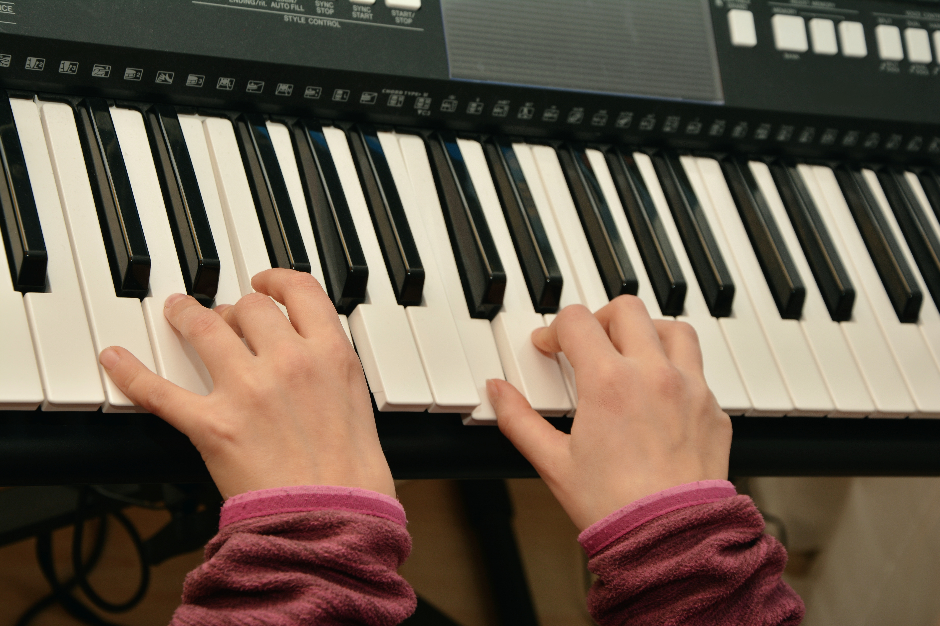  1:30pm Painting  (SF)  3:30pm Rosary with Lynn (LR) | 9:30am Exercise with Patsy (SF)  10:30am Devotions with Chaplain Austin (SF)  10:30am Pet Therapy with Lily  (room to room)  1:30pm Jewelry Making with Patsy  (SF) | 9:30am Exercise with Patsy (SF)  10:30am Hymn Singing (SF)  2:00pm BINGO!  (SF)  4:00pm Pet Therapy with Darby (room to room) | 9:30am Exercise with Patsy (SF)  10:30am Reading with Patsy Love Comes Softly (SF)  1:30pm Pet Therapy with Murphy (room to room)  2:30pm Happy Hour with Mayor, Ran Williams (SF) | 9:30am Chair Chi  (SF)  10:30am UNO (SF)  2:00pm Movie Matinee (SF)
SF- Soda Fountain DR- Dining Room LR- Living Room CY- Courtyard
NHC Place Farragut ALF
Sunday | Monday | Tuesday | Wednesday | Thursday | Friday | Saturday
10 | 11 | 12 | 13 | 14 | 15 | 16

9:30am Chair Chi  (SF)  10:30am Sunday Service (DR)  1:30pm Chaplain’s Intercom Service  2:30am Sunday Afternoon at the Movies (SF) | 9:30am Exercise with Patsy (SF)  10:30am Reading with Patsy Love Comes Softly (SF)  10:30am Pet Therapy with Heather (room to room)  1:15pm Ice-Cream Social (SF)  2:00pm BINGO!  (SF) | 9:30am Exercise with Patsy (SF)  10:30am UNO (SF)  1:15pm Afternoon in the Courtyard  2:00pm Ball Bounce (SF)  3:30pm Rosary with Lynn (LR) | 9:30am Exercise with Patsy (SF)  10:30am Devotions with Chaplain Austin (SF)  10:30am Pet Therapy with Lily  (room to room)  2:00pm Live Musical Performance by  Jon Wigle Man of a Thousand Voices (DR) | 9:00am VOTING with Election Commission (SF)  2:00pm BINGO!  (SF)  4:00pm Pet Therapy with Darby (room to room) | 9:30am Exercise with Patsy (SF)  10:30am Reading with Patsy Love Comes Softly (SF)  1:30pm Pet Therapy with Murphy (room to room)  2:00pm Happy Hour (SF) | 9:30am Chair Chi  (SF)  10:30am Shut the Box (SF)  2:00pm Movie Matinee (SF)
Physical, Emotional/Spiritual, Vocational, Intellectual, Social, Environmental
Sunday | Monday | Tuesday | Wednesday | Thursday | Friday | Saturday
17 | 18 | 19 | 20 | 21 | 22 | 23

NHC Place Farragut ALF
9:30am Chair Chi  (SF)  10:30am Sunday Service (DR)  1:30pm Chaplain’s Intercom Service  2:30am Sunday Afternoon at the Movies (SF) | 9:30am Exercise with Patsy (SF)  10:30am Reading with Patsy Love Comes Softly (SF)  10:30am Pet Therapy with Heather (room to room)  1:15pm Ice-Cream Social (SF)  2:00pm BINGO!  (SF) | 9:30am Exercise with Patsy (SF)  10:30am Shut the Box (SF)  1:00pm Balloon Bounce Fun (SF)  2:00pm Jewelry Making with Patsy (SF)  3:30pm Rosary with Lynn (LR) | 9:30am Exercise with Patsy (SF)  10:30am Devotions with Chaplain Austin (SF)  10:30am Pet Therapy with Lily  (room to room)  10:45am Lunch at Cracker Barrel!  (Meet in the lobby)  2:30pm Ball Bounce (SF) | 9:30am Exercise with Patsy (SF)  10:30am Hymn Singing (SF)  2:00pm BINGO!  (SF)  4:00pm Pet Therapy with Darby (room to room) | 9:30am Exercise with Patsy (SF)  10:30am Reading with Patsy Love Comes Softly (SF)  1:30pm Pet Therapy with Murphy (room to room)  2:00pm Happy Hour (SF) | 9:30am Chair Chi  (SF)  10:30am UNO (SF)  2:00pm Movie Matinee (SF)
Activity Calendar is subject to change. Please see daily activity signs
NHC Place Farragut ALF
Sunday | Monday | Tuesday | Wednesday | Thursday | Friday | Saturday
24 | 25 | 26 | 27 | 28 | 29 | 30

9:30am Chair Chi  (SF)  10:30am Sunday Service (DR)  1:30pm Chaplain’s Intercom Service  2:30am Sunday Afternoon at the Movies (SF) | 9:30am Exercise with Patsy (SF)  10:30am Reading with Patsy Love Comes Softly (SF)  10:30am Pet Therapy with Heather (room to room)  1:15pm Ice-Cream Social (SF)  2:00pm BINGO!  (SF) | 9:30am Exercise with Patsy (SF)  10:30am Painting (SF)  2:00pm Resident Council (DR)  3:00pm Monthly Birthday Party (SF)  3:30 Rosary with Lynn (LR) | 9:30am Exercise with Patsy (SF)  10:30am Devotions with Chaplain Austin (SF)  10:30am Pet Therapy with Lily  (room to room)  1:30pm Balloon Bounce Fun (SF) | 9:30am Exercise with Patsy (SF)  10:30am Hymn Singing (SF)  2:00pm BINGO!  (SF)  4:00pm Pet Therapy with Darby (room to room) | 9:30am Exercise with Patsy (SF)  10:30am Reading with Patsy Love Comes Softly (SF)  1:30pm Pet Therapy with Murphy (room to room)  2:00pm Happy Hour (SF) | 9:30am Chair Chi  (SF)  10:30am Shut the Box (SF)  2:00pm Movie Matinee (SF)
Physical, Emotional/ Spiritual, Vocational, Intellectual, Social, Environmental
Sunday | Monday | Tuesday | Wednesday | Thursday | Friday | Saturday
31 | 1 | 2 | 3 | 4 | 5 | 6

9:30am Chair Chi
(SF)

10:30am Sunday Service (DR)

1:30pm Chaplain’s Intercom Service

2:30am Sunday Afternoon at the Movies
9:30am Chair Chi
(SF)

10:30am Sunday Service (DR)

1:30pm Chaplain’s Intercom Service

2:30am Sunday Afternoon at the Movies (SF)
SF- Soda Fountain, DR- Dining Room, LR- Living Room , CY- Courtyard

