NHC Place Farragut ALF  Sunday Monday Tuesday Wednesday Thursday Friday Saturday  27 28 29 30 31 1 2 |  |  |  |  | 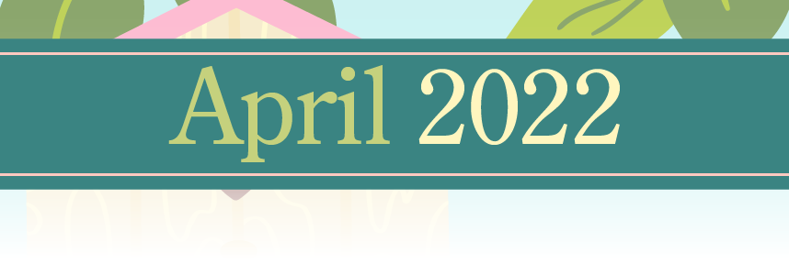
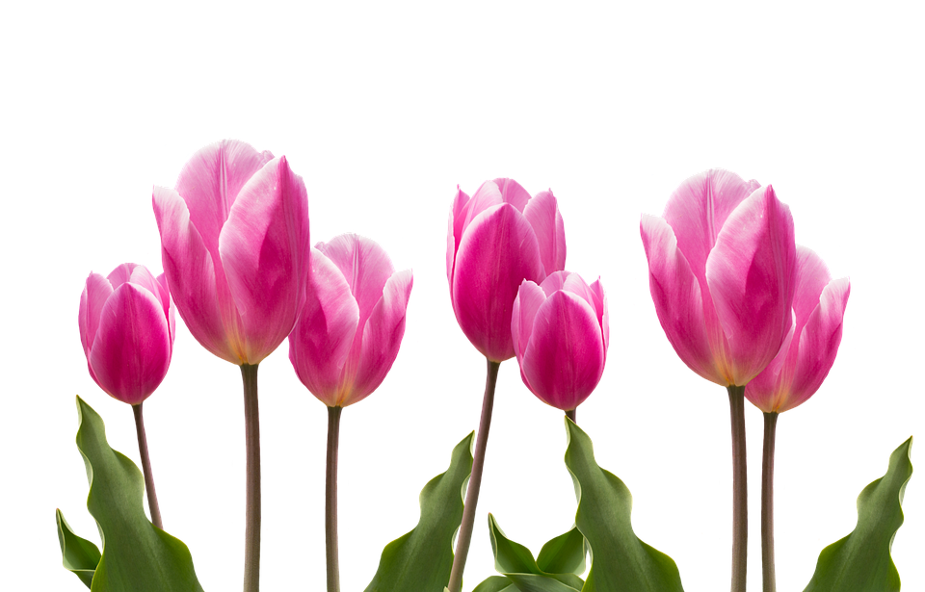 |  |  |  |  | 9:30 Exercise with Patsy (SF)  10:30am Hymn Singing (SF)  1:30pm Jewelry Making (SF)  1:30pm Pet Therapy with Murphy (room to room)  3:00pm Happy Hour (SF) | Patsy  9:30 Exercise with Patsy (SF)  10:30am Finish the Phrase  2:00pm Movie Matinee (SF)
Activity Calendar is subject to change. Come join us in some fun!!
NHC Place Farragut ALF
Sunday | Monday | Tuesday | Wednesday | Thursday | Friday | Saturday
3 | 4 | 5 | 6 | 7 | 8 | 9

9:30am Chair Chi (SF)  10:30am Sunday Service (DR)  1:30pm Chaplain’s Intercom Service  2:30pm Movie (SF) | 9:30 Exercise with Patsy (SF)  10:30am Bingo! (SF)  10:30am Pet Therapy with Heather (room to room)  1:30pm Trivia Plus (SF)  2:00pm Oldies but Goodies Sing-A-Long (SF) | 9:30 Exercise with Patsy (SF)  10:30am Piano w/ Jan (SF)  2:00pm Bingo! (SF)  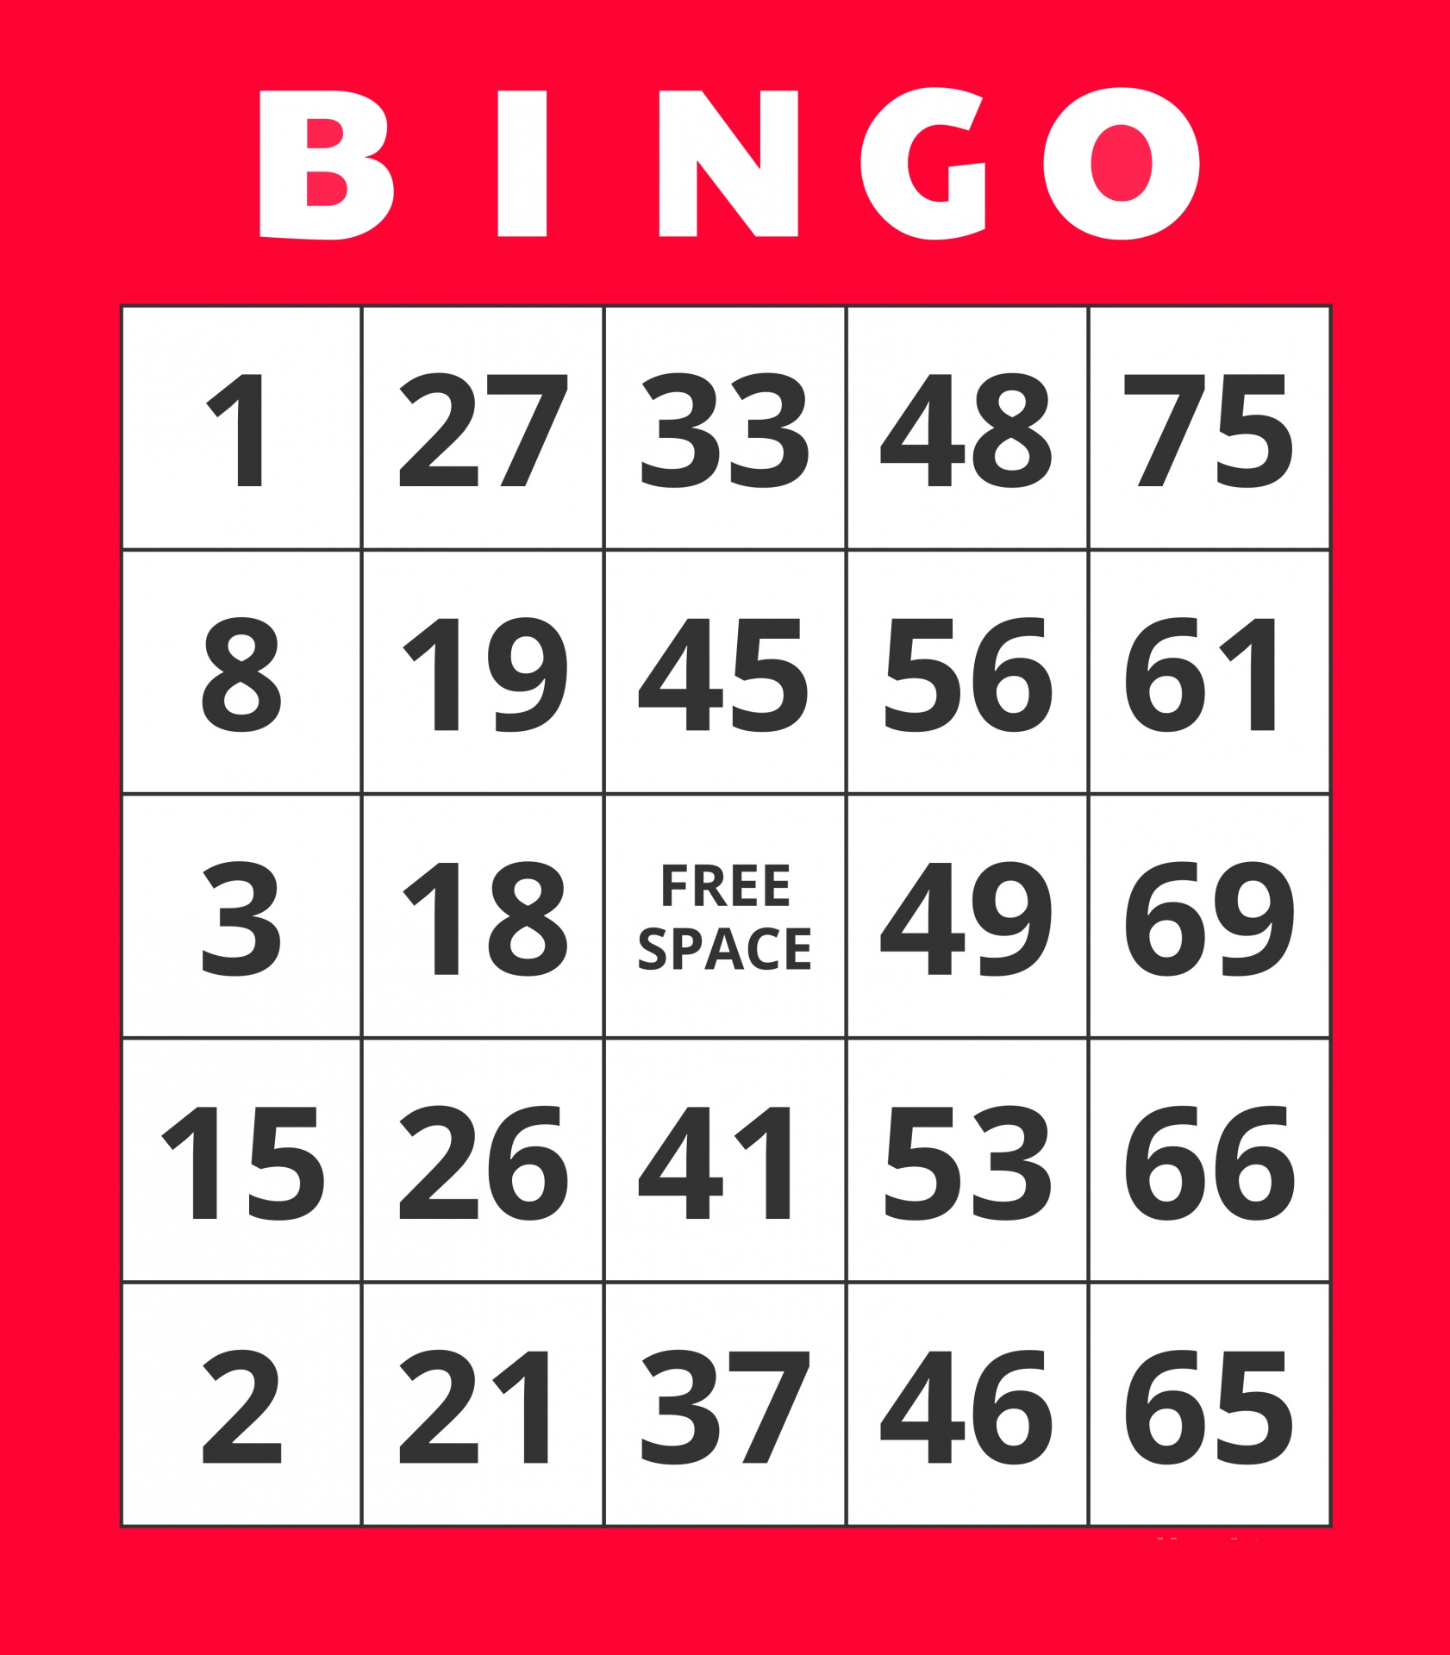 | 9:30 Exercise with Patsy (SF)  10:30am Devotions with Chaplain Austin (SF)  10:30am Pet Therapy with Lily (room to room)  2:00pm Easter Arts and Crafts (SF) | 9:30 Exercise with Patsy (SF)  10:30am Daily Devotions (SF)  1:30pm Family Feud (SF)  2:30pm Theatre Thursday and Snacks (SF)  4:00pm Pet Therapy with Darby (room to room) | 9:30am Exercise with Patsy (SF)  10:30am Current Events and Coffee (SF)  1:30pm UNO Games (SF)  1:30pm Pet Therapy with Murphy (room to room)  3:00pm Happy Hour (SF) | Sara  9:30am Chair Chi (SF)  10:30am Spring Colors  2:30pm Movie Matinee
SF- Soda Fountain, DR- Dining Room, LR- Living Room, CY- Courtyard
Sunday | Monday | Tuesday | Wednesday | Thursday | Friday | Saturday
10 | 11 | 12 | 13 | 14 | 15 | 16

April: NHC Place Farragut
9:30am Chair Chi (SF)  10:30am Sunday Service (DR)  1:30pm Chaplain’s Intercom Service  2:30pm Movie (SF) | 9:30am Exercise with Patsy (SF)  10:30am Bingo! (SF)  10:30am Pet Therapy with Heather (room to room)  2:00pm Knox County Primary Election Review (SF) | 9:30am VOTING with the Election Commission! (SF)  10:30am Daily Devotions (LR)  2:00pm Bingo! (SF) | 9:30am Exercise with Patsy (SF)  10:30am Devotions with Chaplain Austin (SF)  10:30am Pet Therapy with Lily (room to room)  1:30pm Balloon Volleyball (SF)  2:30pm Easter Sing-A-Long (SF) | 9:30am Exercise with Patsy (SF)  10:30am Chronicles and Current Events (SF)  2:00pm Easter Painting (SF)  4:00pm Pet Therapy with Darby (room to room) | 9:30am Exercise with Patsy (SF)  10:30am Hymn Singing (SF)  1:30pm Pet Therapy with Murphy (room to room)  1:30pm Jewelry Making (SF)  3:00pm Happy Hour (SF) | Emily  9:30am Chair Chi (SF)  10:30am Bunny Ring Toss (SF)  2:30pm Movie Matinee
Physical, Emotional/ Spiritual, Vocational, Intellectual, Social, Environmental
NHC Place Farragut ALF
Sunday | Monday | Tuesday | Wednesday | Thursday | Friday | Saturday
17 | 18 | 19 | 20 | 21 | 22 | 23

Easter  Sunday  9:30am Chair Chi (SF)  10:30am Sunday Service (DR)  1:30pm Chaplain’s Intercom Service  2:30pm Movie (SF) | 9:30am Exercise with Patsy (SF)  10:30am Bingo! (SF)  10:30am Pet Therapy with Heather (room to room)  2:00pm Sing-A-Long Music (SF) | 9:30am Exercise with Patsy (SF)  10:30am Chronicles and Current Events (LR)  1:30pm Men’s Club Meeting (LR)  2:00pm Bingo! (SF) | 9:30am Exercise with Patsy (SF)  10:30am Devotions with Chaplain Austin (SF)  10:30am Pet Therapy with Lily (room to room)  2:00 Man of a Thousand Voices Music with Jon Wigle (DR) | 9:30am Exercise with Patsy (SF)  10:30am Jigsaw and Word Puzzling (SF)  2:00pm Balloon Bounce Fun  4:00pm Pet Therapy with Darby (room to room) | 9:30am Exercise with Patsy (SF)  10:30am Board Games (SF)  1:30pm Pet Therapy with Murphy (room to room)  1:30pm Courtyard Active Games  3:00pm Happy Hour (SF) | Patsy  9:30am Exercise with Patsy (SF)  10:30am Bird Watching  2:00pm Singing Hymns (SF)
SF- Soda Fountain, DR- Dining Room, LR- Living Room, CY- Courtyard
NHC Place Farragut ALF
Sunday | Monday | Tuesday | Wednesday | Thursday | Friday | Saturday
24 | 25 | 26 | 27 | 28 | 29 | 30

9:30am Chair Chi (SF)  10:30am Sunday Service (DR)  1:30pm Chaplain’s Intercom Service  2:30pm Movie (SF) | 9:30am Morning Exercise  10:30am Bingo! (SF)  10:30am Pet Therapy with Heather (room to room)  2:00pm Singing Hymns (SF) | 9:30am Exercise with Patsy (SF)  10:30am Bingo! (SF)  2:00pm Resident Council  3:00pm Courtyard Ice Creams | 9:30am Exercise with Patsy (SF)  10:30am Devotions with Chaplain Austin (SF)  10:30am Pet Therapy with Lily (room to room)  2:00pm Monthly Birthday Party (SF) | 9:30am Exercise with Patsy (SF)  10:30am Cards Club (SF)  3:00pm Old Time Rock n Roll with Conrad-O  4:00pm Pet Therapy with Darby (room to room) | 9:30am Exercise with Patsy (SF)  1:30pm Pet Therapy with Murphy (room to room)  1:30pm Bird Watching (CY)  3:00pm Happy Hour (SF) | Julita  9:30am Morning Exercise (SF)  10:30am Trivia Time (SF)  2:00pm Movie Matinee

