◄ Sep 2021 | October 2021 |  |  |  |  | Nov 2021 ►
Sun | Mon | Tue | Wed | Thu | Fri | Sat
 |  | 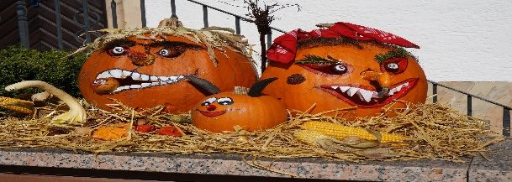 |  |  | 1  10:30a-1:1 Visits 3rd  2:00p-Shuffle Board | 2 TNN @ Missouri 12:00pm  10:30a- Leisure Cart  2:00p-Finish My Phrase
3  Daily TV church services & Gospel music on channel 811 for leisure & Bible study work pages as interested & prayer partner as requested | 4  10:30a Bingosize  2:00p- Hangman | 5  10:30a-Temple Baptist  2:00p-Andy Griffith Trivia | 6  10:30a Bingosize  2:00p-Bingo | 7  10:30a-Balloon Inspirations  2:00p- Halloween Coloring | 8  10:30a-Comfort Cart 3rd  2:00p-Volleyball | 9 TNN v/s SC  10:30a-Bedside Books  2:00p- Q-Tip Skeletons
10  Daily TV church services & Gospel music on channel 811 for leisure & Bible study work pages as interested & prayer partner as requested | 11  10:30a Bingosize  2:00p-Evening spa | 12  10:30a-Temple Baptist  2:00p- Art & Crafts Fun | 13  10:30a Bingosize  2:00p-Bingosize  $STORE$ | 14  10:30a-1:1 Visits  2:00p-Election Committee | 15  10:30a-3rd Floor 1:1 visits  2:00p- Smores | 16 TNN @ Mississippi  10:30a-Krispy Kreme Spooky Donuts  2:00p-Ghostly Bean Bag Toss
17  Daily TV church services & Gospel music on channel 811 for leisure & Bible study work pages as interested & prayer partner as requested | 18 Come Join Our  Fall Festival 2nd floor dining room | 19  10:30a-Temple Baptist  2:00p-Hot Potato | 20  10:30a Bingosize  2:00p-Bingo | 21  10:30a- Morning Exercise  2:00p-Courtyard Visits & Fall Cleanup | 22  10:30a-Coffee Cart 3rd  2:00p-Monthly Birthday Party | 23 TNN @ Alabama  10:30-Spooky Manicures  2:00p-Ghost Busters
24  Daily TV church services & Gospel music on channel 811 for leisure & Bible study work pages as interested & prayer partner as requested | 25 Leggings/shirts  10:30a Bingosize  2:00p- Pumpkin Contest | 26 Granny/PJ Day  10:30a-Temple Baptist  2:00p-Residents COuncil | 27 wicked witch  10:30a Bingosize  2:00p-Bingo | 28 Flannel/scarecrow  10:30a-Spooky Stories  2:00p- Halloween Word search | 29 Halloween Dressup  10:30a-Halloween Parade  2:00p- Monster Mash Party | 30  10:30a-Lollipop Ghost  2:00p-Halloween Movie
31 HAPPY HALLOWEEN  Daily TV church services & Gospel music on channel 811 for leisure & Bible study work pages as interested & prayer partner as requested | Please let activities know if you need any extra leisure supplies or help with family contacts by phone, skpe, or mail. All activites are subject to change at anytime due to covid 19 precautions…Also available for leisure time.. (Tablets, Chrome book, ipods, wi game, jigsaw & word puzzles, reading supplies, coloring supplies, art supplies, movies and library assistance also shopping online if needed. Pet Therapy will visit throughout the month as able due to COVID precautions
Join us for Spirit week and dress accordingly 25th/29th

