◄ Oct 2021 | November 2021 |  |  |  |  | Dec 2021 ►
Sun | Mon | Tue | Wed | Thu | Fri | Sat
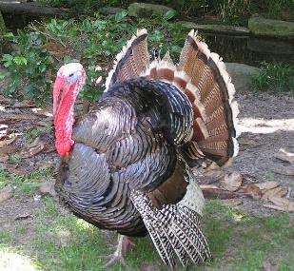 | 1  10:30a-Bingosize  2:00p- Activity Of Choice | 2  10:30a-Temple Baptist  2:00p-Thankful Turkey Craft. | 3  10:30a-Bingosize  2:00p- Courtyard, Coffee & Gossip | 4  10:30a-Thankful Stories and Recipes  2:00p-Name That Tune | 5  10:30a- Leisure Cart  2:00p- Shuffleboard  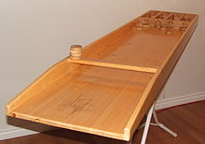 | 6 TN @ KY 7p  10:30a- Turkey Talk Bedside Visits  2:00p- Dress Your Turkey Coloring Contest.
7  Daily TV church services & Gospel music on channel 811 for leisure & Bible study work pages as interested & prayer partner as requested | 8  10:30a- 1:1-Visits  2:00p-Virtual Reality Trips. | 9  10:30a- Temple Baptist  2:00p- Farmers Market | 10  10:30a-Bingosize  2:00p Bingo | 11 Veterans Day  10:30a-Morning Coffee.  2:00p- Thankful for our Veterians. | 12  10:30a- Waffle Brunch.  2:00p- Thanksgiving Wordsearch Fun | 13 TN vs GA 12p  10:30a-Pumpkin Pie and Coffee Treat  2:00p-Fall Wreath Craft.
14  Daily TV church services & Gospel music on channel 811 for leisure & Bible study work pages as interested & prayer partner as requested | 15  10:30a-Bingosize  2:00p-Evening Manicures | 16  10:30a- Temple Baptist  2:00p-Balloon Volley Ball | 17  10:30a-Bingosize  2:00p-Bingo | 18  10:30a-Morning Exercise  2:00p- Hangman Word Game | 19  10:30a-Comfort Cart  2:00p- Monthly Birthday Party. | 20 TN vs South AL  TBA  10:30-Leisure Cart  2:00p-Turkey Hollow The Movie
21  Daily TV church services & Gospel music on channel 811 for leisure & Bible study work pages as interested & prayer partner as requested | 22  10:30a-Bingosize  2:00p- Deck The Halls With Christmas Decor | 23  10:30a- Temple Baptist  2:00p- Resident Council | 24  10:30a-Bingosize  2:00p –I’m thankful For__________. | 25  HAPPY Thanksgiving Macy’s Parade 9am-12pm | 26  10:30a- 1:1 Visits  2:00p- Word From Words.  Iamthankfulforyou | 27 TN vs Van TBA  10:30a-Morning Manicures  2:00p-Turkey Bingo
28  Daily TV church services & Gospel music on channel 811 for leisure & Bible study work pages as interested & prayer partner as requested | 29  10:30a-Bingosize  2:00p- Bingosize Store.  $$$$$$$$$$$$$$ | 30  10:30a- Temple Baptist  2:00p- My Christmas Wish List. | Please let activities know if you need any extra leisure supplies or help with family contacts by phone, skpe, or mail. All activites are subject to change at anytime due to COVID-19 precautions…Also available for leisure time- Tablets, Chrome book, ipods, Wii game, jigsaw & word puzzles, reading supplies, coloring supplies, art supplies, movies and library assistance also shopping online if needed. Pet Therapy will visit throughout the month as able due to COVID precautions

