◄ May 2022 | June 2022 |  |  |  |  | Jul 2022 ►
Sun | Mon | Tue | Wed | Thu | Fri | Sat
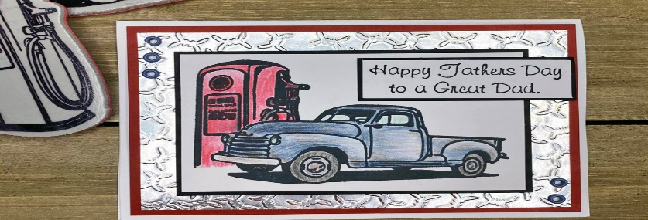 |  |  | 1  10:30a-Bingocize  2:00p-Bingo | 2  10:30a-Courtyard Coffee  2:00p-Watermelon In The Courtyard | 3  10:30a- 3rd Floor 1:1 Visits  2:00p-Word from Words | 4  10:30a-Father’s Day Coloring  2:00p-Balloon Volleyball
5  11:00 Chl. 4 Temple Baptist  Chl 811 Gospel Music  Leisure & Bible study pages & prayer partner available, Volunteer Services held as able | 6  10:30a-Bingocize  2:00p-Afternoon Spa | 7  10:30a-Temple Baptist  2:00p- Father’s Day Scramble | 8  10:30a-Bingocize  2:00p-Bingo | 9  10:30a-Morning Exercise in Courtyard  2:00p-Ice Cream Sundaes | 10  10:30a-3rd Floor Leisure Carts  2:00p-Music In The Courtyard | 11  10:30a-Morning Manicures  2:00p-Bingo For Fun
12  11:00 Chl. 4 Temple Baptist  Chl 811 Gospel Music  Leisure & Bible study pages & prayer partner available, Volunteer Services held as able | 13  10:30a-Bingocize  2:00p-Activity Fun & Game Of Chioce | 14  10:30a-Temple Baptist  2:00p-Victory In Jesus | 15  10:30a-Bingocize  2:00p- Reading Library with Diane | 16  10:30a-Father’s Day Puzzles  2:00p-Father’s Day Painting | 17  10:30a-Donuts with Dad  2:00p- Courtyard Water Fun | 18  10:30a-Coffee & Gossip  2:00p-Shuffleboard
19 Happy Fathers Day  Happy Juneteenth  11:00 Chl. 4 Temple Baptist  Chl 811 Gospel Music  Leisure & Bible study pages & prayer partner  available, | 20  10:30a-Bingocize  2:00p-Bingocize store | 21 Summer Begins  10:30a-Temple Baptist  2:00p-Resident Council | 22  10:30a-Bingocize  2:00p-Bingo | 23  10:30a-Balloon Exercise  2:00p- Music By Request | 24  10:30a-3rd Floor Comfort Cart  2:00p- Monthly Birthday Party | 25  10:30a-Morning Manicures  2:00p-Hangman
26  11:00 Chl. 4 Temple Baptist  Chl 811 Gospel Music  Leisure & Bible study pages & prayer partner available, Volunteer Services held as able | 27  10:30a-Bingocize  2:00p-Courtyard Blaster Games | 28  10:30a-Temple Baptist  2:00p-Hot Potato | 29  10:30a-Bingocize  2:00p- Magic Show | 30  10:30a-Oculus  Fun  2:00p- Movie & Popcorn | Also Available: tablets, chromebooks, iPods, Wii gaming, jigsaw & word puzzles, reading supplies, adult & regular coloring, arts & crafts, movies, radios

