NHC JOPLIN
October 2021
SUNDAY | MONDAY | TUESDAY | WEDNESDAY | THURSDAY | FRIDAY | SATURDAY
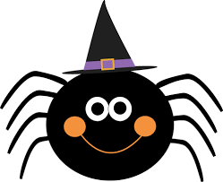 | 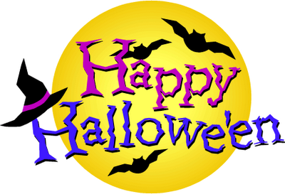 | *Activities are subject to change as the conditions change and to meet the needs of our residents* | Location Key  MDR – Main Dining Room  ADR – Assisted Dining Room  AR—Activity Room  IR—In Room Activities | 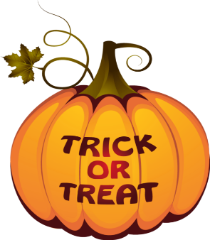 | 1 Homemade Cookie Day  9:00 am- One on One Programs  10:30 am – Coffee and Conversation with homemade cookies- AR  2:00 pm – Surprise Bingo-MDR  3:00 pm – Ice Cream Social- MDR | 2  Independent Activities  Activity Packets are available in Center Court
3  Independent Activities  Activity Packets are available in Center Court | 4 National Cinnamon Roll Day  10:15 am - Monday Manis- MDR  2:00 pm – Prize Bingo and cinnamon rolls-MDR  3:00 pm – One on One Programs - IR | 5  10:30 am -Dance to Music –MDR  11:15 am – Therapeutic Circle-ADR  2:00 pm- Yahtzee- MDR  3:00 pm – Ice Cream Social- MDR | 6  9:00 am- One on One Programs  10:30am- Bible Study - AR  11:15am- Therapeutic Circle-ADR  2:00pm – Snack Bingo- MDR  3:00pm- Country Store Shopping- AR | 7  10:30 am – Name 10– MDR  11:15 am – Therapeutic Circle-ADR  2:00 pm - Pumpkin Patch- Courtyard | 8  9:00 am- One on One Programs- IR  10:30 am – Craft Time: Luminaries- AR  2:00 pm – Surprise Bingo-MDR  3:00 pm – Ice Cream Social- MDR | 9  Independent Activities  Activity Packets are available in Center Court
10  Independent Activities  Activity Packets are available in Center Court | 11 Columbus Day  10:15 am – Monday Manis – MDR  2:00 pm – Prize Bingo-MDR  3:00 pm – One on One Programs-IR | 12  10:30 am – Sittercise- MDR  11:15 am – Therapeutic Circle-ADR  1:30 pm - Song Service- MDR  3:00 pm- Ice Cream Social- MDR | 13  9:00 am– One on One Programs  10:30 am - Bible Study- AR  11:15 am – Therapeutic Circle- ADR  2:00 pm – Funny Money Bingo -MDR  3:00 pm – ASL (American Sign Language) Class - MDR | 14  10:30 am–Corn Hole - MDR  11:15 am – Therapeutic Circle-ADR  2:00 pm - Thirsty Thursday Happy Hour with games and snacks- MDR | 15  9:00 am- One on One Programs- IR  10:30 am – Cooking Club- AR  2:00 pm – Surprise Bingo-MDR  3:00 pm – Ice Cream Social- MDR | 16  Independent Activities  Activity Packets are available in Center Court
17  Independent Activities  Activity Packets are available in Center Court | 18  10:15 am – Monday Manis- MDR  2:00 pm – Prize Bingo-MDR  3:00 pm –Cupcake Decorating with Christiana- AR  One on One Programs-IR | 19  10:30 am –Soccer- MDR  11:15 am – Therapeutic Circle-ADR  2:00 pm – Texas Hold Em Poker- MDR  3:00 pm – Ice Cream Social- MDR | 20  9:00 am – One on One Programs  10:30 am - Bible study-MDR  11:15 am – Therapeutic Circle- ADR  2:00 pm – Snack Bingo-MDR  3:00 pm – Country Store Shopping- AR | 21  10:30 am – Name That Tune– MDR  11:15 am – Therapeutic Circle-ADR  2:00 pm- Movie Matinee with popcorn - AR | 22  9:00 am -One on One Programs- IR  10:30 am – Coffee and Conversation- AR  2:00 pm – Surprise Bingo-MDR  3:00 pm – Monthly Birthday Party- MDR | 23  Independent Activities  Activity Packets are available in Center Court  1:00 pm Therapy Dog Visit
24  Independent Activities  Activity Packets are available in Center Court  31 HAPPY HALLOWEEN | 25  10:15 am – Monday Manis - MDR  2:00 pm – Prize Bingo-MDR  3:00 pm – One on One Programs-IR | 26  10:15 am – Resident Council- MDR  11:15 am – Therapeutic Circle-ADR  2:00 pm – Win, Lose or Draw - MDR  3:00 pm- Ice Cream Social- MDR | 27  9:00 am – One on One Programs  10:30 am - Bible Study- AR  11:15 am – Therapeutic Circle- ADR  2:00 pm – Funny Money Bingo -MDR  3:00 pm – ASL (American Sign Language) Class - MDR | 28 National Chocolate Day  10:30 am–Race Car Obstacle Course - MDR  11:15 am – Therapeutic Circle-ADR  2:00 pm – Coffee and Chocolate tasting Social with brownies- MDR | 29  9:00 am- One on One Programs- IR  10:30 am – Science For Seniors- AR  2:00 pm – Halloween Party with candy apples and costume contest- MDR | 30  Independent Activities  Activity Packets are available in Center Court

