Sunday | Monday | Tuesday | Wednesday | Thursday | Friday | Saturday
 |  |  |  |  | 1 | 2
3 | 4 | 5 | 6 | 7 | 8 | 9
10 | 11  Columbus Day (US)  Indigenous Peoples’ Day  Thanksgiving (Canada) | 12 | 13 | 14 | 15 | 16
17 | 18 | 19 | 20 | 21 | 22 | 23
24 | 25 | 26 | 27 | 28 | 29 | 30
31

Halloween
~
Holston – All activities are subject to change |  |  |  |  | 9:30 Virtual Music  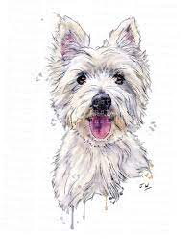  11:00 Pet Visits with Jack  2:00 Armchair Germany Travelers | October Chronicles  12:00 Vols at MI  1:30 Pet Visits with Watson
  2:00 Worship Congregation in Main Dining Room with  Pastor Paul  Activity Supplies are available ask your CNA if interested | 9:30 Nail Polish – 100/200 Halls  2:00 Scare Crow Fashion Show - Garden | 8:30 Focus Paper Delivery  10:00   2:30 Virtual Men’s Group with Christian | 9:30 Scripture & Snack  2:00 Oktoberfest with Don Hinkle   | 9:00 1:1 Fun  2:00 Art Therapy   | 9:30 Virtual Music  11:00 Pet Visits with Jack  2:00 Armchair Travel | Columbus Day Word Puzzles    Vols VS: South Carolina 
2:00 Worship Congregation in Main Dining Room with  Pastor Paul  Activity Supplies are available ask your CNA if interested | 9:30 Nail Polish –  300 Hall  1:30 Randy/Bobby Guitar/sing along | 8:30 Focus Paper Delivery  10:00 Garden Gathering  2:00 Lady’s Tea Social | 9:00 Scripture & Snack  10:00 VOTE Knoxville  2:00 Bingocize | 9:00 1:1 Fun  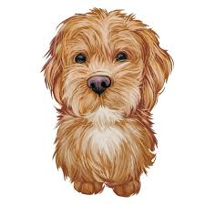  2:00 Art Therapy  4:30 Pet visits with Watson   | 9:30 Virtual Music  11:00 Pet Visits with Jack  2:00 Armchair Travel Knoxville Haunts | Brain Games  Vols Vs. Mississippi
2:00 Worship Congregation in Main Dining Room with  Pastor Paul  Activity Supplies are available ask your CNA if interested | 9:30 Nail Polish –  400 Hall    2:00 Funny Money Auction | 8:30 Focus Paper  Delivery  10:00 Bingocize  2:00 Resident Council | 9:00 Scripture & Snack    2:00 Birthday Fun with Hugh Warren | 9:00 1:1 Fun  2:00 Art Therapy  4:30 Pet Visits  with Watson | 9:30 Virtual Music  11:00 Pet Visits with Jack  2:00 Armchair Travel Ghost Tours | 1:30 Pet Visits with Watson  Vols @ Alabama
2:00 Worship Congregation in Main Dining Room with  Pastor Paul  Activity Supplies are available ask your CNA if interested | 9:30 Nail Polish –  500 – 600 Halls    1:30 Murder Mystery Matinee | 8:30 Focus Paper Delivery  10:00 Garden Gathering    2:00 Real Life Clue game | 9:30 Scripture & Snack  2:00 Bingocize | 9:00 1:1 Fun  2:00 Art Therapy  4:30 Pet Visits  with Watson | 10:30 Halloween dress up parade  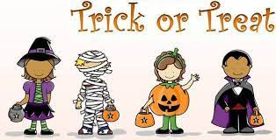  11:00 Pet Visits w/ Jack  2:00 Armchair Travel | 1:30 Pet Visits with Watson  Vols @ Kentucky
2:00 Worship Congregation in Main Dining Room with  Pastor Paul    Activity Supplies are available ask your CNA if interested | Additional Activity Information:  For your independent leisure, we have jigsaw puzzles, coloring books lending library,  bible studies, magazines, laptops, virtual visits upon request. Scheduled  family visits @ https://www.nhccare.com/locations/holston

NHC Holston, 3916 Boyd’s Bridge Pike, Knoxville, TN 37918 ~ Facebook: Holston Healthcare ~ Volunteer opportunities? Yes! Call the Recreation Department!

