August is already here, and the year continues to fly by. Schools are getting back in session making these dog days of summer a bit more hectic for many families. We wish everyone a smooth transition back into daily routines and hope you enjoy the remaining bits of summer!

**Special Events:** We will be having Ice cream socials on the 9th and 23rd of august at 2:00.

**Announcements for Families:** We encourage family members to join out scheduled group activities. you can find the calendar on our NHC Athens website.

**Thanks:** Thank you to hospice of Chattanooga and NHC home care of Athens for monthly bingo donations.

**National Senior Citizen Day**   
  
  
  
August 21st recognizes all those in their golden years with National Senior Citizen Day. At NHC, we want to eliminate any stigma associated with being a “Senior Citizen” and embrace all the rewards that come along with growing older. In addition to wisdom, patience, and in many cases grandchildren, growing older has many wonderful attributes. However, one often forgotten perk is the discounts. We have compiled a list of great discounts for you to check out [HERE](https://nhccare.com/finding-seniors-ways-to-save/) – and celebrate Senior Citizen Day every day!

**National Immunization Month**   
  
August is National Immunization Month and serves as a reminder to get receive your vaccines for the upcoming season. This reminder stresses the importance of vaccines and their role in protecting people of all ages. Make sure to talk with your physicians about you and your family’s best vaccine schedules!   
 

**Apps for Seniors**  
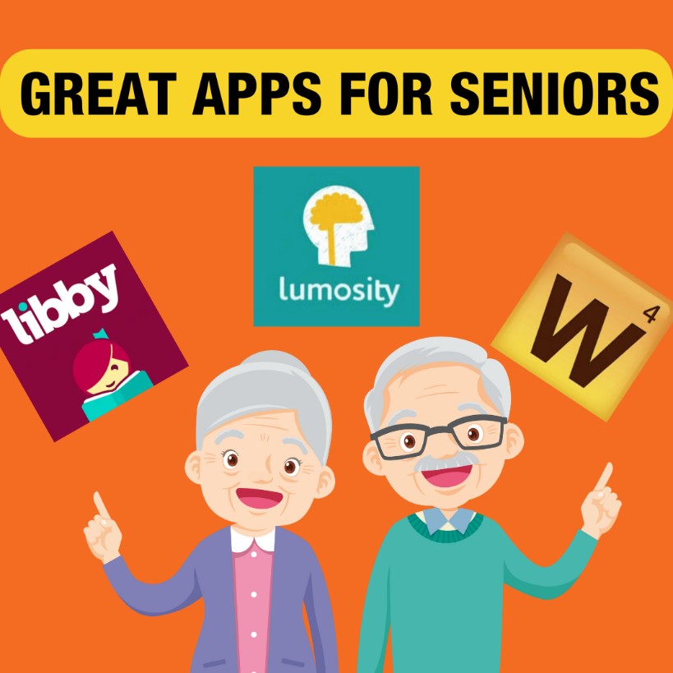  
  
Looking to add some excitement and convenience to your loved one’s daily routine? Check out these fantastic apps designed with seniors in mind:

**Libby:** Dive into a world of books with Libby, the app that connects you to your local library's eBook and audiobook collections. Borrow and read your favorite titles from the comfort of your home for free! It's perfect for all book lovers, offering endless reading and listening options.

**Words With Friends:** Keep your mind sharp and have fun with Words With Friends, the popular word game that lets you challenge friends and family to Scrabble-like matches. It's a great way to stay socially connected and mentally stimulated, all while enjoying some friendly competition.

**Lumosity:** Boost your brainpower with Lumosity, an app offering a variety of brain-training games designed to improve memory, problem-solving skills, and cognitive abilities. With personalized training programs, it's a fun and engaging way to keep your mind active and healthy.