

Happy February! It's the month where chocolate is a food group, and the Super Bowl commercials are the real MVPs. Whether you're cheering for the Chiefs or the Eagles, or just here for the snacks and laughs, we hope you have a fantastic time!

**Special Events:** 2/9 @ 6:00 Super Bowl Sundaes 2/15 @ 2:00 Galentines Day Marinara Sauce Fountain with Snacks.  
  
**Announcements:** Karl's first Thursday omelets price increase from $3 to $5.

**Pride in Food Service Week**  
From February 3rd to 7th, we are celebrating Pride in Food Service Week. We want to extend a heartfelt thank you to our incredible partners in Food and Nutrition Services. These dedicated team members work tirelessly to ensure our patients receive delicious and nutritious meals multiple times a day.

During your next visit, please take a moment to express your gratitude and appreciation for their hard work and commitment. We appreciate you joining us in recognizing and celebrating our amazing Food and Nutrition Services team!

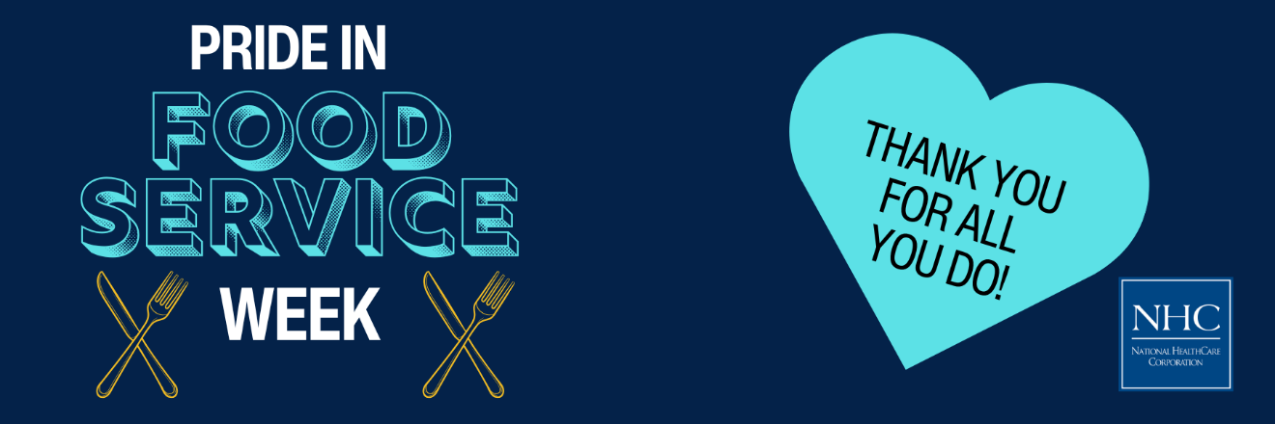

**Celebrate Heart Month with Us!**

February is American Heart Month, a time to raise awareness about heart disease and promote heart-healthy lifestyles. Heart disease is the leading cause of death in the U.S., but many cases can be prevented with healthier choices. This month, let's take action to protect our hearts and encourage our loved ones to do the same.

Learn about the signs of heart disease, adopt heart-healthy habits, and support initiatives like the American Heart Association's "Life is Why" campaign. Together, we can make a difference in the fight against heart disease. [**Visit our blog post**](https://nhccare.com/celebrate-heart-month-take-action-for-your-heart/) to read more and take steps to safeguard your heart health!  
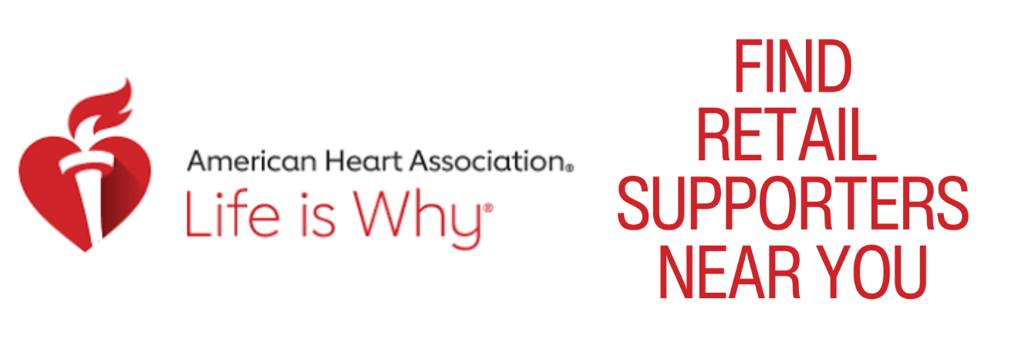

**Friendly Reminder**

The season is here where flu and other viruses are prevalent in our community. We kindly ask for your cooperation in keeping our patients safe and healthy. If you are feeling unwell, please consider postponing your visit until you are feeling better. Your understanding and support are greatly appreciated as we work together to maintain a healthy environment for everyone.

Thank you for your help and consideration!  
  
