

Happy February! It's the month where chocolate is a food group, and the Super Bowl commercials are the real MVPs. Whether you're cheering for the Chiefs or the Eagles, or just here for the snacks and laughs, we hope you have a fantastic time!

**Special Events:** It's time to Feel the Love @ 'The Fort'! Yes, the love month of February is here, and NHC Fort Sanders invites you to join us in some heartfelt experiences and be a part of the sharing and caring with one another. On that note, would like to introduce Mia Lavi, Life Enrichment Intern from UT, who will be hosting a "Sweetheart Soirée" Week starting with Sweetheart Singo on Feb. 7th @ 2:00pm in the Dining Room, followed by 'Operation Love Letters' made by the Cupid's Appreciation Crew on Feb. 11th @ 2:00p. And if that isn't sweet enough, Mia also invites you to join her for a 'Sugar-n-Spice, Cookies so Nice' baking activity on Feb. 13th @ 2:00p in the Activity Room. NHC Fort Sanders will end the love week on Valentine's Day with the Valentine King & Queen Coronation Celebration @ 2:00pm in the Dining Room. We look forward in celebrating this month of love and joy with you and your loved ones!   
  
**Announcements for Families:** Attention NHC Families and Partners! If you know anyone who has a little extra time on their hand and would like to volunteer at "The Fort", please have them contact Carla Kinser, Life Enrichment Director, via phone: (865) 525-4131 (ext. 116) or via email: [carla.kinser@nhccare.com](mailto:carla.kinser@nhccare.com). There are many ways to volunteer at our center whether it's assisting with a group activity, helping with our dining program, delivering mail, visiting with residents 1:1, etc. We're sure we can find an interest for you that not only meets our needs but fulfills your purpose in how you can help others. And Families, you are welcomed to join your resident loved one in our center's group activities at any time and enjoy the experience with them. Activity Calendars are posted in resident rooms, on our digital TVs located on each floor near the elevator, and also on NHC Fort Sanders webpage.   
  
**Any Special Thanks:** NHC Fort Sanders would like to give a special 'shout out' to Kimberly Way with Caris Hospice for leading/assisting residents with a watercolor painting activity in which each resident painted their own unique snowman to make a fun and colorful winter wonderland display for visitors to enjoy! Thank You, Kimberly, for sending us some winter magic our way!

**Pride in Food Service Week**  
From February 3rd to 7th, we are celebrating Pride in Food Service Week. We want to extend a heartfelt thank you to our incredible partners in Food and Nutrition Services. These dedicated team members work tirelessly to ensure our patients receive delicious and nutritious meals multiple times a day.

During your next visit, please take a moment to express your gratitude and appreciation for their hard work and commitment. We appreciate you joining us in recognizing and celebrating our amazing Food and Nutrition Services team!

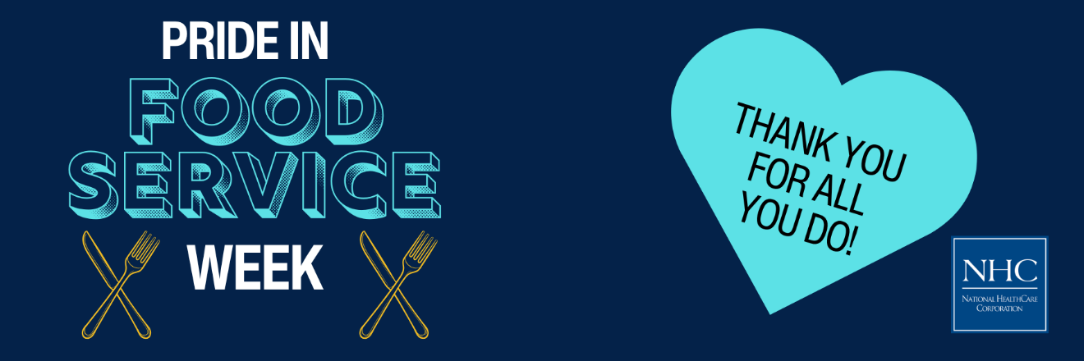

**Celebrate Heart Month with Us!**

February is American Heart Month, a time to raise awareness about heart disease and promote heart-healthy lifestyles. Heart disease is the leading cause of death in the U.S., but many cases can be prevented with healthier choices. This month, let's take action to protect our hearts and encourage our loved ones to do the same.

Learn about the signs of heart disease, adopt heart-healthy habits, and support initiatives like the American Heart Association's "Life is Why" campaign. Together, we can make a difference in the fight against heart disease. [**Visit our blog post**](https://nhccare.com/celebrate-heart-month-take-action-for-your-heart/) to read more and take steps to safeguard your heart health!  
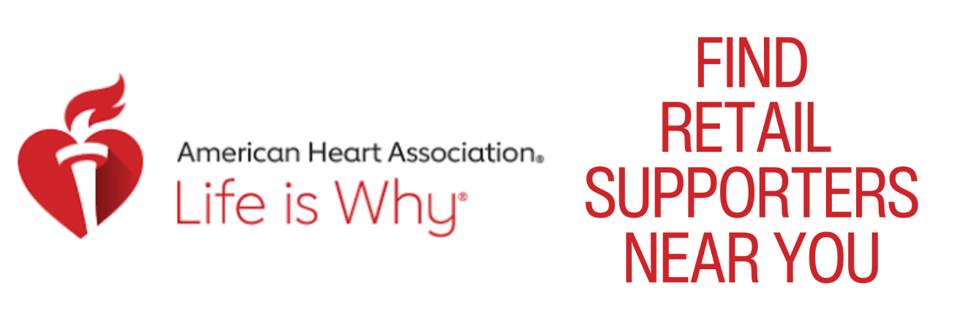

**Friendly Reminder**

The season is here where flu and other viruses are prevalent in our community. We kindly ask for your cooperation in keeping our patients safe and healthy. If you are feeling unwell, please consider postponing your visit until you are feeling better. Your understanding and support are greatly appreciated as we work together to maintain a healthy environment for everyone.

Thank you for your help and consideration!  
  
