

Happy February! It's the month where chocolate is a food group, and the Super Bowl commercials are the real MVPs. Whether you're cheering for the Chiefs or the Eagles, or just here for the snacks and laughs, we hope you have a fantastic time!

**Special Events:** It is the month of love and hearts! Happy February everyone! We are excited to see what fun we can get into this month. Groundhog Day is celebrated on February 2nd. I know we are all anxiously awaiting the news if we have another six weeks of winter or an early spring. I think everyone is ready for the temperatures to rise – but we will wait to hear it from Punxsutawney Phil! Timothy is coming to perform for us on February 4th at 2:00pm. We are thrilled! His voice is a fan favorite, and everyone is excited for the show. You do not want to miss it! We are going to be baking on February 5th at 2:00pm. We are making Valentine’s Day cookies and will decorate them, too. It is almost Super Bowl Sunday! We are celebrating early with a Super Bowl Themed Popcorn Friday on February 7th at 2:00pm. We are going to be playing Remember the Titans to get us in the football spirit. Super Bowl Sunday is February 9th – It will be the Chiefs vs. Eagles for the second year in a row! We are implementing an evening program this month with Hymns and Hot Chocolate hosted by our lovely volunteer Micki on February 12th at 5:30pm. We are celebrating Valentine’s Day with a party on February 13th at 2:00pm. February 13th is also National Galentine’s Day so we will make sure our ladies have an extra day of celebration. Valentine’s Day is February 14th, and we will spread all the love and cheer to our residents. President’s Day is observed on February 17th, and we will do President Trivia at 10:30am. We have our Monthly Resident Council Meeting on February 18th at 2:00pm. This is an opportunity for our residents and patients to express concerns, suggestions, and compliments. We will have live music with Paul Indelicato on February 19th at 2:30pm. He is another fan favorite, and we are excited to see what he has in store for us! Our friend, Kimberly Way, is coming back to do a crafting hour with us on February 20th at 2:00pm. She is extremely talented and accommodates to all skill level. Please join us! We are baking again on February 25th at 2:00pm – we are making heart shaped cinnamon rolls! We want to have a monthly birthday party for our friends with February birthdays on February 26th at 2:00pm. We will have mini cupcakes, punch, and we will sing Happy Birthday of course. February 27th is National Strawberry Day, and we are celebrating with Strawberry Mocktails and watercolor painting at 2:00pm. We are trying something new with two movie nights at 4:30pm. We have our first one on February 10th and the next will be February 24th. If any family or friends have suggestions, please let our Life Enrichment Team know. Our Chaplain continues to lead his Worship Service every Tuesday at 3:30pm and Sunday at 10:30am in the Assisted Living Dining Room. He is also available for in-room visitation. Micki and Maria will continue to lead their Joy of Jesus Devotional every Tuesday morning at 10:30am. Catholic Communion is available for anyone that is interested. Please let a staff member know if we can help. Be on the lookout for flyers around the facility addressing additional groups, scheduling changes, spontaneous events, and more! We hope to see you there!   
  
**Announcements for Families:** Family and friends are always welcome in our activities, and we encourage you to join in on the fun with your loved one. Our program is designed to stimulate and support your highest social, physical, and emotional functional levels while completing your therapy. Please contact Emily Hatch or Sara Bell at ext. 518 if you have any questions!   
  
**Special Thanks:** We want to give a huge shoutout to our Life Enrichment Teams in the NHC family! National Activity Professionals Week took place last month, but we celebrate them every month! Activity Professionals make a difference every day, and they work so hard to keep the residents engaged, happy, and having fun. They are such a light in our facilities, and they advocate for our loved ones. Please take a moment to thank them for all they do when you get the chance. THANK YOU LIFE ENRICHMENT!

**Pride in Food Service Week**  
From February 3rd to 7th, we are celebrating Pride in Food Service Week. We want to extend a heartfelt thank you to our incredible partners in Food and Nutrition Services. These dedicated team members work tirelessly to ensure our patients receive delicious and nutritious meals multiple times a day.

During your next visit, please take a moment to express your gratitude and appreciation for their hard work and commitment. We appreciate you joining us in recognizing and celebrating our amazing Food and Nutrition Services team!

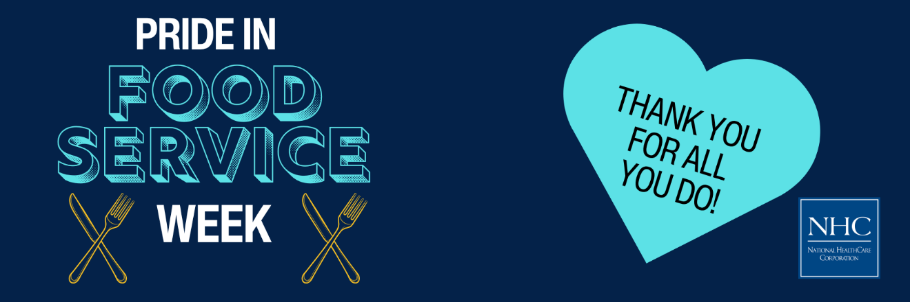

**Celebrate Heart Month with Us!**

February is American Heart Month, a time to raise awareness about heart disease and promote heart-healthy lifestyles. Heart disease is the leading cause of death in the U.S., but many cases can be prevented with healthier choices. This month, let's take action to protect our hearts and encourage our loved ones to do the same.

Learn about the signs of heart disease, adopt heart-healthy habits, and support initiatives like the American Heart Association's "Life is Why" campaign. Together, we can make a difference in the fight against heart disease. [**Visit our blog post**](https://nhccare.com/celebrate-heart-month-take-action-for-your-heart/) to read more and take steps to safeguard your heart health!  


**Friendly Reminder**

The season is here where flu and other viruses are prevalent in our community. We kindly ask for your cooperation in keeping our patients safe and healthy. If you are feeling unwell, please consider postponing your visit until you are feeling better. Your understanding and support are greatly appreciated as we work together to maintain a healthy environment for everyone.

Thank you for your help and consideration!  
  
