

Happy February! It's the month where chocolate is a food group, and the Super Bowl commercials are the real MVPs. Whether you're cheering for the Chiefs or the Eagles, or just here for the snacks and laughs, we hope you have a fantastic time!

**Special Events:** Valentine’s Sweetheart Formal will be held on 2/14 at 2:30! We will be announcing King & Queen, eating, dancing and socializing. Year of Art this month will be “Pop Art" held on 2/13 at 10:30am. Performers this month will all be starting at 2:30 pm Curt Mathson 2/3, Raymond Akers 2/7, Robert Phillips 2/11, The Sev7ens 2/18, Lightnin’ Charlie 2/20, Dan Perkins 12/21, and Johnny Cash 2/28 Aaron Howard will be at 10:30am on 2/14 Monthly Birthday Celebrations will be held on 2/27.   
  
**Announcements for Families:** Welcome to our Center! We are honored that you have chosen NHC for your care. Patients, families, and/or patient representatives are welcome to bring food from outside into the center during your stay with us. If you choose to do this, please review the guidelines below to help ensure these outside food items remain safe for consumption. Guidelines for Safe Food Handling for Food Brought in from Outside Sources Food or beverage items may be stored in the center nourishment pantries, refrigerators or freezers, if applicable Food and/or beverage items brought into the center should be securely packaged and labeled with: 1) Patient’s Name and 2) the date the item(s) were brought into the center Food or beverage items stored in center nourishment pantries will be monitored and discarded by the center as follows: Perishable foods will be discarded within 7 days unless expiration is before the 7 days per manufacturer’s Use by, Best by, or Expiration dates. Other non-perishable items such as pre-packaged beverages, crackers, cookies, etc. will be discarded according to the manufacturer’s directions. It is recommended that perishable foods that are generally served hot, be heated prior to consuming. Center staff will be available to assist the patient, as needed, with access to food or beverage items brought in from outside sources. Proper hand sanitation will be performed for safe food handling. Home-canned and preserved food items are discouraged from being brought into the center because of food-borne illness risk.  
  
**Special Thanks:** Please follow us on our Facebook page for updates on things going on and to see all the fun. Thank you all for supporting our staff members, patients and volunteers. Family is everything and we thank you for being a part of our NHC Bristol community!

**Pride in Food Service Week**  
From February 3rd to 7th, we are celebrating Pride in Food Service Week. We want to extend a heartfelt thank you to our incredible partners in Food and Nutrition Services. These dedicated team members work tirelessly to ensure our patients receive delicious and nutritious meals multiple times a day.

During your next visit, please take a moment to express your gratitude and appreciation for their hard work and commitment. We appreciate you joining us in recognizing and celebrating our amazing Food and Nutrition Services team!

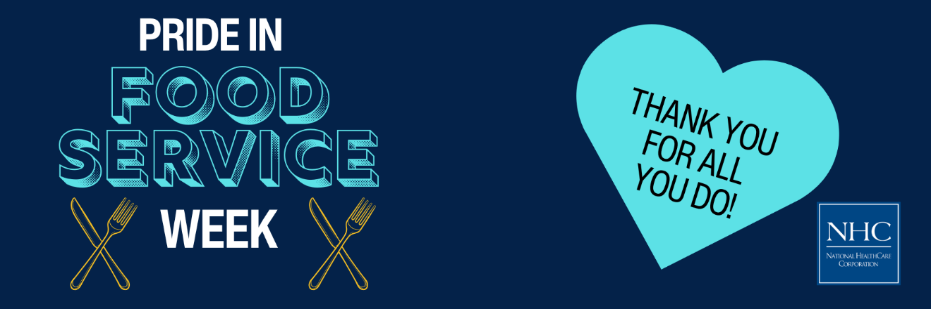

**Celebrate Heart Month with Us!**

February is American Heart Month, a time to raise awareness about heart disease and promote heart-healthy lifestyles. Heart disease is the leading cause of death in the U.S., but many cases can be prevented with healthier choices. This month, let's take action to protect our hearts and encourage our loved ones to do the same.

Learn about the signs of heart disease, adopt heart-healthy habits, and support initiatives like the American Heart Association's "Life is Why" campaign. Together, we can make a difference in the fight against heart disease. [**Visit our blog post**](https://nhccare.com/celebrate-heart-month-take-action-for-your-heart/) to read more and take steps to safeguard your heart health!  


**Friendly Reminder**

The season is here where flu and other viruses are prevalent in our community. We kindly ask for your cooperation in keeping our patients safe and healthy. If you are feeling unwell, please consider postponing your visit until you are feeling better. Your understanding and support are greatly appreciated as we work together to maintain a healthy environment for everyone.

Thank you for your help and consideration!  
  
