Dear Families,  
   
We hope this new year will bring you joy, prosperity, and countless memorable moments. As we embark on 2025, please remember to use caution if you are not feeling well and delay your visit until you are better. Thank you for helping us prevent illness and promote a healthy new year.

**Special Events:** 4th at 6:30pm BINGO TRIVIA 8th at 6:30pm Science with Lauren 9th at 4:00pm Snowball Fight 23rd at 6:30pm Fishin’ Chips 30th at 4:00pm Color & Sip (mocktail).  
  
**Special Thanks:** NHC Maintenance Partners Appreciation Week NHC Life Enrichment Department Appreciation Week.

Day by Day Podcast

A new year brings fresh opportunities to set intentions and focus on wellness. To help you

start the year strong, we’re thrilled to introduce our new episode featuring Eric Colette,

CEO of A Mind for All Seasons. In this episode, we dive into practical tips for improving

brain health—a great way to prioritize yourself while continuing to provide exceptional care

to those around you.

Check it out here: <https://nhccare.com/brain-health/>

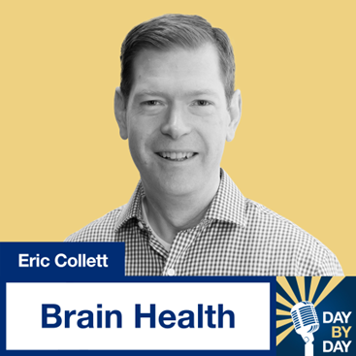

Partner Shout-Outs  
We would like to recognize our Maintenance and Life Enrichment partners. These individuals work hard at our center, and we appreciate their dedication to the environment and our patients! Please help us thank them this month when you visit.

