Dear Families,  
   
We hope this new year will bring you joy, prosperity, and countless memorable moments. As we embark on 2025, please remember to use caution if you are not feeling well and delay your visit until you are better. Thank you for helping us prevent illness and promote a healthy new year.

**Special Events:** 1/6/25 - A birthday for Elvis with impersonator and more fun throughout the week, 1/12/25 Celebration of Life, 1/15/25 Holston monthly birthday party, 1/17/24 Dolly Day, 1/20/25 Spa Day. 1/22/25 Glamour Day, 1/29/25 Chinese New Year.  
 **Announcements for Families:** Please check for any unlabeled items in your Loved-one's closet and mark with a sharpie to avoid lost and found. If you would like to perform your special talent or interest for our residents and patients, contact Kim to be added to the calendar of great ideas and events! 865-521-1500x 3028 Rooms can be reserved for family gatherings by RSVP to Kim.  
  
**Any Special Thanks:** Thank you Santa Colin, H.A.B.I.T. Pet Therapy dogs, Choirs and Carolers, Christmas Tree decorators, Angel Tree Gift-givers, Knoxville Ice Bears, All weekly volunteers and church groups, girls and boy scouts, and our chaplain, priest and minister who care for our spiritual needs.

Day by Day Podcast

A new year brings fresh opportunities to set intentions and focus on wellness. To help you

start the year strong, we’re thrilled to introduce our new episode featuring Eric Colette,

CEO of A Mind for All Seasons. In this episode, we dive into practical tips for improving

brain health—a great way to prioritize yourself while continuing to provide exceptional care

to those around you.

Check it out here: <https://nhccare.com/brain-health/>

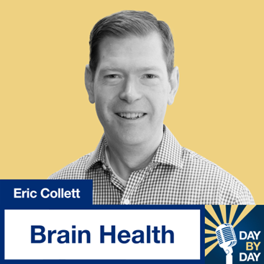

Partner Shout-Outs  
We would like to recognize our Maintenance and Life Enrichment partners. These individuals work hard at our center, and we appreciate their dedication to the environment and our patients! Please help us thank them this month when you visit.

