Dear Families,  
   
We hope this new year will bring you joy, prosperity, and countless memorable moments. As we embark on 2025, please remember to use caution if you are not feeling well and delay your visit until you are better. Thank you for helping us prevent illness and promote a healthy new year.

**Special Events:** HAPPY NEW YEAR from "The Fort"! Yes, we're kicking off 2025 with some fun winter activities for our NHC residents starting with Elvis Music Trivia on Jan. 8th honoring Elvis Presley's Birthday. And who says building a snowman has to be done outside when residents have an opportunity to stay inside and paint a snowman instead with Kimberly Way with Caris Hospice on Jan. 23rd @ 2:00p. We'll continue to pop off the New Year with Confetti Popcorn on Jan. 28th during our Tasty Tuesday activity in the afternoon. Then NHC residents will get a chance to rock around the clock and celebrate 2025 at our New Year's Birthday Bash on Jan. 31st @ 2:00p in the ground floor dining room.   
  
**Announcements for Families:** Attention NHC Families and Partners! If you know anyone who has a little extra time on their hand and would like to volunteer at "The Fort", please have them contact Carla Kinser, Life Enrichment Director, via phone: (865) 525-4131 (ext. 116) or via email: [carla.kinser@nhccare.com](mailto:carla.kinser@nhccare.com). There are many ways to volunteer at our center whether it's assisting with a group activity, helping with our dining program, delivering mail, visiting with residents 1:1, etc. We're sure we can find an interest for you that not only meets our needs but fulfills your purpose in how you can help others. And Families, you are welcomed to join your resident loved one in our center's group activities at any time and enjoy the experience with them. Activity Calendars are posted in resident rooms, on our digital TVs located on each floor near the elevator, and also on NHC Fort Sanders webpage.   
  
**Any Special Thanks:** NHC Fort Sanders would like to say thank you to all our NHC partners, families, volunteers, vendors, and community organizations such as the University of Tennessee Veterinary Medicine, The Elks Club, and Summit Medical Group of Knoxville for all your wonderful Christmas donations and assisting residents at our Annual NHC Christmas Store! Because of you, NHC residents experienced the magic of Christmas! And a special thank you and shout out to the NHC wound care team for dressing up as Santa and Elf for a photo booth at our NHC Christmas Store, including delivering Christmas gifts to our NHC residents! We appreciate your Christmas spirit during the holiday season!

Day by Day Podcast

A new year brings fresh opportunities to set intentions and focus on wellness. To help you

start the year strong, we’re thrilled to introduce our new episode featuring Eric Colette,

CEO of A Mind for All Seasons. In this episode, we dive into practical tips for improving

brain health—a great way to prioritize yourself while continuing to provide exceptional care

to those around you.

Check it out here: <https://nhccare.com/brain-health/>

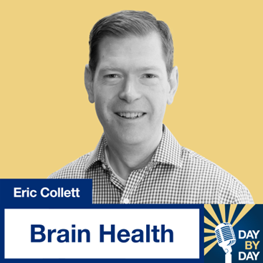

Partner Shout-Outs  
We would like to recognize our Maintenance and Life Enrichment partners. These individuals work hard at our center, and we appreciate their dedication to the environment and our patients! Please help us thank them this month when you visit.

