Dear Families,  
   
We hope this new year will bring you joy, prosperity, and countless memorable moments. As we embark on 2025, please remember to use caution if you are not feeling well and delay your visit until you are better. Thank you for helping us prevent illness and promote a healthy new year.

**Special Events:** It is 2025! Happy January everyone! We want to have another year of fun. January 1st is New Years Day, and we will be doing What’s New in 2025 at 2:00pm with our residents. We will also talk about New Year traditions and superstitions. We will have Winter Wonderland Suncatchers on January 7th at 2:00pm to switch out the Christmas decorations. January 8th is Elvis Presley’s birthday, and we are so excited to welcome back Buddy Kidd to perform his Elvis Presley Tribute. This is going to be a spectacular performance that you do not want to miss. January 20th we celebrate Martin Luther King Day, and we will have puzzles throughout the common areas in honor of this special day. We also have live music with Mitch and John on January 23rd at 2:30pm, and they will be doing their show “At The Jukebox.” Come sing along and enjoy the fun! Timothy is joining us toward the end of the month on January 30th. His voice is absolutely incredible, and we cannot wait to share it with you. Don’t forget that we have popcorn and a movie every Friday. If any family or friends have suggestions, please let our Life Enrichment Team know. Our Chaplain continues to lead his Worship Service every Tuesday at 3:30pm and Sunday at 10:30am in the Assisted Living Soda Fountain. He is also available for in-room visitation. Micki and Maria will continue to lead their Joy of Jesus Devotional every Tuesday morning at 10:30am. Catholic Communion is available for anyone that is interested. Please let a staff member know if we can help. Be on the lookout for flyers around the facility addressing additional groups, scheduling changes, spontaneous events, and more! We hope to see you there! Happy New Year!  
  
**Announcements for Families:** Family and friends are always welcome in our activities, and we encourage you to join in on the fun with your loved ones. Our program is designed to stimulate and support your highest social, physical, and emotional functional levels while completing your therapy. Please contact Emily Hatch or Sara Bell at ext. 518 if you have any questions!   
  
**Special Thanks:** We want to give a huge shoutout to our DON, Christina Moersdorf and ADON Bradi Hendrickson for hosting a pop-up Sweets & Coffee bar for all staff. It was the sweetest treat for the holiday season. Thank you so much for all you do! Not only do you go above and beyond for the patients, but you go above and beyond for our staff. THANK YOU! Happy New Year!

Day by Day Podcast

A new year brings fresh opportunities to set intentions and focus on wellness. To help you

start the year strong, we’re thrilled to introduce our new episode featuring Eric Colette,

CEO of A Mind for All Seasons. In this episode, we dive into practical tips for improving

brain health—a great way to prioritize yourself while continuing to provide exceptional care

to those around you.

Check it out here: <https://nhccare.com/brain-health/>

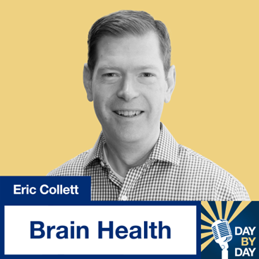

Partner Shout-Outs  
We would like to recognize our Maintenance and Life Enrichment partners. These individuals work hard at our center, and we appreciate their dedication to the environment and our patients! Please help us thank them this month when you visit.

