Dear Families,  
   
We hope this new year will bring you joy, prosperity, and countless memorable moments. As we embark on 2025, please remember to use caution if you are not feeling well and delay your visit until you are better. Thank you for helping us prevent illness and promote a healthy new year.

**Special Events:** Performers this month all starting at 2:30 pm Raymond Akers 1/3, Robert Phillips 1/10, Lightnin’ Charlie 1/16, Dan Perkins 1/17 The Sev7ens 1/21, Dan Perkins 1/17 , and Elvis on 1/31 We will be celebrating all things ELVIS on Jan 8th for his Birthday. Traveling Tuesday to Oxford, England.  
  
**Announcements for Families:** Happy New Year! We would love for you all to Follow "NHC Healthcare Bristol " on Facebook to see fun, exciting things we do around the facility! This year we will be doing the "Year of Art," starting off with Zentangles. We are strongly encouraging the resident’s creativity come to flow, and later on in the year will be showing off all their art! We will also be hosting a Valentine's Sweetheart Prom and crowning a King and Queen. We would love for you all to come and be a part of the excitement.   
  
**Any Special Thanks:** We want to thank everyone who donated supplies or brought in shoeboxes for the residents. Santa put a smile on a lot of faces.

Day by Day Podcast

A new year brings fresh opportunities to set intentions and focus on wellness. To help you

start the year strong, we’re thrilled to introduce our new episode featuring Eric Colette,

CEO of A Mind for All Seasons. In this episode, we dive into practical tips for improving

brain health—a great way to prioritize yourself while continuing to provide exceptional care

to those around you.

Check it out here: <https://nhccare.com/brain-health/>

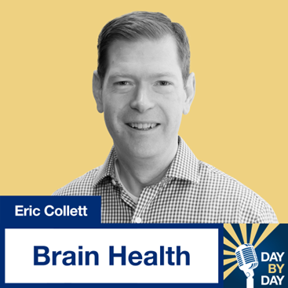

Partner Shout-Outs  
We would like to recognize our Maintenance and Life Enrichment partners. These individuals work hard at our center, and we appreciate their dedication to the environment and our patients! Please help us thank them this month when you visit.

