November 2022 Springfield Rehab & Healthcare Center
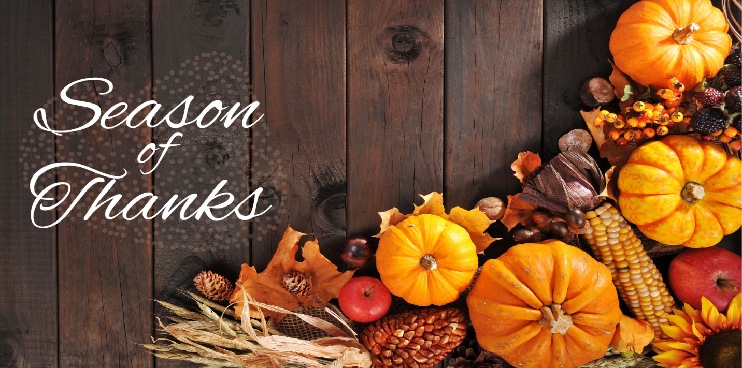
While there are many things to be thankful for year-round, November is the official Season of Thanksgiving. It is a time to celebrate what we are grateful for and take moments to enjoy all that we have. We are thankful to each one of you and hope you have a blessed coming Thanksgiving.
Important Dates:
November 6 Daylight Savings Time Ends
November 11 Veteran’s Day
November 24 Thanksgiving

Center News: Please join us for our center’s Veteran’s Day Celebration on November 11th at 2:00pm. Feel free to contact us for any information regarding the event.

Honoring Veterans Section
During this special Veteran’s Day, we would like to give thanks to all those who have served. We will never forget the sacrifices and bravery of the men and women who gave everything to protect our freedoms. We are especially thankful for all our partners and residents who have served in the past. Your courage has set an example for us all. Happy Veteran’s Day!
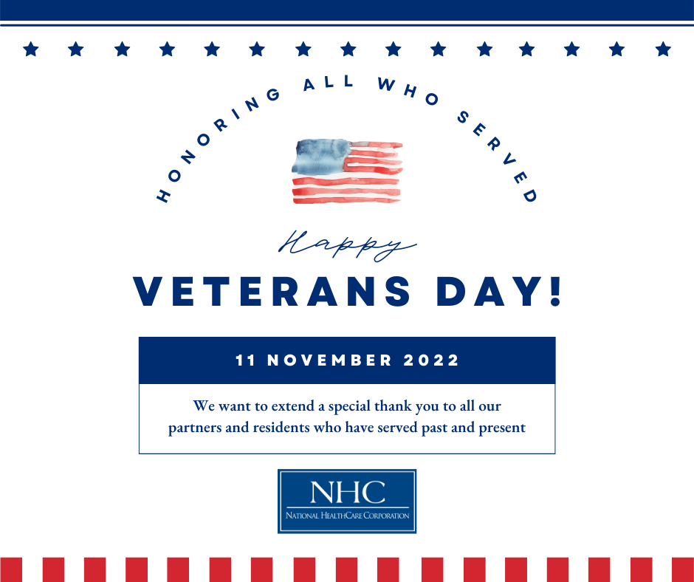
National HomeCare, Hospice, and Palliative Care Month
We would like to recognize our partners in HomeCare, Hospice, and Palliative care for their hard work and dedication. These valued partners provide much needed services in crucial times of our patients’ continuum of care. Thank you to all these amazing individuals for the care they give!
