November 2022 Osage Beach
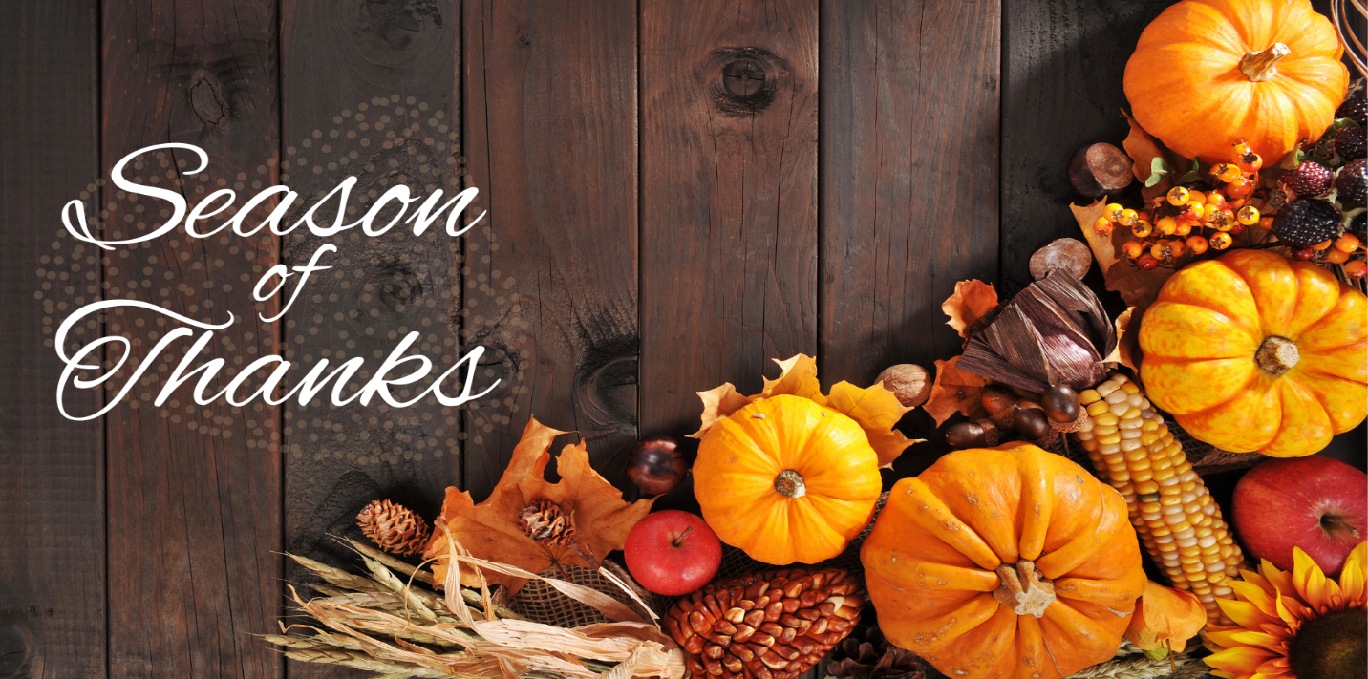
While there are many things to be thankful for year-round, November is the official Season of Thanksgiving. It is a time to celebrate what we are grateful for and take moments to enjoy all that we have. We are thankful to each one of you and hope you have a blessed coming Thanksgiving.
Important Dates:
November 6 Daylight Savings Time Ends
November 11 Veteran’s Day
November 24 Thanksgiving

Center News: We would like to invite you to the following events. On November 3rd we’re making homemade peanut butter cookies for peanut butter lover's month. November 10th we’re making loaded nachos for our Cooking Club. On November 11th we’re having our Veteran's Honor Parade and Celebration. November 13th - Riverview Baptist. November 17th will be our Monthly Birthday Party for our residents. November 18th - BJ Davis Music and Boaz- Therapy Dog Visit, November 20th - Cowboy Church. November 24th will be our Thanksgiving meal. November 27th - Calvary Church. Lastly, November 30th is our Resident Dine-in.

Partner Spotlight: We would like to extend a special thanks to Linda Kirby in dietary this month. Linda does an incredible job with providing care for our residents. Thank you for all that you do Linda!

Honoring Veterans Section
During this special Veteran’s Day, we would like to give thanks to all those who have served. We will never forget the sacrifices and bravery of the men and women who gave everything to protect our freedoms. We are especially thankful for all our partners and residents who have served in the past. Your courage has set an example for us all. Happy Veteran’s Day!
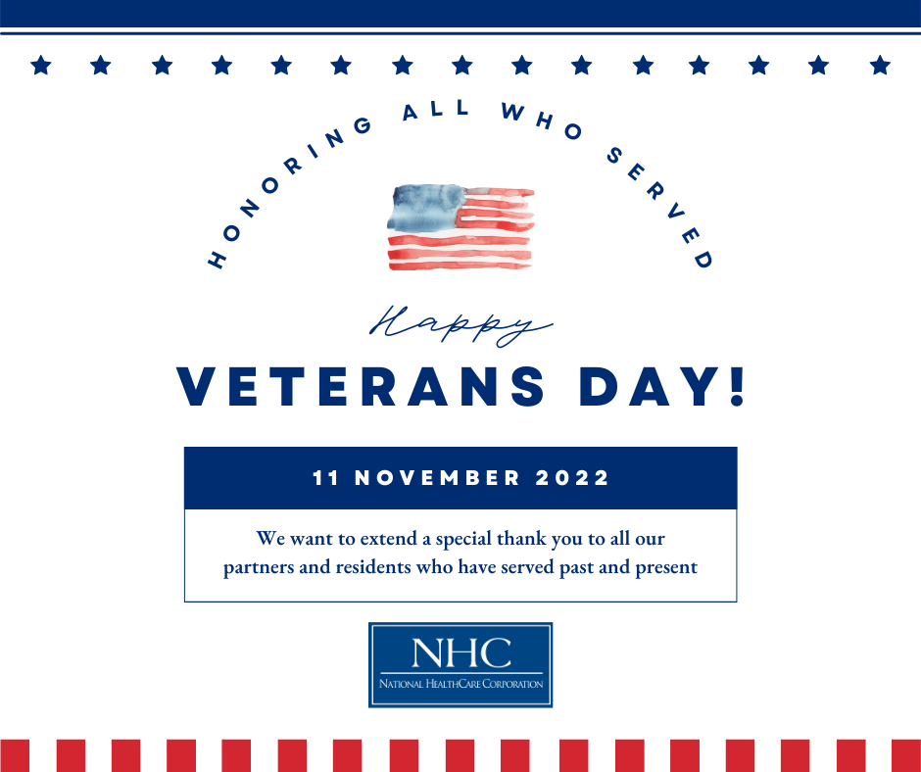
National HomeCare, Hospice, and Palliative Care Month
We would like to recognize our partners in HomeCare, Hospice, and Palliative care for their hard work and dedication. These valued partners provide much needed services in crucial times of our patients’ continuum of care. Thank you to all these amazing individuals for the care they give!
