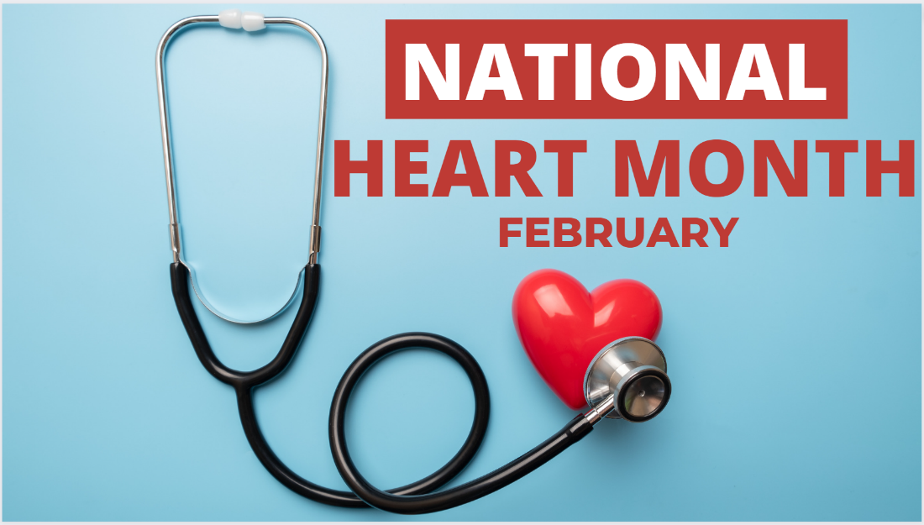
NHC Springfield February 2023 Family Newsletter

Dates to remember:
February 3 – National Wear Red Day: Go Red for Women
February 14 – Valentine's Day
February 20 – President's Day
Center Introduction:
Love is in the air and we are excited to celebrate our favorite Valentines this month! Join us in celebrating all things love and get into the heart of this wonderful holiday.
Center News: We have an exciting month ahead filled with some fun events. Music with Reverend Paul the 7th at 2:00pm. Valentine's Day Party & Love Songs with Scarlett & Good Shepherd the 14th at 2:00pm. Fat Tuesday Party on the 21st at 2:00pm. Please let us know if you have any questions.
American Heart Month
February is American Heart Month. One of the greatest gifts you can give yourself is focusing on your cardiovascular health. Check out these special tips from the American Heart Association. Remember to wear red this Friday and Go Red for Women!
10 Tips for Senior Caregivers
Caring for a Senior relative can have its challenges. It is important to remember you are not alone in this process. Take a look at 10 tips for Senior caregivers here.
