December 2022 Springfield Family Newsletter
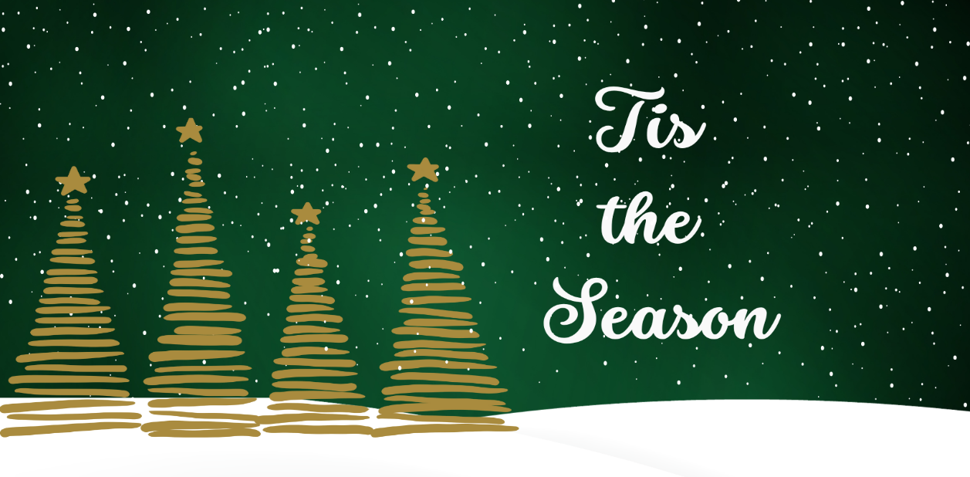
Center Introduction: As the year comes to a close, we celebrate the year that’s passed and the year soon to begin. This is the season to spend time with loved ones and we’re thankful we get to spend time with them every day. We’re very excited to share with you all our upcoming events for the holiday season. Check out our blog about minimizing holiday stress for elderly relatives by clicking here .
Important Dates:
Dec. 7 – Pearl Harbor Remembrance
Dec. 24 - Christmas Eve
Dec. 25 - Christmas
Center News: On December 7th we’re having our Christmas Light Outing. December 9th at 11:00 we have our Good Holiday Feelings Music Program. December 16th at 10:00 Coffee & Cinnamon Rolls w/ Seasons Hospice. December 21st at 2:00 is our Jingle & Mingle Holiday Party w/ Isaac Kenneth. December 23rd at 2:00 Ice Cream Social & Christmas Carols w/ Good Shepherd. December 30th at 2:00 we’ll have our Ringing in the New Year Party.
Special Announcements for Families: Unfortunately, the resident Christmas Party will be for residents only. No family members at this time.
Are you up to date on your boosters?
It’s important during this time of visiting family and friends to remember to stay up to date on your vaccines. CDC recommends anyone 12 and over stay up to date on their vaccine boosters. To learn more , please CLICK HERE .
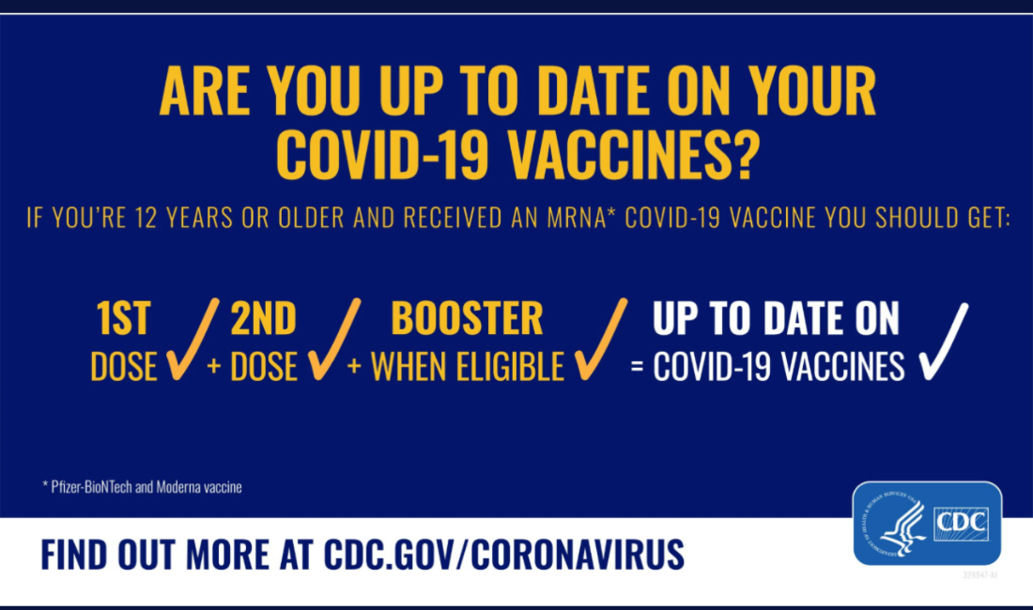
Christmas note: NHC wishes everyone a merry Christmas and Happy Holidays. Please make sure to call if you have any questions regarding visitation and how to be safe when coming into the center to visit your loved ones.
