December 2022 Maryland Heights Family Newsletter
Center Introduction: As the year comes to a close, we celebrate the year that’s passed and the year soon to begin. This is the season to spend time with loved ones and we’re thankful we get to spend time with them every day. We’re very excited to share with you all our upcoming events for the holiday season. Check out our blog about minimizing holiday stress for elderly relatives by clicking here .
Important Dates:
Dec. 7 – Pearl Harbor Remembrance
Dec. 24 - Christmas Eve
Dec. 25 - Christmas
Center News: We have many events coming up this month! Shriner's Band Christmas Concert is on December 7th at 7pm, Our Holiday Party w/JEM Express is on December 16th at 2pm. Resident Christmas Dinner will be held on December 25th. Lastly, our Christmas Lights Tours will be Mondays at 6pm.
Special Announcements for Families: Do you and a few family members want to get together with your resident for a Christmas gathering in December? Call or stop at the front desk and speak to Hope to reserve a 2 hour time slot in the library (seats 5) or conference room (seats 8).
Special Thanks: Thank you to Lighthouse Baptist Church, and to everyone who donated Christmas gifts to our residents from our Angel Tree! 2). Congratulations to our Resident of the Month Sandra Ware, and our Partner of the Month Hope Zarro!
Are you up to date on your boosters?
It’s important during this time of visiting family and friends to remember to stay up to date on your vaccines. CDC recommends anyone 12 and over stay up to date on their vaccine boosters. To learn more , please CLICK HERE .
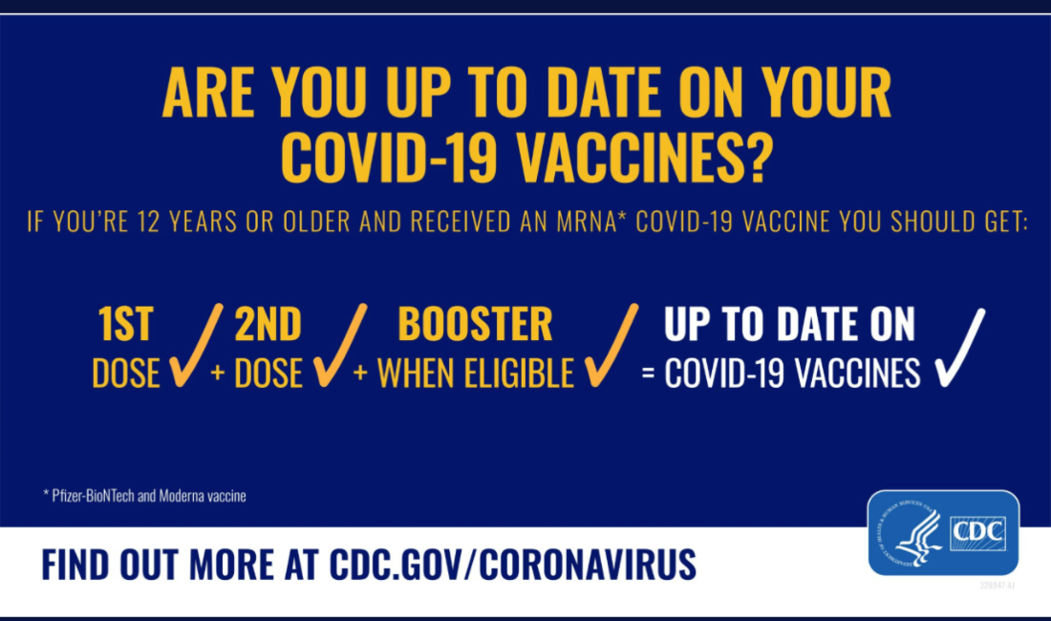
Christmas note: NHC wishes everyone a merry Christmas and Happy Holidays. Please make sure to call if you have any questions regarding visitation and how to be safe when coming into the center to visit your loved ones.
