◄ Oct 2022 | End of Daylight Savings Time November 2022 |  |  |  |  | Dec 2022 ►
Sun | Mon | Tue | Wed | Thu | Fri | Sat
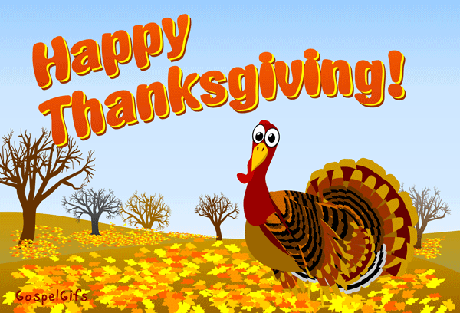 |  | 1  10:30a-Temple Baptist  2:00p- Our Thankful Tree | 2  10:30a -Bingocize  2:00p-Bingocize  $$ Store $$ | 3  10:30-Music Of choice  2:00p- Thanksgiving  Triva | 4  10:30a-3^{rd Floor}  Coffee Cart  2:00p-ShuffleBoard  Contest | 5 TN @ Georgia 3:30  10:30a- Rolling Leisure Cart  2:00p- Balloon Volleyball
6 DAY LIGHTS SAVINGS TIME ENDS  11:00 Chl. 4 Temple Baptist  Chl 811 Gospel Music  Leisure & Bible study pages & prayer partner available, Volunteer Services held as able (Deacon David visiting between 11:00a-12:00p) | 7  10:30a: Bingocize  2:00p- Courtyard Social w/coffee | 8  10:30a-Temple Baptist  2:00p- National Cappuccino Day | 9  10:30a -Bingocize  2:00p-Bingo | 10  10:30-Arts & Crafts  2:00p- Word from Words | 11  10:30a-3^{rd Floor}  Leisure Cart  2:00p-Veterians Day Remembrance | 12 Missouri @ TN  10:30a-Rolling Coffee Cart  2:00p- Hangman
13 Pet Therapy Visits  11:00 Chl. 4 Temple Baptist  Chl 811 Gospel Music  Leisure & Bible study pages & prayer partner available, Volunteer Services held as able | 14  10:30a-Bingocize  2:00p-Corn Hole Contest | 15  10:30a-Temple Baptist  2:00p- Hot Chocolate in The Courtyard | 16  10:30a -Bingocize  2:00p- Bingo | 17  10:30- Morning Exercise  2:00p- Painting W/Kimberly from Caris Hospice | 18  10:30a-3^{rd Floor}  Comfort Cart  2:00p-Monthly Birthday Party | 19 TN @ SC  10:30a-Morning Coffee Talk  2:00p- Wordsearch Fun
20 Pet Therapy Visits  11:00 Chl. 4 Temple Baptist  Chl 811 Gospel Music  Leisure & Bible study pages & prayer partner available, Volunteer Services held as able | 21  10:30a-Bingocize  2:00p-Deck the Halls | 22  10:30a-Temple Baptist  2:00p-Resident Council | 23  10:30a Bingocize  2:00p- Afternoon Spa | 24  9:00a-12:00p Macy’s Day Parade on NBC  Happy Thanksgiving | 25  10:30a-3^{rd Floor}  1:1 Visits  2:00p-Name That Tune | 26 TN @ Vanderbilt  10:30- In Room Manicures  2:00p-Shuffleboard
27 Pet Therapy Visits  11:00 Chl. 4 Temple Baptist  Chl 811 Gospel Music  Leisure & Bible study pages & prayer partner available, Volunteer Services held as able | 28  10:30a-Bingocize  2:00p- Movie & Popcorn | 29  10:30a-Temple Baptist  2:00p- Be Merry & Decorate | 30  10:30a -Bingocize  2:00p- Bingo | Also Available:  tablets, chromebooks, iPods, Wii gaming, jigsaw & word puzzles, reading supplies, adult & regular coloring, arts & crafts, movies, radios

Please Help Welcome Deacon David. He is our new Catholic Deacon who will be visiting 1 Sunday a month for service,1:1 visits and communion by request

