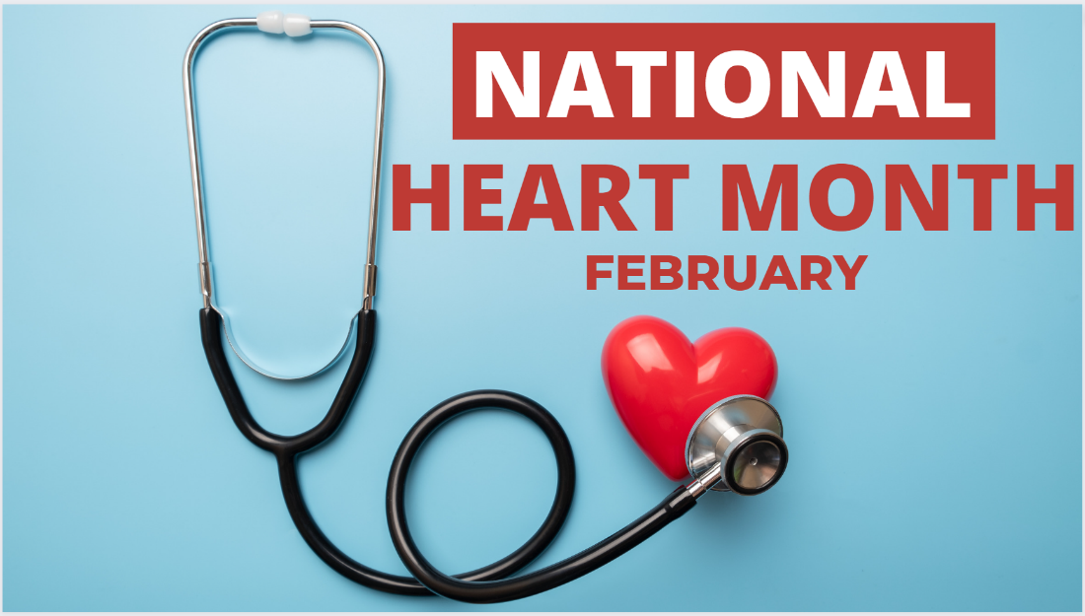
NHC Knoxville February 2023 Family Newsletter

Dates to remember:
February 3 – National Wear Red Day: Go Red for Women
February 14 – Valentine's Day
February 20 – President's Day
Center Introduction:
Love is in the air and we are excited to celebrate our favorite Valentines this month! Join us in celebrating all things love and get into the heart of this wonderful holiday.
Center News:
Fountain City Library, Valentines King and Queen Party, Elvis Concert, Birthday Party, Movie and Popcorn. Please call or check our activities calendars if you have any questions.

Special Announcements for Families:
We will be choosing A new NHC King and Queen Feb 13th, we have 2 new church services added to our schedule.

Special Thanks:
Arlington Church Of Christ, Southside Baptist Church, Temple Baptist Church, Fountain City Library, Caris Hospice care. Thank you for everything that you do!

American Heart Month
February is American Heart Month. One of the greatest gifts you can give yourself is focusing on your cardiovascular health. Check out these special tips from the American Heart Association. Remember to wear red this Friday and Go Red for Women!
10 Tips for Senior Caregivers
Caring for a Senior relative can have its challenges. It is important to remember you are not alone in this process. Take a look at 10 tips for Senior caregivers here.

