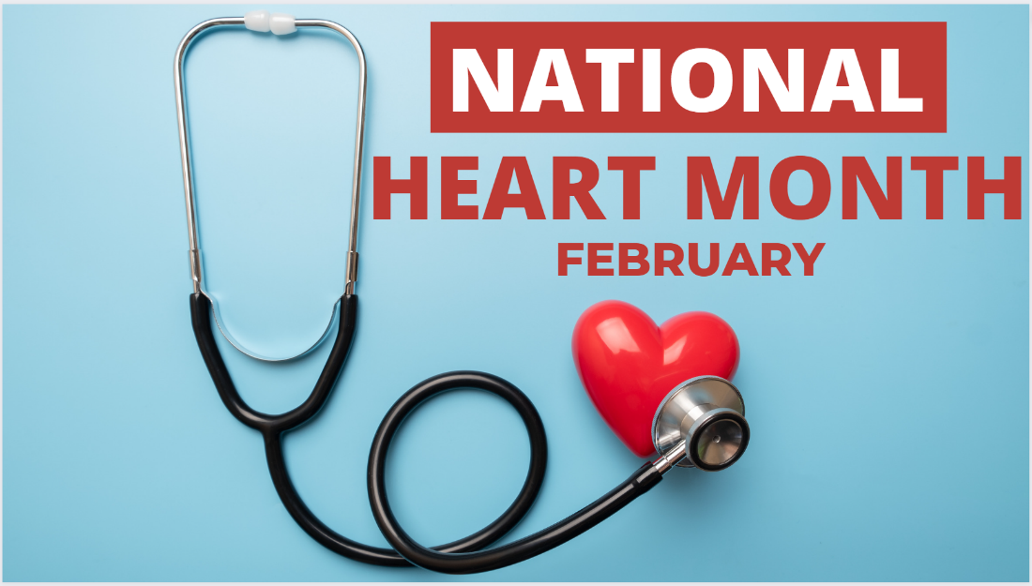
February 2023 Family Newsletter

Dates to remember:
February 3 – National Wear Red Day: Go Red for Women
February 14 – Valentine's Day
February 20 – President's Day
Center Introduction:
Love is in the air and we are excited to celebrate our favorite Valentines this month! Join us in celebrating all things love and get into the heart of this wonderful holiday.
Center News:
Super Bowl Party Friday February 10th at 1:15 and Valentine's Day Party Tuesday February 14th at 2:00 pm. The residents will be selling Valentine's baskets to residents and staff that has candy, light up rose, stuffed animal, balloon and drink for $12 Thursday February 9th-to Tuesday February 14th. We will be starting a new cooking class once a month, this month is Thursday February 16th at 2:00pm.

Special Announcements for Families:
We are in need of volunteers, we currently only have 1 volunteer, other than the companies who come in from Hospice agencies. If you can spare the time, we would greatly appreciate the help. Wear your favorite Football Team attire Friday February 10th.

Special Thanks:
Thank you, Alesha at Elara Caring Hospice, Tristie at Crown Hospice, Morgan at Missouri Delta Hospice, Annalea at Legacy Hospice and the Votech students for helping with activities this month.

American Heart Month
February is American Heart Month. One of the greatest gifts you can give yourself is focusing on your cardiovascular health. Check out these special tips from the American Heart Association. Remember to wear red this Friday and Go Red for Women!
10 Tips for Senior Caregivers
Caring for a Senior relative can have its challenges. It is important to remember you are not alone in this process. Take a look at 10 tips for Senior caregivers here.
