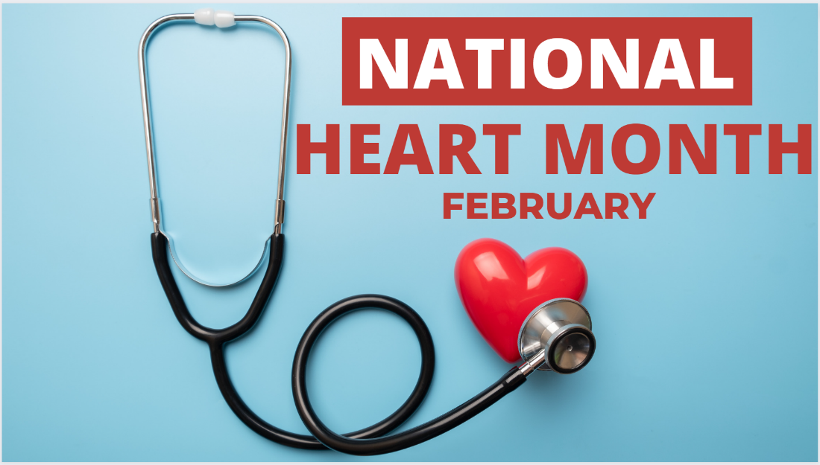
NHC Holston February 2023 Family Newsletter

Dates to remember:
February 3 – National Wear Red Day: Go Red for Women
February 14 – Valentine's Day
February 20 – President's Day
Center Introduction:
Love is in the air and we are excited to celebrate our favorite Valentines this month! Join us in celebrating all things love and get into the heart of this wonderful holiday.
Center News:
We have many exciting events happening this month. Hymn Sing with Washington Presbyterian Feb. 7, at 6:30 p.m. Making and baking pies and cookies Feb 10th and 12th at 2:00 Feb 10-14 Vote for Holston Resident King and Queen in front hallway Coronation of valentine King and Queen Feb 14 at 11:30 followed by Coronation Concert with recording artist John Young at 2:00. Mardi Gras Fun and festivities Feb 20th and 21st at 2:00. Community Outreach for local school early reader school children Feb 27th and Feb 28th with Dr. Seuss story books. You are welcome to attend Worship with temple Baptist at 2:00 each Sunday.

Special Announcements for Families:
I would like to extend an invitation to all groups, neighbors, families, businesses, churches, schools, and sports teams to Holston! Join us in volunteer opportunities to meet our patients, residents, and partners as we grow in community post pandemic! Let's enjoy "Community in '23!" Our Alzheimer's Association fundraising has begun! Look for the Valentine Raffle basket if you would like to participate! Also, you may purchase an in room Singing Valentine and heart shaped Mylar balloon. Present your loved-one with a message and song on Valentine’s Day morning! cost is $5.00. Contact Kim or Rebecca at 865-524-1500 for song selection and payment method.

Special Thanks:
Alpha Kappa Alpha Sorority, Inc. Alpha Pi Omega Chapter, Temple Baptist - Torrey Lasley, HABIT Therapy and volunteers, Washington Presbyterian - Krista, UT Jazz bandmembers, Youth Symposium Artwork - Fenecia and students and rendition of "Moving Forward in Equality", Family volunteers, and the housekeeping department for weekend movies! Bingocize grant and Tennessee person centered music grant, each one plays and integral part in our center.

American Heart Month
February is American Heart Month. One of the greatest gifts you can give yourself is focusing on your cardiovascular health. Check out these special tips from the American Heart Association. Remember to wear red this Friday and Go Red for Women!
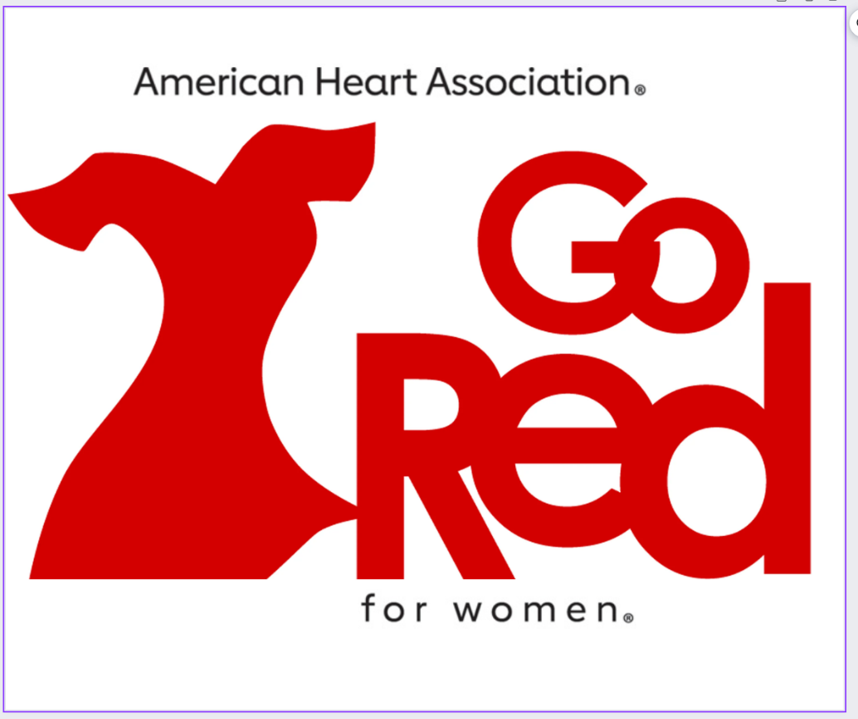
10 Tips for Senior Caregivers
Caring for a Senior relative can have its challenges. It is important to remember you are not alone in this process. Take a look at 10 tips for Senior caregivers here.
