2023
2023
Sunday | Monday | Tuesday | Wednesday | Thursday | Friday | Saturday
1 | 2 Morning Mail Delivery  Bringing in the New Year  Do you have any resolutions?  10:00 (A) 10:30 (B) 11:00 (C)  What Advice would you give for a better year?  2:00 (A) 2:30 (B) 3:00 (C) | 3 Morning Mail Delivery  Winter Facts and Trivia  10:00 (A) 10:30 (B) 11:00 (C)  Craft Corner-Making Snow, Snowflake Art  2:30 (MDR) | 4 Morning Mail Delivery  Devotion with Pastor James  10:30 (MDR)  2:00 (MDR) | 5 Morning Mail Delivery  Brain Games  10:00 (A) 10:30 (B) 11:00 (C)  Naitonal Bird Watching Day  Facts and Trivia about Birds  2:30 (A) 3:00 (B) 3:30 (C) | 6 Morning Mail Delivery  Balloon Ball  10:00 (A) 10:30 (B) 11:00 (C)  2:00 (MDR) | 7  Devotion with St. John Baptist Church  10:30 (MDR)  Weekend Activity Packs are  Located on each unit
8 Watch your favorite  Church Service on tv  Devotion with Rev. Tobias  3:30 (MDR)  Hallmark Movie  CH. 21 | 9 Morning Mail Delivery  Elvis Facts and Triva  10:00 (A) 10:30 (B)  Dev. w/ Rev. Harris 10:30 (C)  Balloon Ball Exercise  2:30 (MDR)  Movie Matinee: Featuring Elvis  3:30 (MDR) | 10 Morning Mail Delivery  Word Search  10:00 (A) 10:30 (B) 11:00 (C)  Gospel Singing with The Sonshine Singers  2:30 (MDR) | 11 Morning Mail Delivery Devotion with Pastor James  10:30 (MDR)  2:00 (MDR) | 12 Morning Mail Delivery  This or That  10:00 (A) 10:30 (B) 11:00 (C)  January Birthday Party  2:30 (MDR) | 13 Morning Mail Delivery  Friday Funnies  10:00 (A) 10:30 (B) 11:00 (C)  2:00 (MDR) | 14  DIY Snowflake Kits located on each unit  Weekend Activity Packs are located on each unit
15 Watch your favorite  Church Service on tv  Hallmark Movie  CH. 21 | 16 Morning Mail Delivery  MLK Day-Facts and Trivia  10:00 (A) 10:30 (B)  Dev. w/ Rev. Harris 10:30 (C)  Balloon Ball Exercise  2:30 (MDR)  Resident Council Meeting  3:30 (MDR) | 17 Morning Mail Delivery  Popcorn Toss  10:00 (A) 10:30 (B) 11:00 (C)  Gospel Singing with  Adoration  2:30 (MDR) | 18 Morning Mail Delivery  Devotion with Pastor James  10:30 (MDR)  2:00 (MDR) | 19 Morning Mail Delivery  Popcorn Facts and Trivia  10:00 (A) 10:30 (B) 11:00 (C)  National Popcorn Day  Popcorn Cart  2:30 (A) 3:00 (B) 3:30 (C) | 20 Morning Mail Delivery  Balloon Ball  10:00 (A) 10:30 (B) 11:00 (C)  2:00 (MDR) | 21  Saturday Morning Rewind-Talk with other residents about your week  Weekend Activity Packs are located on each unit
22 Watch your favortie  Church Service on tv  Hallmark Movie  CH. 21 | 23 Morning Mail Delivery  Brain Games  10:00 (A) 10:30 (B)  Dev. W/ Rev. Jerry Harris (C)  Balloon Ball Exercise  2:30 (MDR) | 24 Morning Mail Delivery  Trivia Tuesday  10:00 (A) 10:30 (B) 11:00 (C)  Gospel Singing with  The Hendersons  2:30 (MDR) | 25 Morning Mail Delivery  Devotion with Pastor James  10:30 (MDR)  2:00 (MDR) | 26 Morning Mail Delivery  This or That  10:00 (A) 10:30 (B) 11:00 (C)  Jeopardy  2:30 (MDR) | 27 Morning Mail Delivery  Memory Magic  10:00 (A) 10:30 (B) 11:00 (C)  2:0  2:00 (MDR) | 28  Evidence of Faith Ministries  10:30 (MDR)  Weekend Activity Packs are located on each unit
29 National Puzzle Day  Did you know working puzzles improves your mood and memory, and it also delays dementia/Alzheimer’s.  Puzzles are located on each wing | 30 Morning Mail Delivery  Remember When  10:00 (A) 10:30 (B) Dev. w/ Rev. Harris 10:30 (C)  Balloon Ball-Exercise  2:30 (MDR) | 31 Morning Mail Delivery  Memory Magic  10:00 (A) 10:30 (B) 11:00 (C)  Craft Corner-Valentine Theme  2:30 (MDR) | 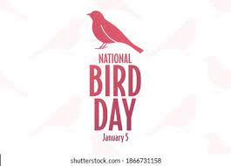 |  | 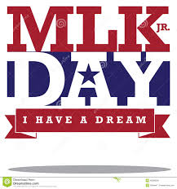
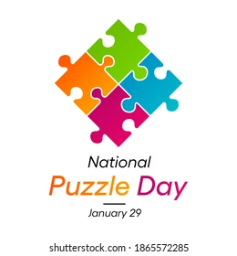 | Birthdays  M. Wesson 04  J. Hicks 04  S. Baker 06  M. Miller 07  D. McWatters 08  J. Alexander 12  H. Frady 13 | Birthdays  E. Chisolm 15  R. Tolbert 16  L. Bradberry 16  A. Hunter 18  M. Bundrick 24  F. Gary 26  H. Jackson 26 | Birthdays  P. Fullbright 29 | Ask about a Manicure  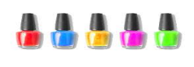 | Do you need a hair appointment?  Call the Activity  Dept.  Ext. 111 | Please note this calendar is subject to change. Staff will keep you up to date on changes.

