December 2022 Bristol Family Newsletter
Center Introduction: As the year comes to a close, we celebrate the year that’s passed and the year soon to begin. This is the season to spend time with loved ones and we’re thankful we get to spend time with them every day. We’re very excited to share with you all our upcoming events for the holiday season. Check out our blog about minimizing holiday stress for elderly relatives by clicking here .
Important Dates:
Dec. 7 – Pearl Harbor Remembrance
Dec. 24 - Christmas Eve
Dec. 25 - Christmas
Center News: We have plenty of events lined up this December! A Holiday Shoe Box Drive, Christmas Party, Performers-Pati Quarles, Raymond Akers, Arron Howard, Lighnin Charlie, Sevens, and more.
Special Announcements for Families: We will be having our annual Holiday Shoe Box drive for residents Christmas party and performers throughout the month. If you have any questions, please feel free to contact us.
Special Thanks: Caris Heath Care, and contributions to our TFGE fundraising, potlucks welcoming new administrator major Whorley.
Are you up to date on your boosters?
It’s important during this time of visiting family and friends to remember to stay up to date on your vaccines. CDC recommends anyone 12 and over stay up to date on their vaccine boosters. To learn more , please CLICK HERE .
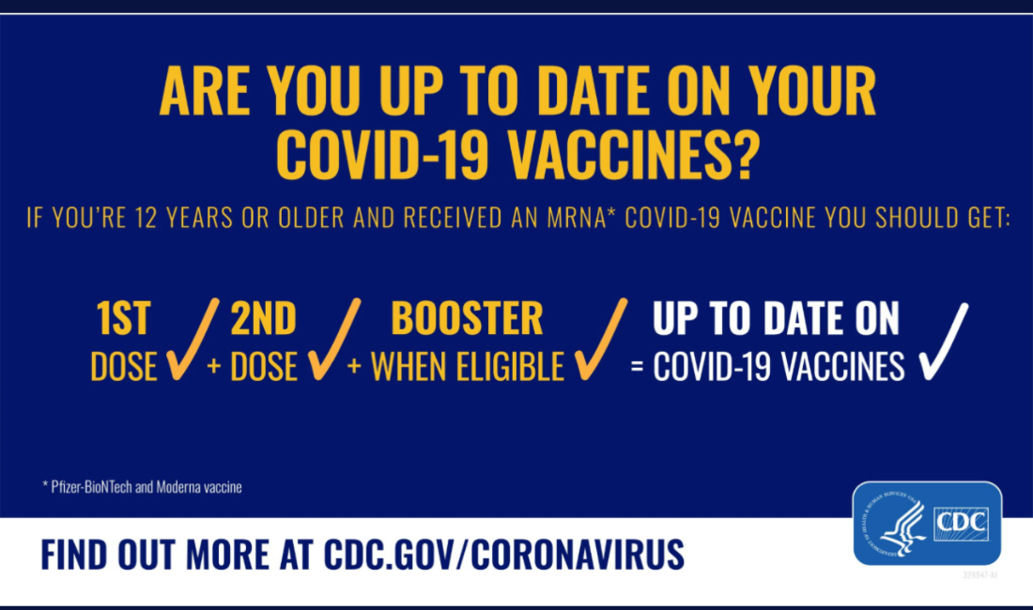
Christmas note: NHC wishes everyone a merry Christmas and Happy Holidays. Please make sure to call if you have any questions regarding visitation and how to be safe when coming into the center to visit your loved ones.
