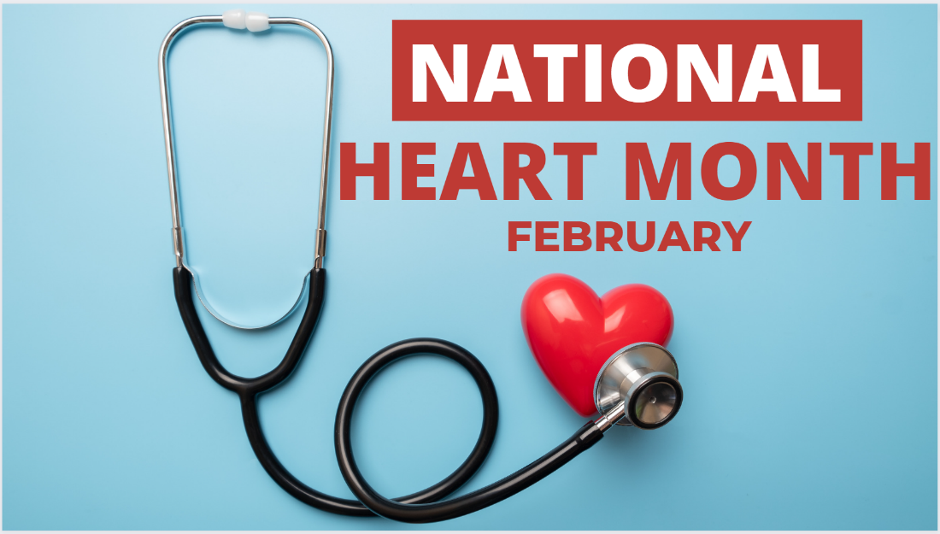
NHC Bluffton February 2023 Family Newsletter

Dates to remember:
February 3 – National Wear Red Day: Go Red for Women
February 14 – Valentine's Day
February 20 – President's Day
Center Introduction:
Love is in the air and we are excited to celebrate our favorite Valentines this month! Join us in celebrating all things love and get into the heart of this wonderful holiday.
Center News:
Wine & Cheese Valentine's Day Party (February 14th), Jim Seem (February 15th), All Star Strummers (February 20th), Mardi Gras Party w/Cheryl (February 22nd), Paul Lewis Music (February 24th), Singing w/ Paul & Susan (February 28th)

Special Announcements for Families:
Valentine's Day Party Wine & Cheese (February 14th). Please call ahead of time if you have any questions.

American Heart Month
February is American Heart Month. One of the greatest gifts you can give yourself is focusing on your cardiovascular health. Check out these special tips from the American Heart Association. Remember to wear red this Friday and Go Red for Women!
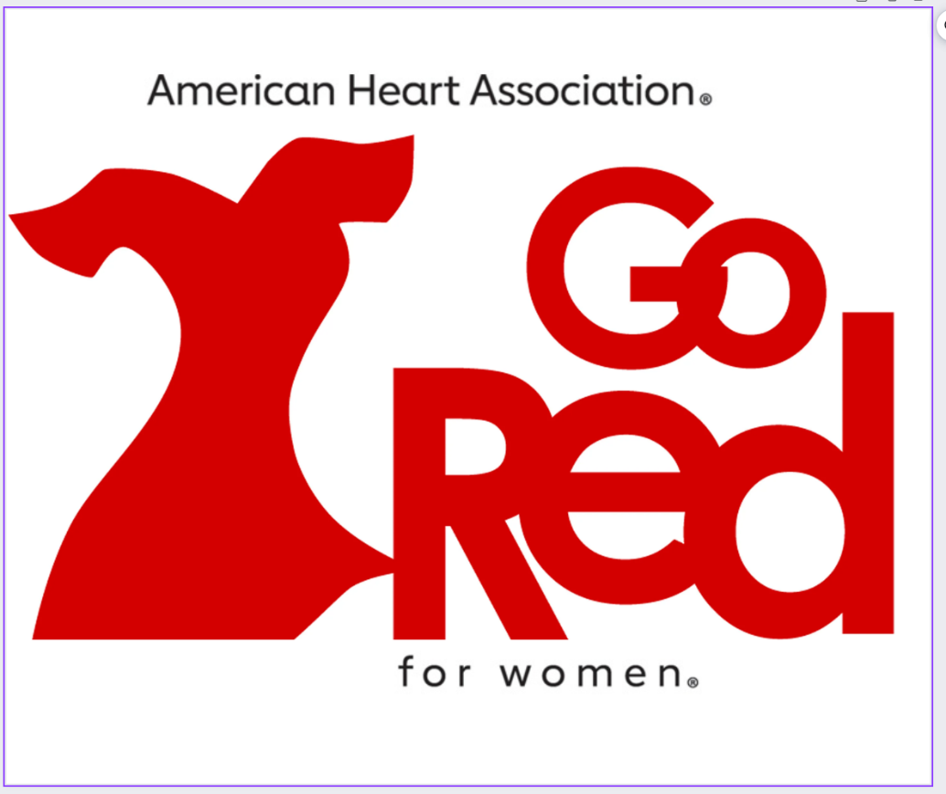
10 Tips for Senior Caregivers
Caring for a Senior relative can have its challenges. It is important to remember you are not alone in this process. Take a look at 10 tips for Senior caregivers here.
