November 2022 Maryland Heights
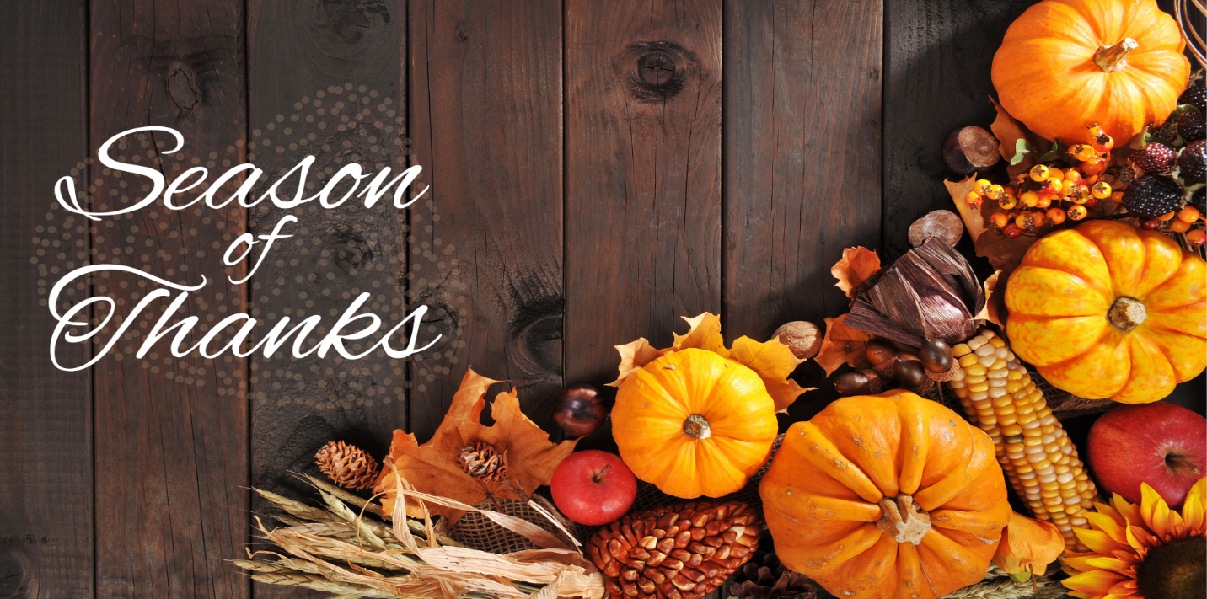
While there are many things to be thankful for year-round, November is the official Season of Thanksgiving. It is a time to celebrate what we are grateful for and take moments to enjoy all that we have. We are thankful to each one of you and hope you have a blessed coming Thanksgiving.
Important Dates:
November 6 Daylight Savings Time Ends
November 11 Veteran’s Day
November 24 Thanksgiving
Center News: Please join us for the following events. We’re hosting St. Charles Tours, Bi-weekly shopping trips, Crafts, and a Chili cookoff! If you have any questions, please feel free to reach out and contact us.
Special News for Families: New assistant administrator Major Whorley. Major has pitched in for Activities while they don't have a director.
Special Thanks: Activities partners Nancy and Kenyae. They’ve had a lot of challenges lately and have still kept quality activities going and our residents engaged. We thank you Nancy and Kenyae for all that you do!
Honoring Veterans Section
During this special Veteran’s Day, we would like to give thanks to all those who have served. We will never forget the sacrifices and bravery of the men and women who gave everything to protect our freedoms. We are especially thankful for all our partners and residents who have served in the past. Your courage has set an example for us all. Happy Veteran’s Day!
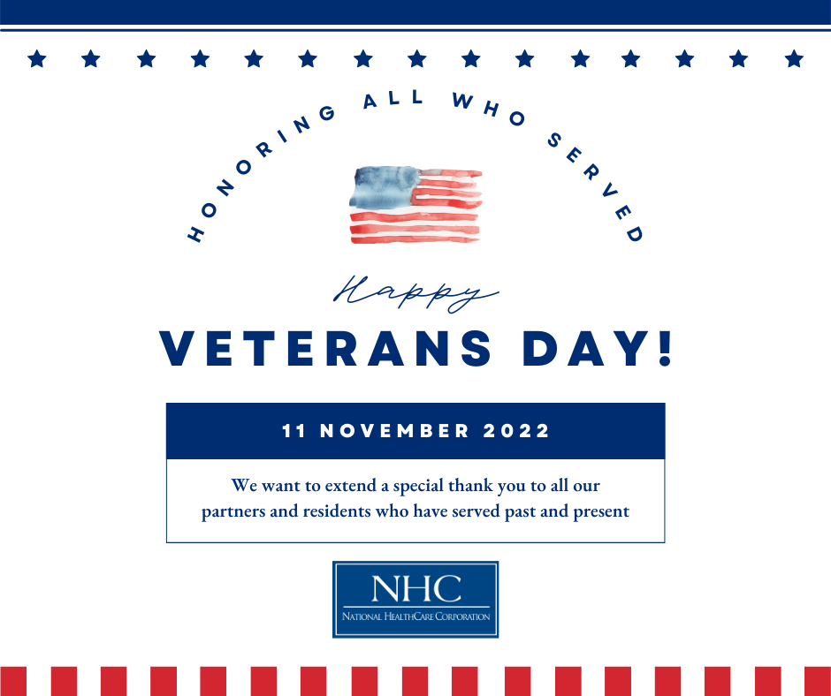
National HomeCare, Hospice, and Palliative Care Month
We would like to recognize our partners in HomeCare, Hospice, and Palliative care for their hard work and dedication. These valued partners provide much needed services in crucial times of our patients’ continuum of care. Thank you to all these amazing individuals for the care they give!
