November 2022 Knoxville
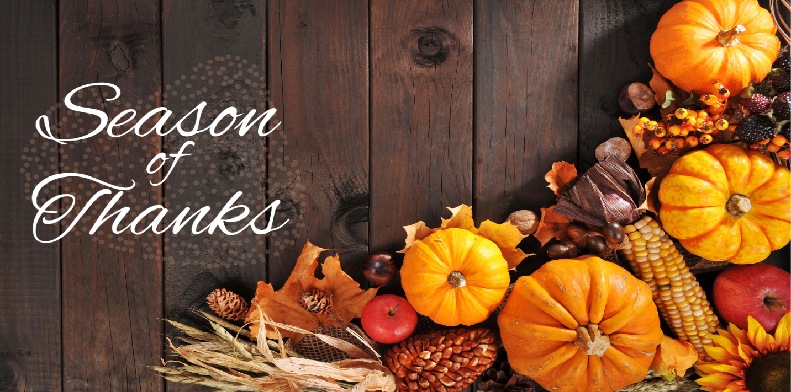
While there are many things to be thankful for year-round, November is the official Season of Thanksgiving. It is a time to celebrate what we are grateful for and take moments to enjoy all that we have. We are thankful to each one of you and hope you have a blessed coming Thanksgiving.
Important Dates:
November 6 Daylight Savings Time Ends
November 11 Veteran’s Day
November 24 Thanksgiving
Center News: This November, we’re having many events at our center. You’re invited to to join us for these events listed. Painting with Kimberly @ Hospice Care, Our Thankful Tree, Corn Hole contest and Deck The Halls. Please feel free to contact us for any information!
Special Thanks: Caris Hospice for painting fun, Temple Baptist Church for Tuesday church services, Frank Smith (residents’ son)for assisting with Bingo.
Honoring Veterans Section
During this special Veteran’s Day, we would like to give thanks to all those who have served. We will never forget the sacrifices and bravery of the men and women who gave everything to protect our freedoms. We are especially thankful for all our partners and residents who have served in the past. Your courage has set an example for us all. Happy Veteran’s Day!
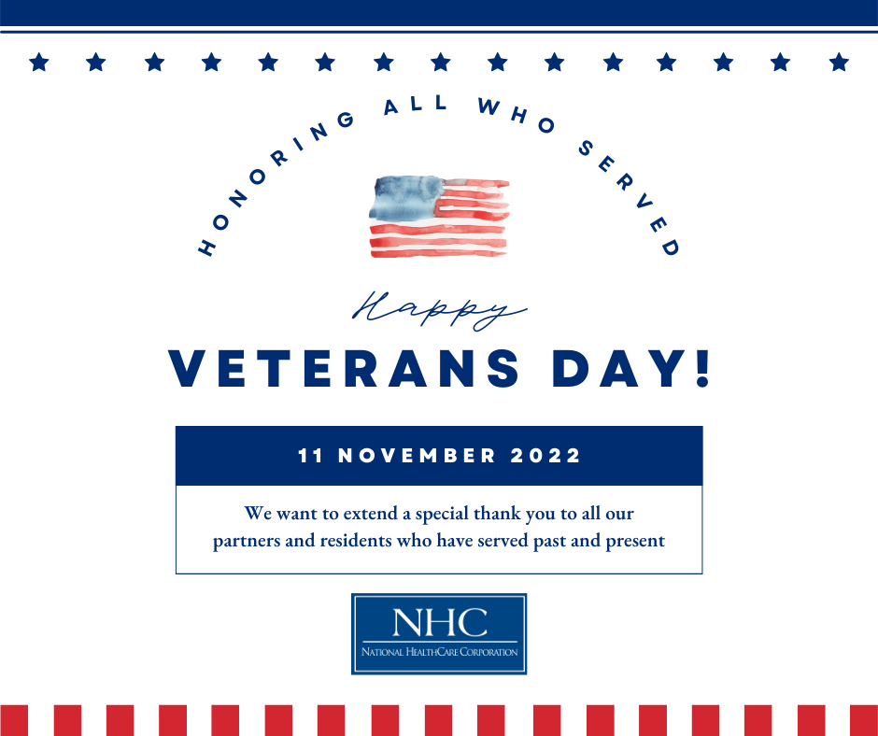
National HomeCare, Hospice, and Palliative Care Month
We would like to recognize our partners in HomeCare, Hospice, and Palliative care for their hard work and dedication. These valued partners provide much needed services in crucial times of our patients’ continuum of care. Thank you to all these amazing individuals for the care they give!
