November 2022 NHC Kennett
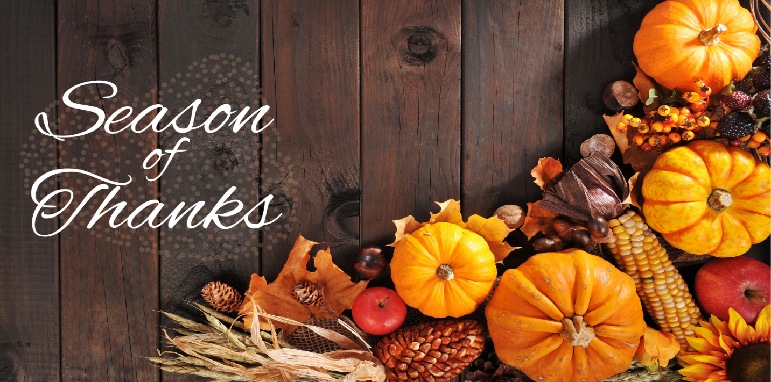
While there are many things to be thankful for year-round, November is the official Season of Thanksgiving. It is a time to celebrate what we are grateful for and take moments to enjoy all that we have. We are thankful to each one of you and hope you have a blessed coming Thanksgiving.
Important Dates:
November 6 Daylight Savings Time Ends
November 11 Veteran’s Day
November 24 Thanksgiving
Center News: November-Veteran's Day Celebration November 11th at 3:00, Boutique Shopping (Previously known as the auction) November 16th at 1:30, Thanksgiving Celebration Tuesday 22nd at 2:00. We have a lot of thanksgiving activities planned throughout the month so contact us with any questions.
Special Announcements for Families: We will be having our family Holiday meals on December 6th evening, with dinner and entertainment. This info will go out next month.
Special Thanks: Thank you for all family members and people in our community for all the donations to our residents and for prizes for games. Also thank you to Elara Caring-Hospice for helping with manicures once a month (we do manicures every Thursday).

Honoring Veterans Section
During this special Veteran’s Day, we would like to give thanks to all those who have served. We will never forget the sacrifices and bravery of the men and women who gave everything to protect our freedoms. We are especially thankful for all our partners and residents who have served in the past. Your courage has set an example for us all. Happy Veteran’s Day!
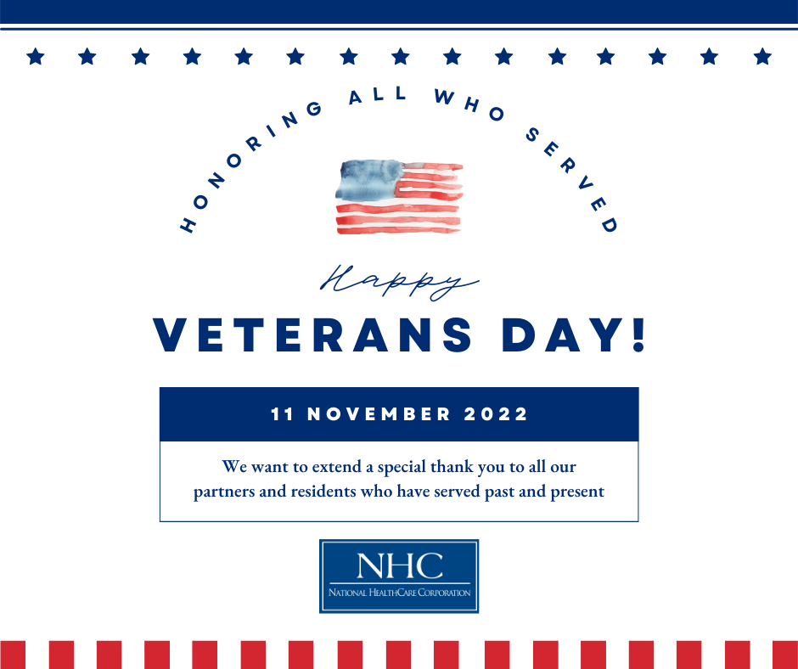
National HomeCare, Hospice, and Palliative Care Month
We would like to recognize our partners in HomeCare, Hospice, and Palliative care for their hard work and dedication. These valued partners provide much needed services in crucial times of our patients’ continuum of care. Thank you to all these amazing individuals for the care they give!
