This is the day that the Lord has made; let us rejoice and be glad in it.    Psalm 118:24 |  |  | 8:30 Focus Paper  11:00 Chair Exercise  2:00 Men’s Group with Christian | 9:00 Scripture & Hydration  9:15 Beauty Shop  11:00 Chair Exercise  Drum it out  2:00 Bingocize | 9:00 1:1 Fun!  10:30 Knox News & Westerns Family Room  2:00 Art Sessions   | 9:00 Virtual laptops  10:30 Valerie & Jack  11:00 Up Lift  2:00 New Technology | November Chronicle Packet  10:00 Fun & Games with Cheryl    1:30 Movie Matinee with Holly VS Georgia
2:00 Worship with Temple Baptist Church  Families are welcome |   9:00 Nails on  100 -200  10:00 Veterans Presentation  Post 2 Vets and Family welcome!  2:00 Funny Money Auction | 8:30 Focus Paper  11:00 Chair Exercise  2:00 Coping with Grief – Caris Hospice Families welcome |  | 9:00 Scripture & Hydration  9:15 Beauty Shop    11:00 Chair Exercise  2:00 Bingocize | 8:30 Angel Tree  10:30 Knox News & Westerns in the Family Room  2:00 Art Sessions | 9:00 Virtual laptops  11:00 Up Lift  2:00 Veterans Tribute- with Caris Healthcare   | Word search  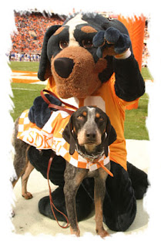  10:00 Fun & Games with Cheryl  1:30 Movie Matinee with Holly  Vols VS Mizzou
2:00 Worship with Temple Baptist Church  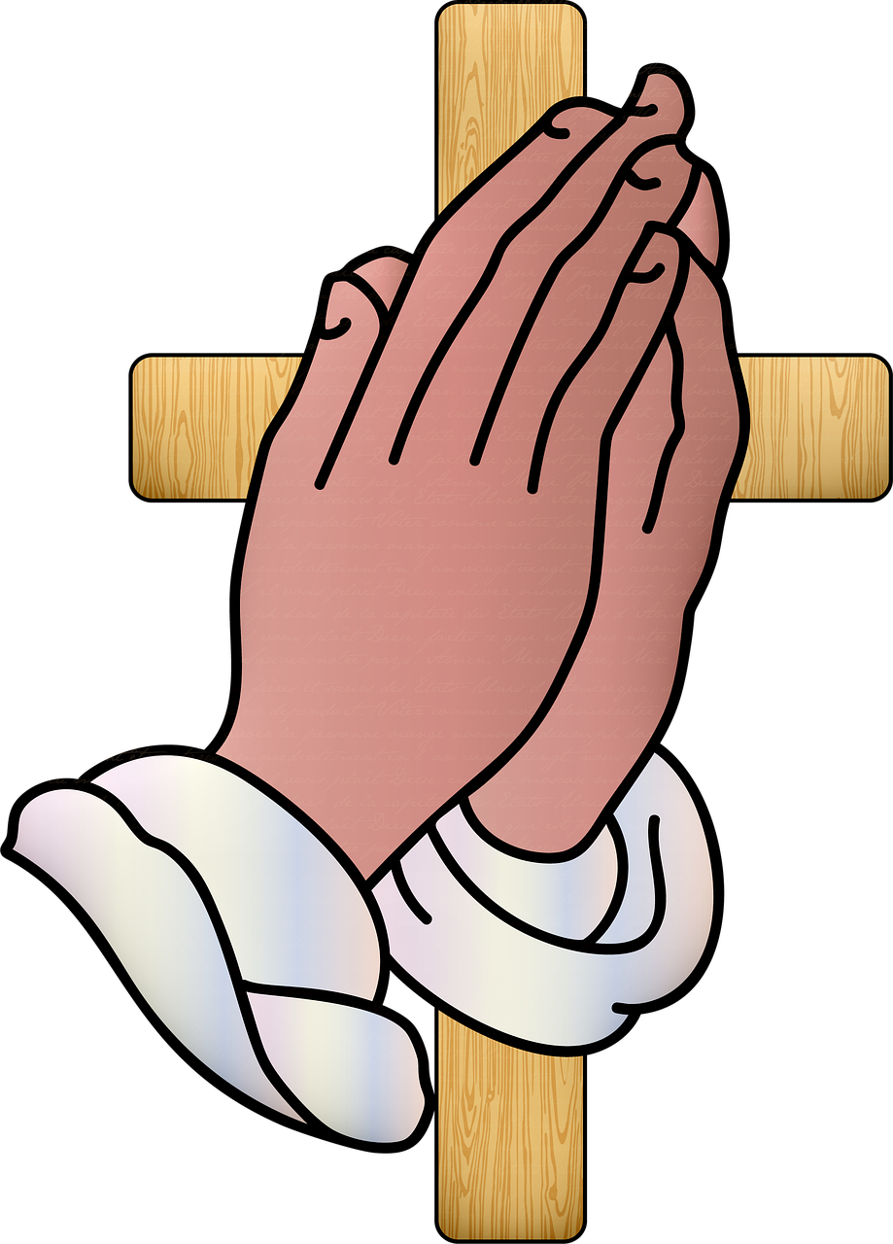 | 9:00 Nails on 300 hall  2:00 Turkey Shoot &  Balloon bop | 8:30 Focus Paper  11:00 Chair Exercise  2:00 Birthday Party  With Terri Conner   |  | 9:00 Scripture & Hydration  9:15 Beauty Shop  11:00 Chair Exercise  Oodles of noodles  2:00 Bingocize | 9:00 1:1 Thanksgiving memories & traditions.  11:30 Family Dinner East  1:00 Family Dinner West  Call 3028 to R.S.V.P. | 9:00 Virtual laptops  10:30 Valerie & Jack  2:00 Armchair Travelers  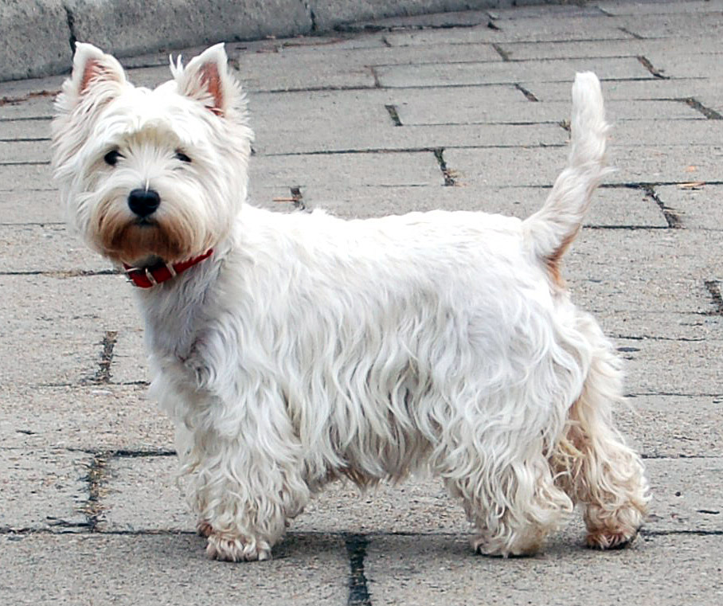 | Thanksgiving Packet  10:00 Fun & Games with Cheryl  1:30 Movie Matinee VOLS VS SC 
2:00 Worship with Temple Baptist Church  Families are welcome | 9:00 Nails on 400 hall  1:00 Resident Council  2:00 Decorate the dining  And family room tree   | 8:30 Focus Paper  11:00 Chair Exercise  2:00 Decorate the Lobby tree |  | 9:00 Scripture & Hydration  9:15 Beauty Shop  11:00 Chair Exercise  2:00 Bingocize | 9:00 Thanksgiving Day Parade  10:00 Room Visits  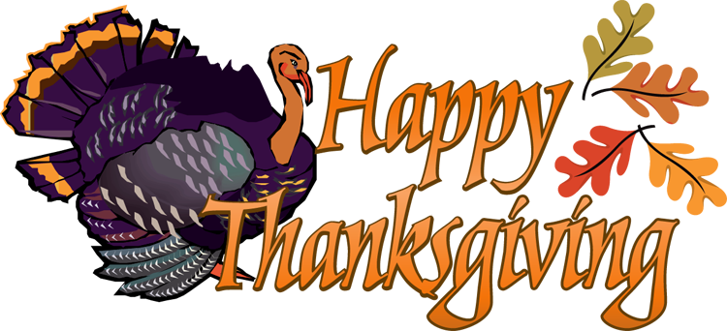  2:00 Family & Friends | 9:00 Virtual laptops  11:00 Up Lift  2:00 Armchair Traveler | Assorted Puzzle Packet  10:00 Fun & Games with Cheryl  1:30 Movie Matinee  
.  2:00 Worship with Temple Baptist Church  Families are welcome | 9:00 Nails on 500 -600  hall  2:00 10,000 Pyramid  Game | 8:30 Focus Paper  11:00 Chair Exercise  2:00 Scatagories |  | 9:00 Scripture & Hydration  9:15 Beauty Shop  11:00 Chair Exercise  2:00 Bingocize | Activities are subject to change  If you want to attend weekend services, movies, or UT game, ask your nursing assistant for an escort to and from the  main dining room or family room.

Additional supplies are available 24/7. Ask our CNAs for books, magazines, newspapers, coloring sheets, crayons, laptops, wordsearch, or music when activities are unavailable.
Sunday | Monday | Tuesday | Wednesday | Thursday | Friday | Saturday
 |  | 1 | 2 | 3 | 4 | 5
6  Daylight Saving Time Ends | 7 | 8 | 9 | 10 | 11  Veterans Day  Remembrance Day (Canada) | 12
13 | 14 | 15 | 16 | 17 | 18 | 19
20 | 21 | 22 | 23 | 24  Thanksgiving Day (US) | 25 | 26
27 | 28 | 29 | 30

