November 2022 NHC Holston
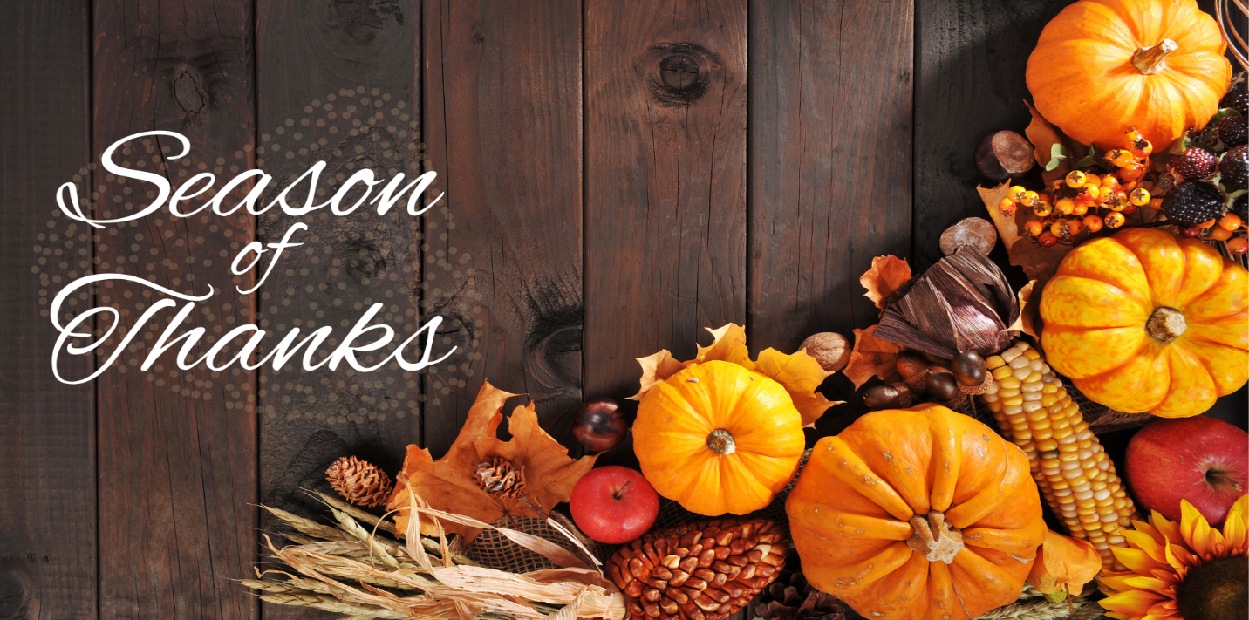
While there are many things to be thankful for year-round, November is the official Season of Thanksgiving. It is a time to celebrate what we are grateful for and take moments to enjoy all that we have. We are thankful to each one of you and hope you have a blessed coming Thanksgiving.
Important Dates:
November 6 Daylight Savings Time Ends
November 11 Veteran’s Day
November 24 Thanksgiving
Center News: Men's Group Tuesday, November 1st @ 2:00. Contact Kim 865-524-1500 X 3028 to RSVP. Temple Baptist provides worship services on Sundays at 2:00 in the main dining room.
You are welcome to attend a Veteran's Brunch and flag presentation with your Holston family member on Nov. 7 at 10:00. RSVP required by Nov 4. Contact Kim Uzonyi Presentation of parade flag to Holston sponsored by VFW Post 2. Flag presented to Holston from Bible Baptist Church, Seymour. Post 2 Knoxville American Legion will be on hand to meet our Veterans and enjoy a light refreshment.
Coping with Grief sponsored by Caris Healthcare/Hospice Nov. 8 at 2:00 for families who are coping with loss of loved one, loss of memory, coping with unexpected changes and challenges especially as the holidays approach. Uplifting tribute to Holston partners, patients, and residents on 11/11 @ 2:00 all are welcome w/out reservation. Thanksgiving Family Dinners will be provided on Thursday, November 17 by Reservation Only. Call the front desk receptionist and pay in advance by Friday, Nov 4, 2022 @4:00. Traditional Thanksgiving meal with pumpkin pie dessert for $10.00 each 10/28 2:45pm. You are welcome to join us in the main dining room for lunch served at 12:00. Call ahead by 10:00 a.m. to order a family dinner and pay $4.00 to the front desk receptionist! Angel Tree will be in the lobby this year on Nov. 21 for those of you who like to be somebody's angel! Call Kim with questions or suggestions.

Special Announcements for Families: Please stop in soon to replace, discard, and organize your loved one's room for the winter season. We are decorating trees this month and welcome your participation. Please note the dates in our November calendar.
Please peruse the calendar for activities you would like to participate in! We invite you to join us while maintaining the core principles and avoid coming if you have had COVID in the last 10 days, have symptoms, or have been with someone who has tested positive for COVID in the past 14 days. We have limited rooms which can be reserved for private family gatherings during the holiday season. If interested, please contact the recreation department, and ask for Kim or Rebecca. If you would like to be part of our team, please contact Kim.
Holston hosts recreation activities 7 days a week, including an evening music mystery event. Kim can help you obtain community service hours or provide information for your volunteer interests. Weekend and evening volunteers are always needed, but there is plenty to do during the day!
Special Thanks: Thank you to Girl Scout Troop 20544 for making lovely Scare Crows for the Care Crow Fashion Show. Thank you to Brian King from NHC Advantage Care for providing items for our recent activities. Brian helped the garden club plant tulips and prepare for the winter season. Thank you, Bearden High School HOSA Volunteers, Holston Volunteers, Life Guard, and Trinity Hills for sponsoring candy and personal time for the Trunk or Treat! Thank you also Caris Healthcare/hospice for facepainting! Thank you, Friends of the Library, for providing books for school aged children to take home at Trunk or Treat to encourage reading! Thank you, VFW Troop 2, for our parade flag to proudly display in our activity room, and for providing special gifts to our military veterans. Thank you, Alzheimer’s Association Holston Heroes and Sara Dickson, our TN Alz liaison for the fundraising and team support! You helped us reach our goal three years in a row! Thanks to those who joined our team and met at the zoo for the Walk to End Alzheimer’s! Your support means a lot to us.
Honoring Veterans Section
During this special Veteran’s Day, we would like to give thanks to all those who have served. We will never forget the sacrifices and bravery of the men and women who gave everything to protect our freedoms. We are especially thankful for all our partners and residents who have served in the past. Your courage has set an example for us all. Happy Veteran’s Day!
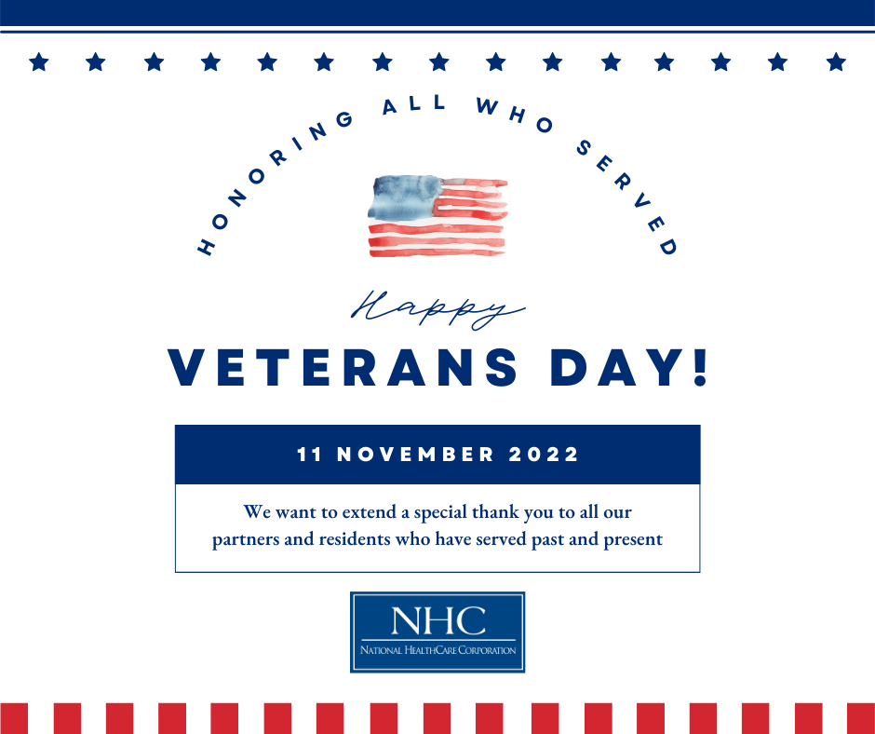
National HomeCare, Hospice, and Palliative Care Month
We would like to recognize our partners in HomeCare, Hospice, and Palliative care for their hard work and dedication. These valued partners provide much needed services in crucial times of our patients’ continuum of care. Thank you to all these amazing individuals for the care they give!
