May Family Newsletter
We welcome May with open arms as more begins to bloom and the sun continues to shine. This month is the start of a lot of Summer fun and we are excited it is here!
Center News
We have a lot of fun events planned for the month of May. On May 10th at 2:00 Mothers and Others Tea Social $3.00, RSVP with Kim. On May 10th, welcome our new pet therapy volunteer and her dog Alice. We will tour facility and meet residents in the chair exercise room. Alice is a rescued Tibetan Terrier therapy dog through HABIT. On May 18th at 2:00 in the main dining room meet an Elvis Impersonator and dance at the party. We are celebrating National Skilled Nursing Care Week the 14th through the 20th. You may see partners wearing crazy outfits throughout that week as you visit your loved one.

Special Announcements for Families
Check out or Facebook page for fun photos of current activity events.

Special Thanks
Thank you to the Jubilee Band for volunteering to perform for our Residents. Thank you to our approved volunteers: Chaplain Peggy, Reanon, Cheryl, Corina, Cindy, Torrey, Christian, Diane, Elizabeth, Becky, Barb, Lily, and Judy! We appreciate all you do.

Important Dates
May 6-12 National Nurses Week
May 9 – Nurse Assessment Coordinator Day (MDS Coordinator)
May 10 – National Night Shift and Third Shift Workers Day
May 14 – Mother's Day
May 14-20 National Skilled Nursing Week
May 29 – Memorial Day
National Nurses Week
We want to honor all our nurses for National Nurses Week. These special individuals continuously devote their time to providing excellent care for all our patients. Thank you to our nurses for putting your heart into everything you do!
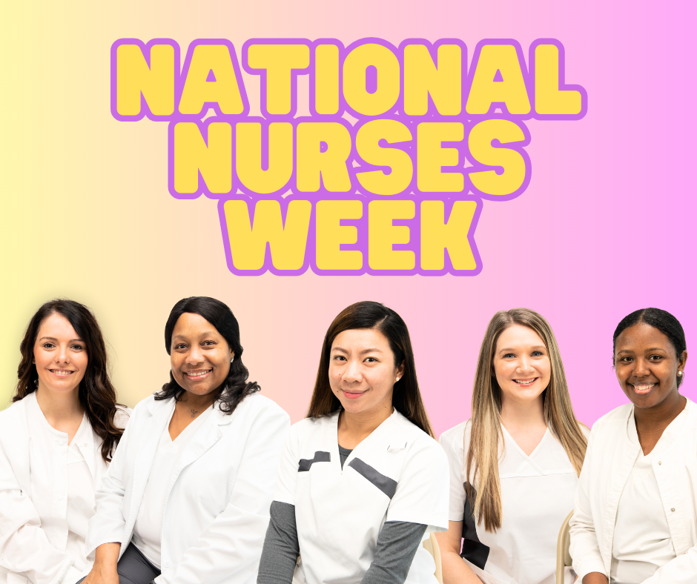
Mother’s Day
We wish every mom a Happy Mother’s Day! Thank you to all the moms in and out of our centers for giving us joy and inspiring us through your actions. If you’re looking for some fun gift ideas in celebration of Mother’s Day, click here.
National Skilled Nursing Week
We want to thank all of wonderful partners and celebrate them in National Skilled Nursing Week. Each one plays a valuable role in making us who we are! We appreciate them as we celebrate this week!
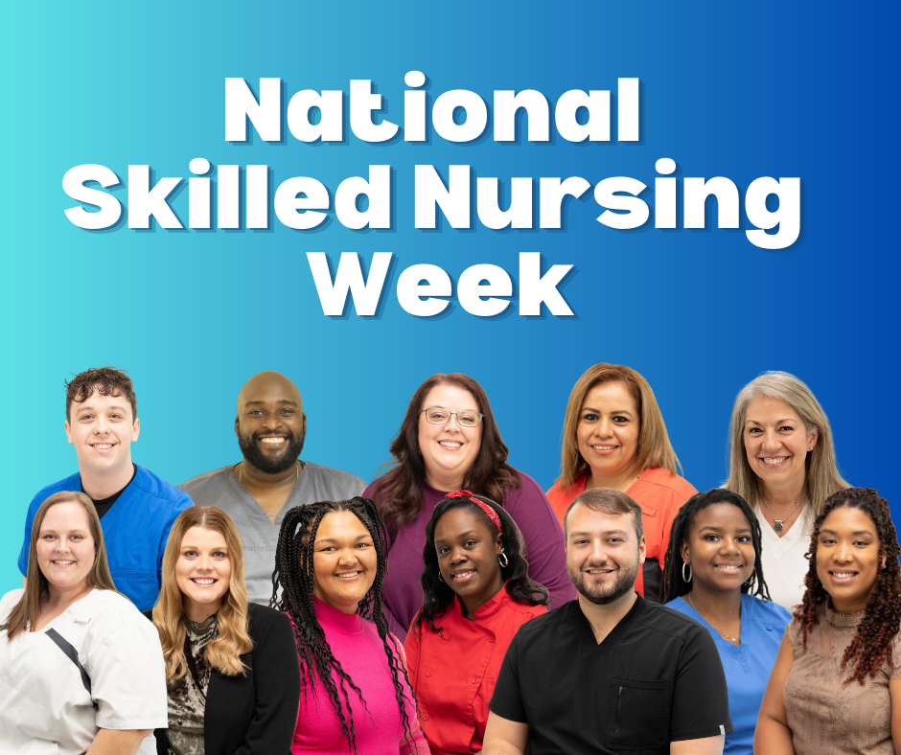
Memorial Day
This month we remember and honor all those who have given so much. We thank all service men and women for the sacrifices they have made. Whether you are a veteran or still active, we will be eternally grateful. If you are interested in giving back to our troops or learning more about Memorial Day, please click here.

