November 2022 Farragut & Cavette Hill
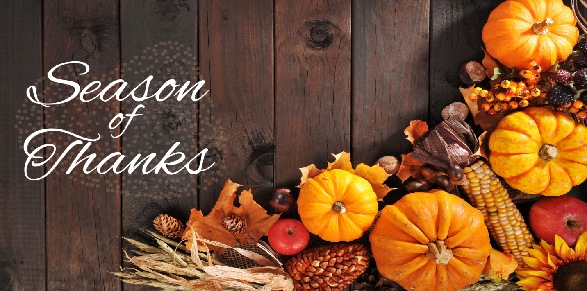
While there are many things to be thankful for year-round, November is the official Season of Thanksgiving. It is a time to celebrate what we are grateful for and take moments to enjoy all that we have. We are thankful to each one of you and hope you have a blessed coming Thanksgiving.
Important Dates:
November 6 Daylight Savings Time Ends
November 11 Veteran’s Day
November 24 Thanksgiving
NHC Place Farragut
Center News: We have planned many activities and special events to satisfy the individual needs and interests of our Residents. Among these events are Piano Music with Jay, Jewelry Making, Out Trips for shopping and for dinning out; Happy Hour with Live Musical Performance; Pet Therapy; Patriotic Arts and Crafts, Veterans Day Celebration, Intergenerational Program- Thankful Crafts, Holiday Theme and Canvas Painting. Please see our activity calendar for a full activity program and if you have any questions, please contact us.
Special Announcements for Families: We would love to invite you to attend any activity program with your loved one. Everyone is invited to help us recognize and thank our veterans for their service. Our Veterans Day Celebration will be held on Friday, November 11th at 2:30 pm.
Special Thanks: Big Thank You to all of ours Volunteers. You are all special people who enhance the life of others. We cannot thank you enough!
Cavette Hill
Center News: This month we are making “Thankful for You” gift baskets! If you have any questions regarding this event, please contact us.
Special Thanks: Thank you to the Knoxville community for voting us the number one Healthcare facility in City View Magazine.
Honoring Veterans Section
During this special Veteran’s Day, we would like to give thanks to all those who have served. We will never forget the sacrifices and bravery of the men and women who gave everything to protect our freedoms. We are especially thankful for all our partners and residents who have served in the past. Your courage has set an example for us all. Happy Veteran’s Day!
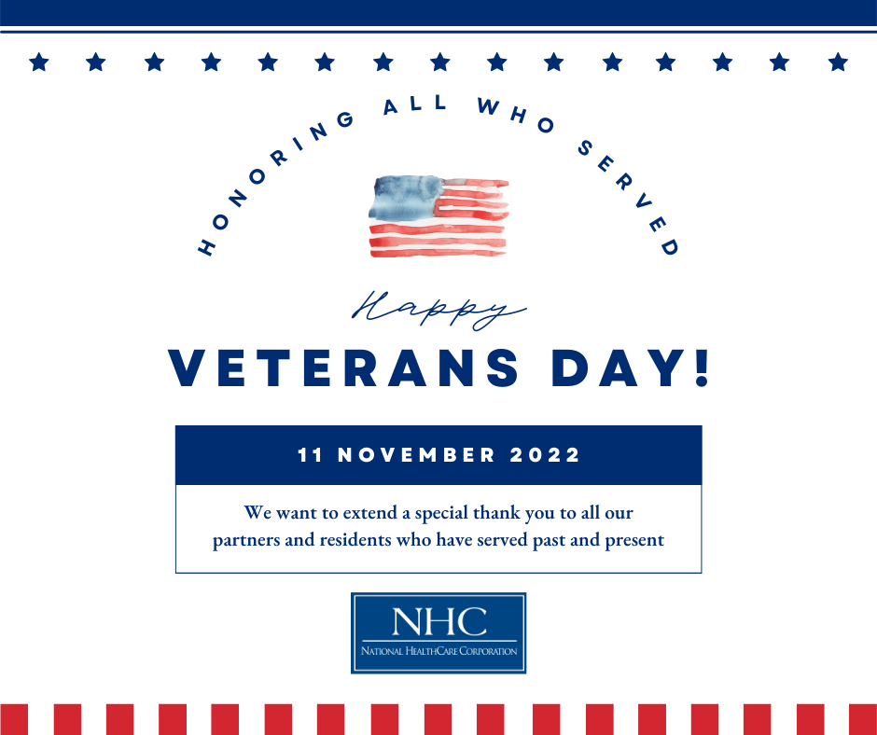
National HomeCare, Hospice, and Palliative Care Month
We would like to recognize our partners in HomeCare, Hospice, and Palliative care for their hard work and dedication. These valued partners provide much needed services in crucial times of our patients’ continuum of care. Thank you to all these amazing individuals for the care they give!
