NHC Place Farragut ALF
Sunday | Monday | Tuesday | Wednesday | Thursday | Friday | Saturday
25 | 26 | 27 | 28 | 29 | 30 | 1

. |  | Activity  Calendar is subject to change.  Come join us in some fun!! |  |  |  | Emily  9:30am Chair Chi  (SF)  10:30am Shut the  Box (SF)  2:30pm Movie Matinee Labyrinth
SF- Soda Fountain DR- Dining Room LR- Living Room CY - Courtyard
Sunday | Monday | Tuesday | Wednesday | Thursday | Friday | Saturday
2 | 3 | 4 | 5 | 6 | 7 | 8

NHC Place Farragut ALF

9:30am Chair Chi  (SF)  10:30am Sunday Service (DR)  2:30pm Sunday Afternoon at the Movies  Gone with the Wind (SF) | 9:30am Exercise with Patsy (SF)  10:30am UNO (SF)  10:30am Pet Therapy with Heather  10:30 Room Visits  1:15pm Ice-Cream  Social (SF)  2:00pm BINGO  (SF)  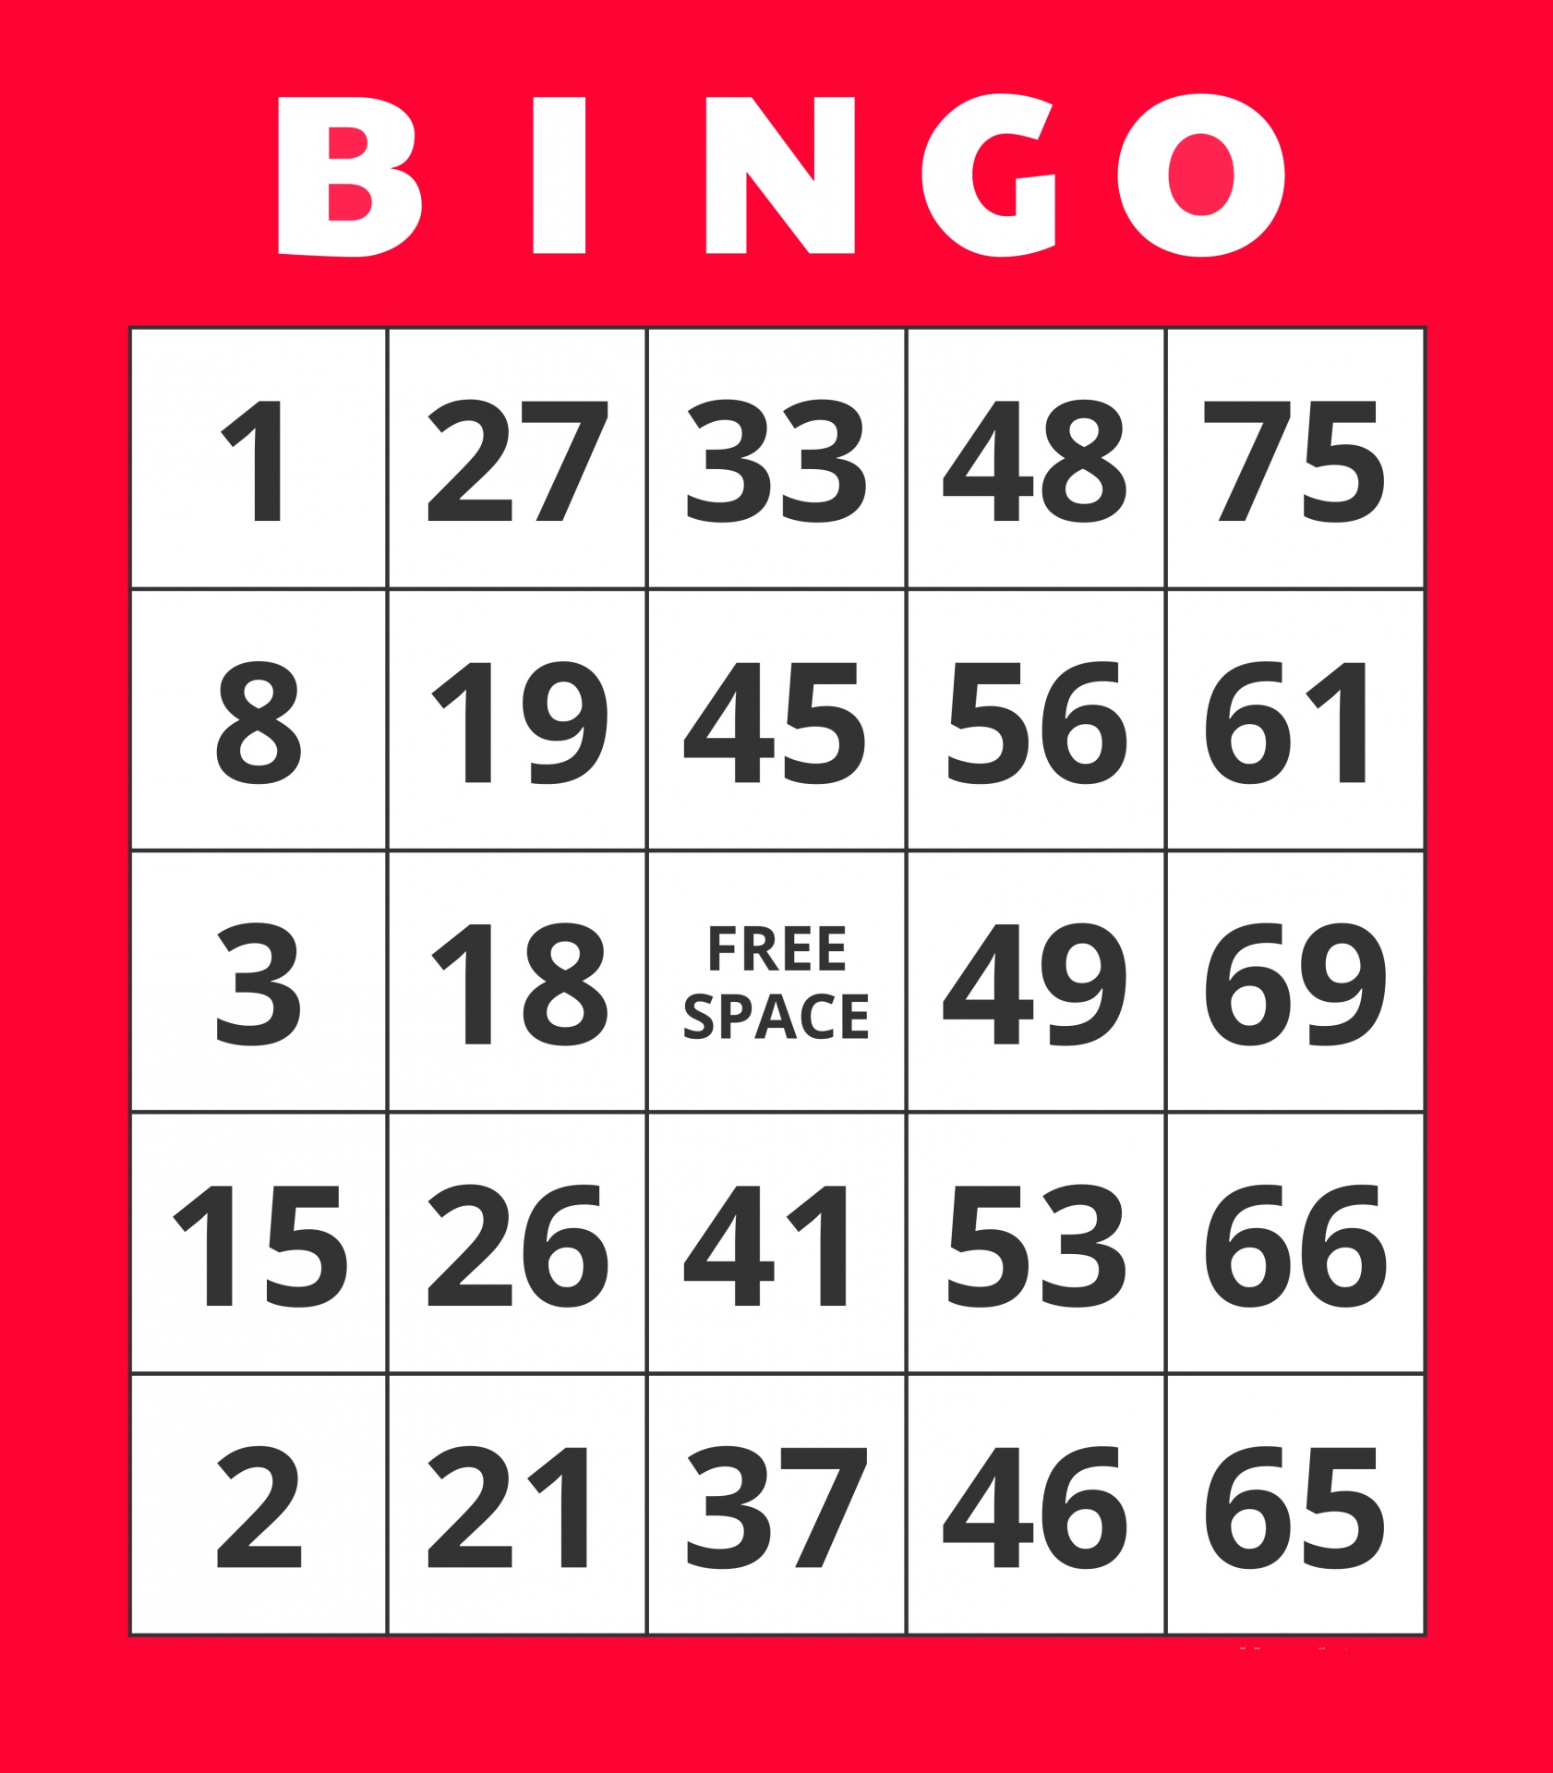 | 9:30am Exercise with Patsy (SF)  10:30am Piano Concert with Jan  (SF)  10:30pm Room Visits  1:30pm Balloon and Ball Bounce Fun (SF)  3:30pm Rosary with Lynn (LR) | 9:30am Exercise with Jennifer (SF)  9:30am Room  Visits  10:30am Devotions with Chaplain Austin (SF)  10:30am Pet Therapy with LILY  1:30pm Canvas Painting “Wondrerfall Creations”(SF) | 9:30am Exercise with Patsy (SF)  10:45am Coffee and Conversation  (SF)  10:45am Room Visits  1:15pm Book Club with Jennifer Coming Out by Danielle Steel (LR)  2:00pm BINGO  (SF)  4:00pm Pet Therapy with Darby | 9:30am Exercise with Patsy (SF)  10:30am Room Visits  10:45am Bird Education with Patsy (LR)  1:30pm Pet Therapy with Murphy  1:30pm Trivia  2:00pm Happy Hour / Tailgate Party (SF) | Jennifer  9:30am Exercise with Jennifer (SF)  10:30am UNO  (SF)  2:30pm Movie Matinee and Popcorn  Hook
Physical, Emotional/Spiritual, Vocational, Intellectual, Social, Environmental
Sunday | Monday | Tuesday | Wednesday | Thursday | Friday | Saturday
9 | 10 | 11 | 12 | 13 | 14 | 15

NHC Place Farragut ALF
9:30am Chair Chi  (SF)  10:30am Sunday Service (DR)  2:30pm Sunday Afternoon at the Movies  Grease (SF) | Columbus Day  9:30am Exercise with Jennifer (SF)  10:30am Reading with Patsy Love Comes Softly  10:30am Pet Therapy with Heather  1:15pm Columbus Day  Ice-Cream  Sundaes  (SF)  2:00pm BINGO  (SF) | 9:30am Exercise with Patsy (SF)  10:30am Out-Trip to Outback Stake House  10:30am UNO  10:30am Room Visits  2:00pm Live Musical Entertainment with Marc Beecher  3:30pm Rosary with Lynn (LR) | 9:30am Exercise with Jennifer (SF)  10:30am Devotions with Chaplain Austin (SF)  10:30am Pet Therapy with LILY  1:30pm Jewelry Making with Patsy (SF)  1:30pm Room Visits | 9:00am VOTING with Knox County Election Commission  State/Federal  General Election  2:00pm BINGO  (SF)  4:00pm Pet Therapy with Darby | 9:30am Exercise with Patsy (SF)  10:30am Room Visits  10:45am Book Club with Jennifer Coming Out by Danielle Steel (LR)  1:30pm Pet Therapy with Murphy  1:30pm Crossword Puzzle  (SF)  2:00pm Happy Hour/ Tailgate Tarty (SF) | Sara  9:30am Chair Chi  (SF)  10:30am Shut the  Box (SF)  2:30pm Movie Matinee  Night at the  Museum
SF- Soda Fountain DR- Dining Room LR-Living Room CY- Courtyard
Sunday | Monday | Tuesday | Wednesday | Thursday | Friday | Saturday
16 | 17 | 18 | 19 | 20 | 21 | 22

Type Healthcare, Assisted Living, Independent Activities, etc., here.

9:30am Chair Chi  (SF)  10:30am Sunday Service (DR)  2:30pm Sunday Afternoon at the Movies  The Edge (SF) | 9:30am Exercise with Jennifer (SF)  10:30am UNO (SF)  10:30am Pet Therapy with Heather  1:15pm Ice-Cream  Social (SF)  2:00pm BINGO  (SF) | 9:30am Exercise with Patsy (SF)  10:45am Hymn Singing (SF)  10:45am Room Visits  2:00pm Live Country Music Entertainment with Michael Ryan (DR) | 9:30am Exercise with Jennifer (SF)  10:30am Devotions with Chaplain Austin (SF)  10:30am Room Visits  10:30am Pet Therapy with LILY  1:30pm Painting  (SF)  1:30pm Out Trip to | 9:30am Exercise with Patsy (SF)  10:45am Coffee and Conversation (SF)  10:45am Room Visits  1:15pm Book Club with Jennifer Coming Out by Danielle Steel (LR)  2:00pm BINGO  (SF)  4:00pm Pet Therapy with Darby | 9:30am Exercise with Patsy (SF)  10:30am Room Visits  10:45am Reading with Patsy Love Comes Softly (LR)  1:30pm Pet Therapy with Murphy  1:30pm Trivia  2:00pm Happy Hour/ Tailgate Party (SF) | Patsy  9:30am Exercise with Patsy (SF)  10:30am UNO  (SF)  2:30pm Movie Matinee and Popcorn  Indiana Jones Last Crusade
Physical Emotional/Spiritual Vocational Intellectual Social Environmental
Sunday | Monday | Tuesday | Wednesday | Thursday | Friday | Saturday
23 | 24 | 25 | 26 | 27 | 28 | 29

Type Healthcare, Assisted Living, Independent Activities, etc., here.

9:30am Chair Chi  (SF)  10:30am Sunday Service (DR)  2:30pm Sunday Afternoon at the Movies (SF)  Monuments Men | 9:30am Exercise with Jennifer (SF)  10:30am UNO! (SF)  10:30am Pet Therapy with Heather  1:15pm Ice-Cream  Social (SF)  2:00pm BINGO  (SF) | 9:30am Exercise with Patsy (SF)  10:45am Book Club with Jennifer  Coming Out by Danielle Steel  10:45am Room Visits  2:00pm Resident Council (DR)  3:00pm Monthly Birthday Party (SF)  3:30pm Rosary with Lynn (LR) | 9:30am Exercise with Jennifer (SF)  10:30am Devotions with Chaplain Austin (SF)  10:30am Pet Therapy with LILY  1:30pm Arts and Crafts (SF) | 9:30am Exercise with Patsy (SF)  10:45am Coffee and Conversation  10:45am Room Visits  1:15pm Book Club with Jennifer (LR)  2:00pm BINGO  (SF)  4:00pm Pet Therapy with Darby  6:00pm -7:00pm  Trick or Treat  Event | 9:30am Exercise with Patsy (SF)  10:30am Room Visits  10:45am Bird Education with Patsy (LR)  1:30pm Pet Therapy with Murphy  2:00pm Halloween Happy Hour (SF) | Julita  9:30am Exercise with Julita (SF)  10:30am Shut the  Box (SF)  2:30pm Movie Matinee  The Burbs
SF- Soda Fountain DR- Dining Room LR- Living Room CY- Courtyard
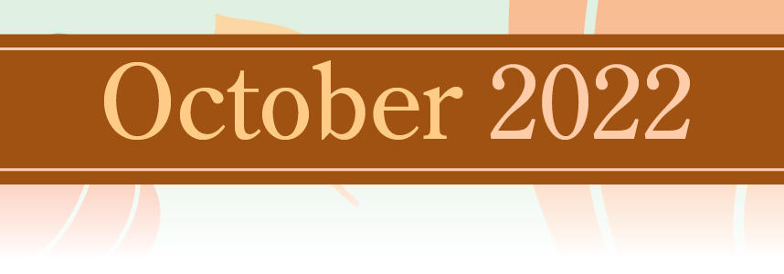  Sunday Monday Tuesday Wednesday Thursday Friday Saturday  30 31 1 2 3 4 5 |  | Type Healthcare, Assisted Living, Independent Activities, etc., here.
9:30am Chair Chi  (SF)  10:30am Sunday Service (DR)  2:30pm Sunday Afternoon at the movies  Hocus Pocus (SF) | Happy Halloween  9:30am Exercise with Jennifer (SF)  10:30am UNO (SF)  10:30am Pet Therapy with Heather  1:15pm Halloween Party  2:00pm BINGO  (SF)
Activity calendar is subject to change

