December 2022 NHC Oak Ridge Family Newsletter
Center Introduction: As the year comes to a close, we celebrate the year that’s passed and the year soon to begin. This is the season to spend time with loved ones and we’re thankful we get to spend time with them every day. We’re very excited to share with you all our upcoming events for the holiday season. Check out our blog about minimizing holiday stress for elderly relatives by clicking here .
Important Dates:
Dec. 7 – Pearl Harbor Remembrance
Dec. 24 - Christmas Eve
Dec. 25 - Christmas
Center News:

Churches
NHC Oak Ridge is in search of a Volunteer Sunday Church Service for our patients.
(any time of day) If interested, please contact NHC Recreation Department
Tonia Duncan
tonia.duncan@nhccare.com

Pet Therapy Wanted
NHC Oak Ridge is looking for Pet Therapy visitors for their patients. Must have Pet Vaccinated and up to date on all shots and Pet Therapy Certified completion.
We also Welcome Residents family pets. You may pick up a copy of our Pet Visitation Policy & Agreement at the front desk and return along with a copy of your pets shot record.

Are you up to date on your boosters?
It’s important during this time of visiting family and friends to remember to stay up to date on your vaccines. CDC recommends anyone 12 and over stay up to date on their vaccine boosters. To learn more , please CLICK HERE .
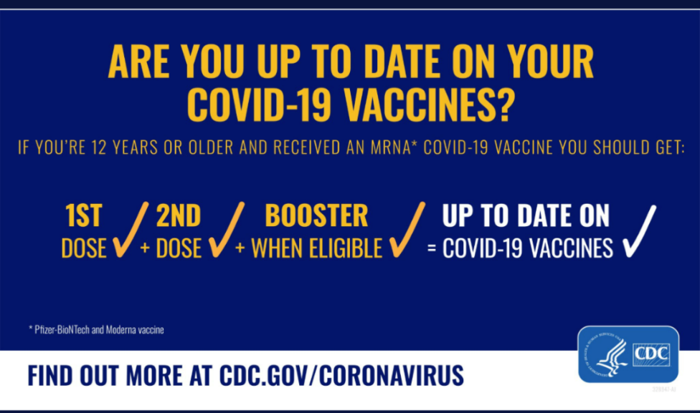
Christmas note: NHC wishes everyone a merry Christmas and Happy Holidays. Please make sure to call if you have any questions regarding visitation and how to be safe when coming into the center to visit your loved ones.
