Sunday | Monday | Tuesday | Wednesday | Thursday | Friday | Saturday
 |  |  |  |  |  | 1
2 | 3 | 4  Yom Kippur Begins | 5 | 6 | 7 | 8
9  Sukkot Begins | 10  Columbus Day (US)  Indigenous Peoples’ Day  Thanksgiving Day (Canada) | 11 | 12 | 13 | 14 | 15
16 | 17  Simchat Torah Begins | 18 | 19 | 20 | 21 | 22
23 | 24  Diwali (Hindi) | 25 | 26 | 27 | 28 | 29
30 | 31  Halloween

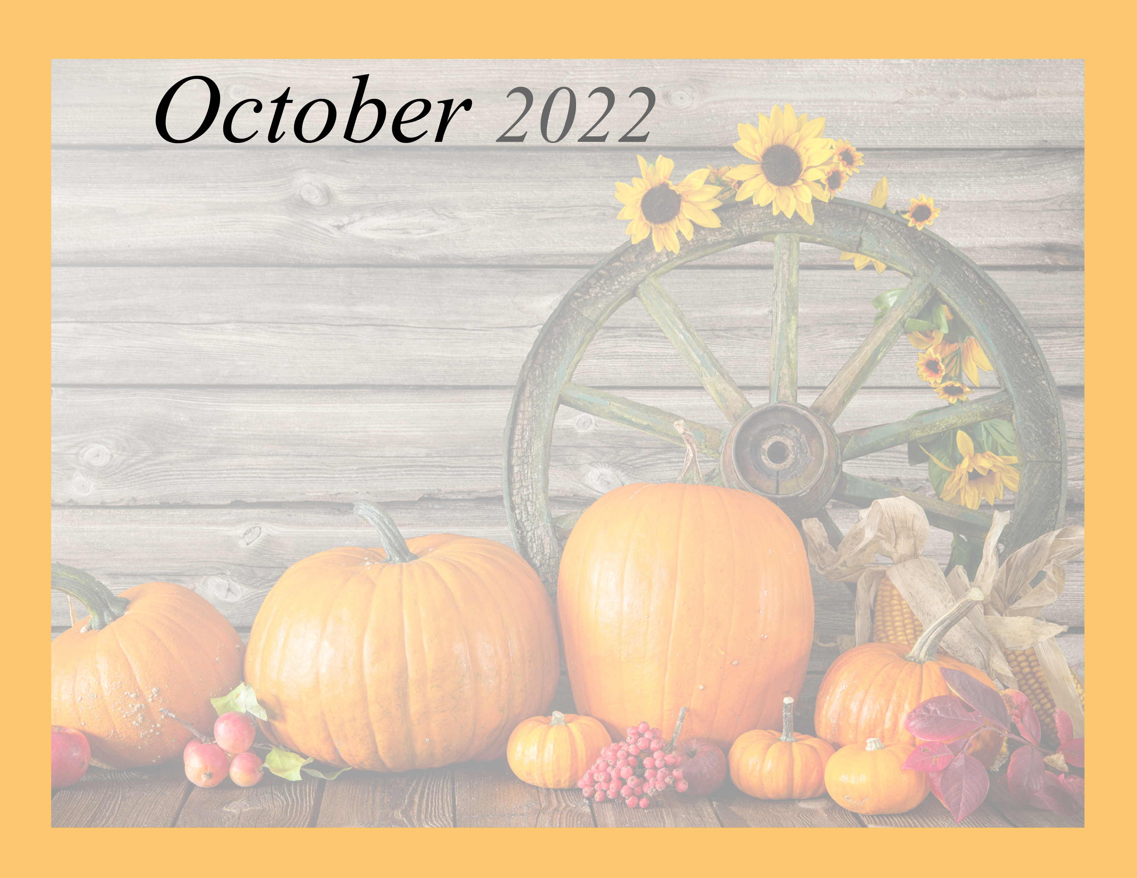 NHC CAVETTE HILL |  |  |  |  |  | 9:30 Plaster Craft  (100/200)  10:45 Time Outside  (100/200)  1:00 Time Outside (300/400)  2:30 Plaster Craft  (300/400) Kristin
12:30 Sunday Service | 9:30 Stained Glass Craft Day 1(100/200)  11:00 Story Time (100/200)  1:00 Stained Glass Craft Day 1 (300/400)  3:00 Courtyard Visit  (300/400) | 9:00 Morning Stretch (100/200)  10:00 Bible Reading  1:00 Stained Glass  Craft Day 2 (300/400)  3:00 Courtyard Visit  (100/200) | 9:30 Daily Chronicles (300/400)  10:30 Ball Circle  (100/200)  1:00 BINGO (300)  2:30 Stained Glass Craft  Day 2 (100/200) | 9:00 Morning Stretch (300/400)  10:30 Church (400)  1:00 Cuckoo Clock Décor (100/200)  3:00 Balloon Ball  (300/400) | 9:30 Sing-A-Long (100/200)  10:30 Ball Circle  (300/400)  1:00 Murphy the Habit dog visits  2:00 Cuckoo Clock Decor (300/400) | 9:00 Ball Toss  (300/400)  10:30 Coloring Pages (300/400)  1:00 Bean Bag Toss  (100/200)  2:00 Bead Painting  (100/200) Bridget Bridget
12:30 Sunday Service | 9:30 Button Turtle Craft (100/200)  10:30 Balloon Ball (300/400)  1:00 Mandala Craft (300/400)  2:30 Indigenous Day! (400) | 9:00 Morning Stretch  (300/400)  10:00 Bible Reading  1:00 POPCORN  2:30 Make a scarecrow (100/200) | 9:00 Daily Chronicles  (100/200)  10:30 Material Guessing Game(300/400)  1:00 BINGO (300)  3:00 Mandala Craft  (100/200) | 9:00 Bean Bag Toss (300/400)  10:30 Church (400 Wing)  2:00 Jon Wigle performs for us!(400)  3:30 Scarecrow Craft  (300/400) | 9:00 Sponge Leaf Painting (100/200)  10:30 Beach Ball Bat Challenge (300/400)  1:00 Murphy the Habit dog visits  2:00 Ghost Planter  (100/200) | 9:30 Fall Leaf Cutouts  (100/200)  10:30 Time in the sun  (300/400)  1:00 Story Time (100/200)  2:30 Ball Play (300/400)  Kristin  Kristin
12:30 Sunday Service | 9:30 Coloring Pages  (300/400)  10:30 Alphabet Game  (100/200)  1:00 Sponge Leaf Painting (300/400)  2:30 Balloon Ball (100/200) | 9:00 Coloring Pages  (100/200)  10:00 Bible Reading (400)  1:00 Button Turtle Craft (300/400)  3:00 Bean Bag Toss (100/200) | 9:30 Trivia (300/400)  10:30 Peanut Butter Bird Feeders (100/200)  1:00 BINGO (300)  3:00 Color to music  (100/200) | 9:00 Hand Massages (300/400)  10:30 Church (400)  1:00 Balloon Ball (100/200)  2:30 Raymond Akers performs for us! (400) | 9:30 Morning Stretch (100/200)  10:30 UNO! (300)  1:00 Murphy the Habit dog visits  2:00 BINGO (300) | 9:30 Egg Carton Turtles (100/200)  10:30 Bean Bag Toss (300/400)  1:00 Bubbles in the courtyard (100/200)  3:00 Coloring Pages (300/400) Bridget  Bridget
12:30 Sunday Service | 9:30 Ghost Planter  (300/400)  10:30 Joke Reading (100/200)  1:00 Sponge Leaf Painting (100/200)  2:30 Bean Bag Toss (300/400) | 9:00 Ghost Bags  (300/400)  10:00 Bible Reading (400)  1:00 UNO! (100/200)  2:30 Color to music  (300/400) | 9:30Trivia (100/200)  10:30 Finish the Song Lyrics (300/400)  1:00BINGO (300)  3:00 Yahtzee! (100/200) | 9:00 Hand Massages (100/200)  10:30 Church (400 Wing)  1:00 Pumpkin Painting (300/400)  3:00 Sunshine in the courtyard | 9:30 Ghost Bags (100/200)  1:00 Murphy the Habit dog visits  2:00 Pumpkin Judging  3:00 Sunshine in the courtyard | 9:30 Ghost Planter  (100/200)  10:30 Nerf Range  (300/400)  1:00 Ball Circle  (100/200)  2:30 Puzzles (300/400)  Kristin
12:30 Sunday Service | 9:30 Daily Chronicles  (300/400)  10:30 Halloween Coloring (100/200)  1:30 Halloween Party  (400) | Autumn is a second spring when every leaf is a flower.
Physical, Emotional/Spiritual, Vocational, Intellectual, Social, Environmental

