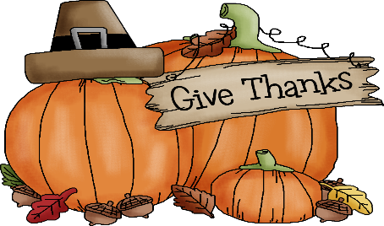
RECREATION/WELLNESS NOVEMBER 2020 CALENDAR OF ACTIVITIES
NHC HEALTHCARE JOPLIN, MO
SUNDAY | MONDAY | TUESDAY | WEDNESDAY | THURSDAY | FRIDAY | SATURDAY
1  Independent Activities  This day in History | 2  Bingo-OTH  One on One Programs –IR  Magazine Scavenger Hunt-IR  These Hands Project  This day in History-IR | 3  Chair Yoga-OTH  Glamour Gals Manicures- IR  Chess/Checkers-IR  This day in History-IR | 4  Bingo-OTH  Black Jack- IR  One on One Programs- IR  This day in History-IR | 5  Morning Devotional- OTH  Ice Cream Social-OTH  Phase 10-IR  Weather Worms-IR  This day in History-IR | 6  Bingo-OTH  Happy Hour Cart w/ Fresh Popcorn –OTH  Old People Problems Comedy of Tom Foss-IR  This day in History-IR | 7  Independent Activities  This day in History-IR
8  Independent Activities  This day in History-IR | 9  Bingo-OTH  One on One Programs –IR  Mystery Bag Challenge  This Day in History-IR | 10  Chair Dancing-OTH  Glamour Gals Manicures- IR  Resident Council-OTH  Lacing Cards- IR  This Day in History-IR | 11  Bingo-OTH  One on One Programs- IR  Phase 10-IR  This Day in History-IR | 12  Morning Devotional- OTH  Ice Cream Social-OTH  Bean Bag Tic Tac Toe-IR  This Day in History-IR | 13  Bingo-OTH  Happy Hour Cart w/ Fresh Popcorn –OTH  Cats will make you laugh your head off-IR | 14  Independent Activities  This day in History-IR
15  Independent Activities | 16  Bingo-OTH  One on One Programs –IR  Thankful Tree-IR  This day in History-IR | 17  Chair Yoga-OTH  Glamour Gals Manicures- IR  Facials-IR  Fall Sun Catchers-IR  This day in History-IR | 18  Bingo-OTH  One on One Programs- IR  Fall in Love with Joplin-IR  This day in History-IR | 19  Morning Devotional- OTH  Ice Cream Social-OTH  Virtual White Cyclone Wooden Roller Coaster-IR  This day in History-IR | 20  Bingo-OTH  Happy Hour Cart w/ Fresh Popcorn –OTH  Funniest Animals of 2020-IR  This day in History-IR | 21  Independent Activities  This day in History-IR
22  Independent Activities  This day in History-IR | 23  Bingo-OTH  One on One Programs –IR  Let us gives thanks-IR  This day in History-IR | 24  Chair Dancing-OTH  Glamour Gals Manicures- IR  Virtual Fall Hike-IR  This day in History-IR | 25  Bingo-OTH  One on One Programs- IR  Mind Teaser Puzzles-IR  This day in History-IR | 26  Morning Devotional- OTH  Ice Cream Social-OTH  Thanksgiving Riddle me this-IR  This day in History-IR | 27  Bingo-OTH  Happy Hour Cart w/ Fresh Popcorn –OTH  Virtual Field Trip- Marineland Dolphin Adventure –IR  This day in History-IR | 28  Independent Activities  This day in History-IR
29  Independent Activities  This day in History-IR | 30  Bingo-OTH  One on One Programs –IR  What’s in the bag? -IR  This day in History-IR |  | Location Key  MDR – Main Dining Room  ADR – Assisted Dining Room  AR—Activity Room  OTH—On The Hall  IR—In Room Activities | *Activities are subject to change as the conditions change and to meet the needs of our residents*

